**Local Residential Exemptions**

A report of

**The Select Board’s**

**Residential Exemption Policy Study Committee (Ad Hoc)**

March 2019

DRAFT

Version 0.95

March 31, 2019

Contacts: Mark Andersen or Vicki Blier

**Executive Summary** **5**

Recommendations 9

**Introduction** **15**

**1. Criteria for Examining Residential Exemptions** **17**

Direct, Intended Consequences 17

Economic and Psychological Impact on the Household 17

Impact on Household Migration 17

Indirect and Second-Order Effects 17

Housing Impact 18

Lexington Budgetary Impact 18

Equitable Taxation 18

Evaluative framework 18

**2. Housing-Cost Stress and Out-Migration in Lexington** **20**

An Analysis of the Public Services and Housing Costs Survey 20

Housing stress 21

1. Renters report high housing stress more often than owners. 21

2. High housing stress is reported at all ages, lengths of residence, incomes, and home values. 22

3. Income is a better predictor of housing stress than is home value. 23

4. Means tested targeting offers higher precision than the State’s Residential Exemption (SRE), but low recall. 24

Migration potential 24

5. Renters are more likely to migrate than owners. 25

6. Housing stress significantly drives migration for homeowners. 26

7. Home value and income are not significant predictors of migration for homeowners. 27

8. Middle aged populations have the highest forecast of migration. 29

Open Response Comments 30

9. Lexington residents are quite concerned about the steady increase in local taxes 30

Statistical Study 30

Summary 30

**3. Property Tax Relief Measures Currently Available to Lexington Residents** **32**

Town Programs 32

The Committee examined programs in place in Lexington today to assist homeowners with property taxes. 32

Property Tax Exemptions 32

Property Tax Deferrals 33

Senior Service Program 34

Utilization of Property Tax Programs in Lexington 34

The Massachusetts Senior Circuit Breaker Property Tax Credit 35

**4. Residential Properties in Lexington** **36**

Classification of Residential Properties 36

Residential Property Types 37

Single Family Homes in Lexington 38

Two-Family Homes in Lexington 39

Condominiums in Lexington 40

Large Apartment Complexes in Lexington 42

Undeveloped Land 43

For-Profit Child Care Facilities 43

Group Living Facilities 44

Brookhaven 45

Affordable and Subsidized Housing 45

Conclusion 45

**5. The Massachusetts Residential Exemption** **47**

State Residential Exemption Process 47

Setting an Exemption Percentage and, thereby, an Exemption Amount 47

Eligibility and Verification 48

Exemption Amount and Tax Rate Calculation 48

Misunderstanding #1. A residential exemption reduces Lexington taxes 54

Misunderstanding #2. A residential exemption simply shifts tax burden onto apartments 54

Misunderstanding #3. A residential exemption is progressive by shifting the tax burden from low price homes onto high price homes 54

Direct Consequences of SRE on Homes and Property Classes 54

Owner-occupied Single Family Homes and Condominiums 54

Tax Burdens Relative to Peer Communities 56

Indirect Consequences of the State Residential Exemption 64

Perspectives from the Lexington Real Estate Community 64

Perspectives from Economists and Housing Policy Experts 65

Aggregate Residential and Commercial Property Value in Lexington 67

Condominium Conversions 68

Income Profile of Winners and Losers with the SRE 70

Residential Exemptions in Massachusetts Communities 73

Summary 74

**6. Massachusetts Model Means-Tested Residential Exemption Laws** **75**

Existing MTRE Laws in Five Towns 75

Massachusetts Model Means-Tested Exemption Laws 76

Adoption 76

Offsetting Loss of Circuit Breaker Tax Credits 77

Funding 77

An Assessor’s Perspective on Means-Tested Residential Exemptions 78

Implementation Issues Experienced by Concord 78

Perspectives from Economists and Housing Policy Experts 79

Summary 79

**7. Lexington Means-Tested Exemption Proposals** **80**

Lexington Proposals 80

Rationales for Eligibility 81

Rationales for Benefits 82

Proposal #1: Circuit Breaker Style Means-Tested Exemption 83

Proposal #2: Octogenarian Means-Tested Tax Exemption 86

Property Tax Freeze Models in other States 89

Evaluation 89

**8. Conclusions and Recommendations** **92**

**Appendix: Property Tax Benchmark Charts** **93**

**Appendix: Services, Housing Stress and Emigration Survey** **110**

Survey Executive Summary 110

1. Overview 111

2. Survey Process 112

Survey Structure 114

3. Survey Respondents 117

4. Comparative Charts and Correlation Analysis on Housing Stress and Migration 122

4a. Housing Stress in the Survey 122

4b. Migration in the Survey 142

5. Correlation Charts 156

6. Open Responses to Survey 160

7. Statistical Analysis of Housing Stress and Predicted Migration Decisions 168

8. Survey Response Summary 174

**Appendix: Related Documents** **193**

Survey Data and Analysis 193

Dr. Jonathan Haughton Tax Equilibrium Model 193

# 

# Executive Summary

This report summarizes the year-long research undertaken by the Select Board’s Residential Exemption Policy Study Committee (Ad Hoc). This Committee was charged by the Lexington Select Board to evaluate residential property tax exemptions as a tool for helping residents remain in their homes. During the course of the year, the Committee surveyed residents, interviewed subject matter experts, reviewed legislation, held two public hearings, and evaluated its applicability for Lexington.

The State’s Residential Exemption (SRE) is a local option available to all municipalities. When adopted, it allows the Select Board to set a uniform flat exemption that is applied to the property tax assessments of verified owner-occupied residential property. A provision of the law maintains revenue levels by increasing the residential tax rates to compensate for exemptions. Thus, the exemption effectively reduces taxes on residential properties with low assessed values, increases taxes on residential properties with high assessed values, and substantially increases taxes on residential properties that are not owner-occupied.

Chapter 1 provides an overview of the framework and terminology developed by the Committee to examine residential exemptions. The Committee identified criteria for examining the effects of residential exemptions as:

* Economic and Psychological Impacts on the Household - the role that property taxation has on financial stress and feelings of alienation toward the Town, and what effect residential exemptions may have on these factors.
* Impact on Household Migration - the effect that residential exemptions may have on migration decisions.
* Housing Impact - whether residential exemptions might change housing costs, the mix of housing types and as a result, the demographics of Lexington.
* Lexington Budgetary Impact - the effect that residential exemptions may have on demographics with resulting impacts on the Town budget.
* Equitable Taxation - how residential exemptions comport with concepts of tax fairness.

An evaluative framework was determined that examines residential exemptions in terms of Precision and Recall, a methodology borrowed from data science.

**Precision:** Out of the group of people that receive benefits from an exemption, how many of them are the intended beneficiaries? The fewer unintended beneficiaries, the higher the precision.

**Recall:** Out of the intended beneficiaries of an exemption, how many of them will receive benefits? The more intended beneficiaries included, the higher the recall.

Chapter 2 Finding limited information from existing studies to answer the Committee’s questions regarding the relationship between home value, housing stress, age, income, the use of Town services and migration decisions, the Committee undertook a detailed survey that reached a representative 7% of the adult population of Lexington. Key findings are presented in this chapter, and all details covered in the survey appendix.

Findings presented in Chapter 2 include:

* Renters report high housing stress, more often than owners.
* High housing stress is reported at all ages, lengths of residence, incomes, and home values.
* Income is a better predictor of housing stress than is home value.
* Means tested targeting offers higher precision than the State’s Residential Exemption (SRE), but low recall (under reaching those with high housing stress).
* Renters are more likely to migrate than owners.
* Housing stress significantly drives migration for homeowners.
* Home value and income are not significant predictors of migration for homeowners.
* Middle aged populations have the highest forecast of migration.
* Lexington residents are very concerned about the steady increase in local taxes

These survey findings suggest that the SRE would *not* directly target those with high housing stress, and that its impact on migration patterns would be limited. Residential exemptions may impact economic health and psychological stress, but survey data suggests that policy makers should *not* expect an exemption to have a material impact on migration.

Chapter 3 provides an overview of property tax relief measures currently available to Lexington residents and the extent to which they are utilized. Most relevant for this discussion are two programs:

* The Massachusetts Senior Circuit Breaker, a State administered program which provides a partial rebate for senior homeowners whose property tax exceeds 10% of their income. The provisions of the State Circuit Breaker are important to understand, as this $1,100 State tax rebate could paradoxically be diminished when the taxpayer receives a residential exemption.
* The Lexington Tax Deferral Program, which is an option for homeowners to manage cash flows by deferring payment of their property taxes. The Committee identified common obstacles that exist for use of the tax deferral: income eligibility ceilings and blocking-actions by mortgage and home equity creditors.

Chapter 4 describes and enumerates the various types of residential property in Lexington and discusses how they may be influenced by the effects of an SRE.

* Homes which could be owner-occupied account for 97% of residential value in Lexington.
* Condominiums account for 10% of all residential parcels and have a median assessed value of $530,000. Due to their lower assessed values, nearly all Lexington condominium owners would benefit from the SRE regardless of their personal level of assets or income.
* Lexington has eight large commercial apartment buildings comprised of 984 units. These large apartment buildings do not qualify for residential exemptions and will receive significant property tax increases with an SRE.
* Lexington has 53 remaining buildable lots. Buildable lots are not owner occupied and will experience an increase in property tax. Increased property tax could incentivize development of these parcels.
* Lexington’s five for-profit child care centers and four for-profit group living facilities are taxed as residential properties but are not owner-occupied. They would experience an increase in property tax with an SRE.
* None of Lexington’s affordable and subsidized rental housing would be affected by an SRE.

Owner-occupancy is the only eligibility criteria for a residential property to qualify for an SRE. It is described by the Massachusetts Division of Revenue as the owner’s primary residence where family, social, civic and economic life is centered and where the homeowner plans to return whenever he or she is away. Owner-occupancy verification is determined by local policy, and may be confirmed by tax returns, driver’s license, utility bills or other evidence.

Chapter 5 describes the Massachusetts State Residential Exemption (SRE) in detail, provides quantified examples of direct effects, discusses the expected indirect effects, defines key concepts, and clarifies misunderstandings articulated at the Committee’s two public hearings.

A direct effect of SRE adoption would be to lower property taxes for owner-occupied homes with assessments that are below a breakeven point[1] and increase property taxes for owner occupied homes above that breakeven point and for all non-owner occupied properties.

* An owner-occupied home at the breakeven point would experience neither an increase nor decrease in property tax due to the SRE.
* The impact on owner-occupied households is proportional to how far above or below the breakeven point their property assessment is.
* The breakeven point is irrelevant to non-owner-occupied properties, instead all such properties would experience the same percentage tax increases.

The financial impact of the SRE is proportional to the size of the exemption set by the Select Board. At the higher exemption rates, for owner-occupied properties near the extremes of assessed-values, tax impacts could amount to thousands of dollars per year. All non-owner-occupied homes would also see large impacts. Tables and charts are provided both to illustrate these effects, and also to compare Lexington’s current and SRE modeled property taxes with example communities. An appendix extends these charts to numerous adjacent, peer, and competing communities.

Over the long term, the SRE has an indirect effect by incentivizing ownership housing and disincentivizing rental housing. This policy could have lasting effects on Lexington housing and demographics, hypothesized to include:

* Absentee homeowners may prefer to sell their homes rather than lease them to others.
* Rental units may be converted to condominiums, because, with an SRE, each condominium unit can qualify for its own residential exemption.
* Converting Lexington rental units to condominiums would shrink the rental market, which would likely increase area rental rates.
* Converted units could reduce economic diversity in Lexington by displacing asset-poor renters.
* Responses which increase owner-occupied housing could increase the total number of residential exemptions and therefore reduce the tax benefit for owner-occupied homes.

At the Committee’s Economist and Policy Expert Roundtable Discussion, further indirect effects were discussed:

* Economists hypothesize that tax changes will affect future property values. While a tax decrease for lower-valued properties, such as condominiums, initially makes these properties seem more affordable, this improved affordability would be expected to make them more attractive to buyers. Many buyers are constrained by ability to pay and will apply their tax savings or tax loss to the purchase price. Purchase affordability could drive an increase in market value for lower priced properties causing their tax assessment to subsequently increase. The opposite would happen for higher priced homes and multi-tenant properties which would find their values and subsequent assessments declining. These housing market adaptations to SRE implementation are anticipated to reverse 28% of the initial tax shift.
* SRE-prompted changes in property values are hypothesized to make a residential exemption a *single-generation* affordability benefit. Current owners would receive both an adjusted tax bill and an adjusted market value, while future property buyers would purchase a property whose value had already shifted in the opposite direction from the tax shift. Future owners would not realize any net affordability benefit when purchasing a Lexington property.

The Committee combined survey data (see Chapter 2) with the projected direct effects of the SRE finding that:

* The SRE would not target financial relief effectively to residents found to have significant housing stress.
* The SRE could adversely impact some residents already experiencing housing stress.

After identifying deficiencies of the SRE, the Committee sought and was granted an enlarged scope by the Select Board to additionally examine Means-Tested Residential Exemptions (MTRE), and to evaluate them in comparision to the SRE.

Chapter 6 examines Means-Tested Residential Exemptions (MTRE), which are tax exemptions given to qualifying residents based on criteria that include income, asset, age, and residency thresholds.

* MTREs of two basic types have been adopted in five Massachusetts towns through Special Legislation (state approval), and provide meaningful assistance to qualified households.
* MTREs can have an unintended side-effect of *reducing* state aid for beneficiaries by decreasing property taxes.
* Using survey data from Chapter 2, the Committee projects that typical means-tested exemptions would precisely target beneficiaries with limited means, however the *majority* of residents with high housing cost stress would receive no relief.

In view of inherent limitations and side-effects of existing MTREs, the Committee recommends that Lexington evaluate creation of its own MTRE variant rather than directly copy from existing models.

Chapter 7 outlines two new modelsfor possible Lexington-specific exemptions which could be further developed through community conversation:

* An MTRE with guidelines to avoid side-effects such as reduction in circuit breaker aid or penalties for surviving spouses.
* An age-based property tax freeze for 80+ year olds.

These proposals target two different populations in Lexington. Detailed notes are provided to guide future legislation away from limitations identified in current programs. Because eligibility for both of these proposed MTRE models attaches to the homeowner rather than to the property, no impact on housing values is anticipated.

Conclusions summarizes final thoughts and provides eight recommendations.

The Committee urges policy makers to review the detailed survey described in the Appendix, which provides insight on housing stress and migration attitudes in relation to age, income, and home value, as well as general concerns about taxes. Tax benchmarking against peer and neighboring communities, along with survey data, could be used to inform many Town projects and policies. This research suggests an interaction between taxes, demographics, and migration which policy makers should further examine to improve Lexington’s position in attracting and retaining residents.

## Recommendations

*No proposed exemption directly targets all residents experiencing high housing cost stress*. The SRE and existing MTREs present the possibility of unintended consequences including changes in Lexington home values and housing types, reduced economic diversity, the direction of benefits to unintended recipients, increased taxation of already-stressed households, and a reduction in State aid to qualifying beneficiaries.

As a result of these findings, the Committee unanimously makes the following eight recommendations to the Select Board, spanning actions for local tax policy, advocacy at the state level, and areas for additional study. Committee members reached the recommendations based on evidence presented, but individual Committee members found their own basis in this evidence differently. With each recommendation we enumerate bases which were used by one or more Committee members to support their position:

**Local Tax Policy:**

1. **Do not adopt the Massachusetts Residential Exemption (SRE)**.
   1. The benefit is not targeted to those in need: Data from our survey shows that concerns about housing stress and property taxes span renters and owners, low value homes and high value homes, and an SRE would offer tax relief to only a portion of those with need. It would also provide benefits to other residents who are not experiencing housing stress.
   2. Taxes would increase on higher value homes, some of which are occupied by residents who are stressed by taxes.
   3. The SRE increases the potential for rents to increase either through direct pass-through of tax increases or indirectly because landlords may be incentivized to convert apartments to condominiums which will reduce the supply of rental units, thus changing the market conditions that influence rents. Survey data shows that renters report housing stress with far greater frequency than homeowners.
   4. Using Lexington tax monies to provide local tax exemptions may directly reduce property tax rebates that 447 moderate income households receive under the Massachusetts [Senior Circuit Breaker Tax Credit](https://www.mass.gov/service-details/senior-circuit-breaker-tax-credit) (2016). The net benefit for these households will be less than anticipated and local tax monies will be wasted by these offset losses.
   5. An SRE does not lower the aggregate residential tax burden in Lexington; it shifts a portion of residential taxes from a majority of residents to a minority who own more expensive homes or non-owner occupied properties.
   6. An SRE would increase the property tax on group residential facilities, making these developments less competitive in Lexington. As the population ages and attitudes about housing ownership evolve, Lexington should promote rather than discourage evolving residential housing solutions.
   7. By providing a tax incentive to owner occupied housing over rental housing, the SRE provides a benefit to owner occupied condominiums over rental units. If landlords were to convert housing stock from rental to ownership, housing and economic diversity in Lexington would be diminished.
   8. Incentives created by a residential exemption may cause actions by owners of non-owner-occupied properties that increase the total number of exemptions granted. These actions include the selling of rental properties to owners who will occupy the property, the conversion of rental properties into owner-occupied condominiums, and the development of empty land. An increased number of exemptions would mathematically lower the net exemption benefit.
   9. When an SRE lowers property taxes associated with a home, economic theory suggests that the price of that home would increase. If this were true, then the present occupant would receive a double benefit (reduced taxes and higher home value) while the future purchaser would receive no net benefit (higher home purchase price required to purchase lower taxes). This dual effect means a residential tax exemption is a *single generation* adjustment with no long term benefit for affordability of Lexington homes. Additionally, a higher purchase price offsetting lower taxes could favor future buyers with more assets and higher credit scores over those with less, giving preference to economically advantaged buyers.
   10. As modelled by Dr. Haughton, 28% of the suggested tax adjustment is undone through hypothesized impact of that tax adjustment on housing prices.
   11. The SRE is hypothesized to make it easier for Lexington residents to “remain in their homes” by reducing property tax stress. Our survey investigated whether there was a relationship between home value and likelihood of migration. The survey results show that beneficiaries of an SRE have a lower self-forecasted migration probability and therefore it seems unlikely that creating an SRE would materially impact migration.
   12. Owner occupancy verification required by an SRE is time consuming to administer and verify, especially for properties held in some types of trusts.
2. **Develop for community consideration a proposal for a means-tested or age-based residential exemption**.
   1. A means-tested residential exemption can be designed to provide aid to those residents who have high property taxes in relation to their income.
      1. Survey results show that low income is more strongly correlated with housing stress than is home value. Thus, income targeting tax relief would more precisely reach those with economic need.
      2. Survey data shows that residents who meet all criteria of typical means-testing (income, age, home value, years of residence) are unlikely to have children in public schools, and therefore are net contributors to town finances even with reduced taxes.
      3. Because a means-tested exemption would affect a small number of households, it would not materially change tax levels for most residents.
      4. Because a means-tested exemption would target the household rather than the property, impact on home values should be minimal.
      5. However, a means-tested residential exemption would target a small segment of residents, while survey data shows that a large portion of residents experience housing stress or express open comments of concern about property taxes; an exemption alone, no matter how well-tailored, will not provide relief to all tax-stressed residents.
   2. An exemption which targets the oldest members of the community can provide financial predictability for a subpopulation with limited flexibility.
      1. Residents are living longer, and a greater number of older seniors (80+) will live in Lexington in the future.
      2. Older seniors are often unable to take on additional work to augment income.
      3. Although older seniors have lower self-forecasted migration, anecdotal evidence suggests that alternatives are expensive and not attractive, forcing some of these residents to remain in their homes even in deteriorating conditions.
      4. Older residents are more likely to experience the death of a spouse, which reduces rather than increases economic support from existing policies such as the State Circuit Breaker.
      5. Older seniors are unlikely to have children in schools, and therefore are a portion of the population which are net contributors, even if their property tax bills were to remain unchanged after age 80.
      6. A simple model suggests that providing a property tax freeze to residents age 80 and above would have a one-time tax effect but would likely cause little impact after that point. However, if the tax policy were also to extend Lexington residency among more older seniors, a resulting reduction in public school children could provide some relief for operating and capital budgets.
      7. Because an exemption for older seniors would target the household rather than the property, the expected impact on home prices would be minimal.
      8. However, it is acknowledged that our survey does not show that seniors age 80+ have either the largest housing stress nor an elevated likelihood of migration. Some committee members believe decisions to migrate occur closer to age 60, and households may be making decisions with this earlier assessment of the benefits and costs of retiring in Lexington.
3. **Promote awareness of existing programs such as tax deferrals, exemptions, and the Massachusetts Senior Circuit Breaker Property Tax Credit**.
   1. Panelists at the Housing Policy and Economics Roundtable Discussion suggested that the Town could increase awareness of existing programs
   2. Residents may not recognize the Circuit Breaker Property Tax Credit as related to property taxes because the application is part of the State income tax return process. It is possible that some eligible community members are not submitting this form.
   3. The Committee learned that this tax credit may be lost by some who would receive an SRE, and therefore public education may also help residents realize that Lexington can not simply provide a residential exemption without a partially-offsetting loss to of this credit to households with low to moderate incomes.
4. **Evaluate increasing eligibility thresholds significantly for the Lexington Tax Deferral Program**.
   1. Income thresholds prevent some Lexington residents from using deferrals; 42 Lexington residents utilized deferrals in FY2018.[2] Increasing eligibility thresholds would ensure that more residents with financial concerns could avail themselves of assistance.
   2. Some argue that targeted tax relief benefits heirs at the expense of community members, making deferrals preferable to exemptions.

**State Advocacy**:

1. **Advocate for expanded access to tax deferrals for homeowners with existing or future mortgages and home equity loans**.
   1. Anecdotal evidence provided by committee members and at public hearings indicated that some residents are blocked from obtaining a tax deferral by a company holding their mortgage or equity loan.
   2. It is hypothesized that one reason only 42 Lexington residents utilized deferrals in FY2018, may be that mortgage holders do not approve the local tax liens that are part of the deferral process.
   3. Panelists agree that deferrals are an important public policy and that action to ensure that mortgage or equity loan creditors cannot easily block tax deferrals would benefit residents seeking such deferrals.
2. **Advocate for expanded access to the state administered Senior Circuit Breaker Property Tax Credit for surviving spouses and those with homes above the current eligibility threshold, as well as expanding the level of rebate**.
   1. A concern was voiced in the Committee’s second public hearing about meeting that existing tax policies do not sufficiently differentiate older seniors as a distinct group. On the loss of a spouse, income cut-offs for single individuals may disqualify surviving spouses from Circuit Breaker rebates.
   2. The existing cap of $1,100 property tax rebate is inadequate assistance for the size of property taxes in Lexington in 2019.

**Further Study**:

1. **Further study the financial needs and supports necessary for Lexington’s population of older (80+) seniors to “age in place”**.
   1. Our oldest senior residents may experience different housing and financial challenges than younger seniors, a concern voiced in the Committee’s second public hearing.
   2. Supports unrelated to property taxes also might be created for older seniors to “age in place”, but further study is needed to identify those supports.
2. **Further study methods to retain middle-aged residents, who have the highest rate of self-forecasted out-migration among all age-cohorts in our survey**.
   1. Survey summary 8: Middle aged populations have the highest self-forecast of migration and these residents may have the highest capacity to afford Lexington’s taxes.
   2. Anecdotal evidence combined with the survey data leads the Committee to believe that out-migration for the aging population occurs within a few years after children graduate from Lexington public schools rather than mid-retirement. Therefore, the community needs to understand these migration trends to enhance Lexington’s economic stability and make aging in Lexington a realistic long term option for more households.

While the Committee does not recommend the SRE nor a direct copy of an existing MTRE, committee members feel that responding to property tax concerns is urgent and important. During this Committee’s term, we heard the voices of residents at public hearings and undertook a survey which shows that residents express consistent open responses calling for property tax relief. Therefore, members of the Committee urge Lexington’s leaders to review these recommendations and take timely actions to support resident concerns about taxes while remaining in Lexington.

# 

# Introduction

A growing school population and a number of significant school and town capital projects have increased financial pressure on Lexington taxpayers. While the Massachusetts Residential Exemption (SRE) has been available and unused in Lexington for decades, it remained unclear whether this law would be an effective tool for tax relief. Therefore, in early 2018 the Lexington Board of Selectmen formed an Ad Hoc Residential Exemption Policy Study Committee (in this report, “the Committee”) to examine whether instituting a residential property tax exemption would serve the interests of the Lexington community.

The Committee was appointed and presented with this charge:

*Preserving affordability for residents is the Board's top financial goal. This ad-hoc committee will... study the Residential Exemption and analyze if adopting the exemption could help reduce the property tax burden and make it easier for residents to remain in their homes. The ad-hoc committee will focus on identifying policy questions and will make recommendations to the Selectmen regarding the residential exemption.[3]*

The SRE is a local option available to all municipalities. When applied, it allows the Select Board to set a uniform flat exemption to all owner-occupied residential properties. A provision of the law maintains municipal revenue at the same level by increasing the residential tax rate by a compensatory amount. The exemption then has the effect of reducing taxes on residential properties with low assessed value, increasing taxes on residential properties with high assessed value, and substantially increasing taxes residential properties which are not owner-occupied. This exemption is used by only 16 of the 351 municipalities in Massachusetts, and communities adopting it are characterized by significant numbers of properties which are not owner-occupied.

After several months of study of the SRE and a first public hearing, the Committee determined that it should also study state-approved local ordinances which provide means-tested exemptions. The Selectmen supported this requested and extended the Committee’s charge and timeline through the end of 2018. The Committee then expanded its scope to include means-tested exemptions which are presently adopted in Sudbury, Concord, Hopkinton, Reading and Wayland.

Means-Tested Residential Exemptions (MTREs) vary across communities, but share the characteristic that eligibility for the exemption is limited to those who qualify, primarily on the basis of income and age. These exemptions typically also have requirements for residency-length, home value, and assets besides one’s primary residence. The Committee’s study and this report also encompass an evaluation of these exemptions, which could be adopted in Lexington through a home rule petition to the Massachusetts legislature.

After reviewing a prior working group’s output and the few reports produced by other communities, the Committee set an ambitious course of seeking more data and expertise to inform this analysis. This report describes the results of two public hearings, a roundtable with real estate brokers, a second roundtable with housing policy experts, and a data analysis of a Services and Housing Stress survey which reached 7% of Lexington's adult population. Furthermore, the Committee consulted with assessment staff in Lexington and other communities to learn about implementation experiences with residential exemptions. This new empirical research was combined with data on Lexington demographics and ownership to provide an overview of how residential exemptions would impact Lexington.

Modifying a community’s taxation policy impacts not only tax bills, but can impact demographics, the type of housing, affordability, budgets, and tax policy for decades. We encourage the community to read this report and debate the present tax policy and proposed changes, and how adoption decisions could shape Lexington’s future.

# 1. Criteria for Examining Residential Exemptions

As the Committee deliberated the pros and cons of various residential exemptions, many considerations occurred to the Committee. Who gains and who loses? Can apartment owners pass through taxes as increased rents? What would happen to housing prices? Should Lexington’s tax policy impact a snowbird who lives part time in Lexington?

With many potential intended and unintended consequences (or “second order effects”), it is challenging to provide a clear and consistent framework. Moreover, effects which seem more “fair” or desirable to one, may seem patently unfair to another.

## Direct, Intended Consequences

The Committee Charge includes the phrase “if adopting the exemption could help reduce the property tax burden and make it easier for residents to remain in their homes.” Interpreting this charge, the Committee identified two interpretations for the phrase “easier for residents to remain in their homes”.

### *Ec*onomic and Psychological Impact on the Household

A common complaint is that Lexington property taxes make it difficult for residents to remain in their homes because large tax costs displace necessary expenses ranging from food, energy, and medical expenses to entertainment. Moreover, even if the economic impact is not a hardship, the stress that some residents may feel in realizing that property taxes are among their largest annual expenses can create a sense of stress and alienation from the town. The Committee’s first interpretation of the phrase “easier for residents to remain” is an attempt to measure for each type of residential exemption whether it significantly impacts economic and psychological stress in the household.

### Impact on Household Migration

Practical interpretation of the phrase “easier for residents to remain in their homes” suggests that the objective is met if residents in fact would more often remain in their Lexington homes. In other words, would adopting a residential exemption impact migration decisions of residents. Some feel that high property taxes have the impact of “forcing” some residents to leave Lexington. A typical political argument is that if the tax burden is decreased, fewer residents will in fact leave Lexington. A literal interpretation of the charge was then to leverage data and expert opinion to evaluate whether residential exemptions would impact decisions made by Lexington households.

## Indirect and Second-Order Effects

Beyond the specific economic and migration impacts of a residential exemption, the Committee found a wide range of impacts which could ripple through the community. We felt these impacts could not be neglected, though they fall outside the wording of the charge. Key categories of these indirect effects also were evaluated for each type of exemption.

### Housing Impact

Residential exemptions may impact housing in several respects: the balance between owner-occupied and non-owner-occupied housing may shift while rents and prices may be affected. For each exemption type, the Committee identified the anticipated housing effects.

### Lexington Budgetary Impact

If a residential exemption succeeds in making it easier for residents to remain in their homes, one should expect a demographic shift to occur and some change in out-migration patterns. Because demographic shifts impact utilization of local services and, in particular, public school enrollment which is by far the most expensive service provided by the Town, a residential exemption might be expected to impact operating and capital costs for Lexington. For each exemption, the Committee evaluated possible budgetary impact.

### Equitable Taxation

Real estate property taxation is grounded in a concept that owners of more property have greater ability to pay than those with less property, and therefore tax policy should be related to that property. This concept of tax policy is enshrined in the Massachusetts Constitution which provides for equal taxation rates on each class of property. The Committee examined how each exemption type impacts concepts of tax fairness. Each exemption policy departs from residential proportionality under some conditions. We identify these conditions and describe how they can relate to tax fairness.

## Evaluative framework

Any potential policy tool created to address the criteria we have described above should be evaluated for how well it will help target residents, and how well it avoids assisting those outside the target. Providing tax relief to those struggling seems a significant goal; providing tax relief to those who are not struggling is an undesirable goal. It may not be possible to meaningfully assist all of the former at the exclusion of the latter. Potential public policies can be compared by how effectively tax relief reaches the target population. In the interpretive portions of this report, we will use the terms precision and recall (borrowed from data science) as a framework for evaluation:

A public policy X is created to target population Y but has the effect of instead helping population Z.

**Precision** = The percentage of people within the actual beneficiary group who are actually members of the targeted group. (What % of class Z are members of class Y.)

**Recall** = The percentage of people in the targeted group who are the actual intended beneficiary group. (What % of members of class Y are in class Z.)

By employing precision and recall as evaluation metrics, the Committee is able to leverage data to quantify how effective exemption public policies are likely to be in their direct consequences. Separately, this report also describes indirect consequences of public policies, which must also be a consideration for policy makers.

# 2. Housing-Cost Stress and Out-Migration in Lexington

## An Analysis of the Public Services and Housing Costs Survey

The Committee undertook a detailed survey of Lexington residents with a goal of increased insight into financial housing stress and migration, and how these might relate to proposed residential property tax exemptions. We wanted to assess what portion of the community experiences high stress related to property taxes, how property taxes and high stress relate to migration decisions, and whether proposed tax exemptions would benefit members of the community with greatest need or least use of services. This section of the report considers survey data as a source of evidence that, by itself, does not constitute a comprehensive assessment of residential exemptions.

The Committee created a survey in summer-fall 2018 and administered it in the October-November 2018 time frame. The survey yielded 1,475 responses from Lexington residents, or approximately 7% of the adult population.

The survey allows assessment of whether relationships exist between demographic and tax levels along with two behavioral variables: housing stress and likelihood of leaving Lexington within ten years (migration). While behavioral variables describe subjective experiences, the Committee believes the broad outlines of the results provide insight into residential exemption policy. Per the Committee’s charge[4], two goals of a residential exemption would be to assist those with high housing stress (especially when property taxes contribute) or to impact decisions to leave Lexington. To discuss measurement of possible policies, we use the conceptual framework of precision and recall.[5] **Precision** is the percentage of those helped by a policy who are in the class of intended beneficiaries. **Recall** is the percentage of all intended beneficiaries assisted by a given policy.

A complete description of this survey, including participation, evaluation of response demographics, illustrative charts, statistical analyses, and responses to open-ended questions is provided in the appendix to this report. Moreover, all data without personally identifying information (PII) will be published. This chapter will summarize key conclusions of the survey, and the appendix can be referenced for complete analysis.

Each conclusion will be identified along with relevance to the Massachusetts State Residential Exemption (SRE) or a Means-Tested Residential Exemption (MTRE). These exemptions are described in more detail in later chapters.

## Housing stress

A first set of insights relates to housing stress, which is the frequency with which owners or renters report that they experience stress related to housing payments. Housing payments may include mortgage, equity loans, home improvement, utilities, or property taxes. The Committee sought to determine whether property tax remedies would materially assist residents experiencing housing stress.

### 1. Renters report high housing stress more often than owners.

The survey provided unequivocal evidence that renters are more often stressed by housing costs than owners. 58% of renters report high housing stress, as compared with only 18% of owners.

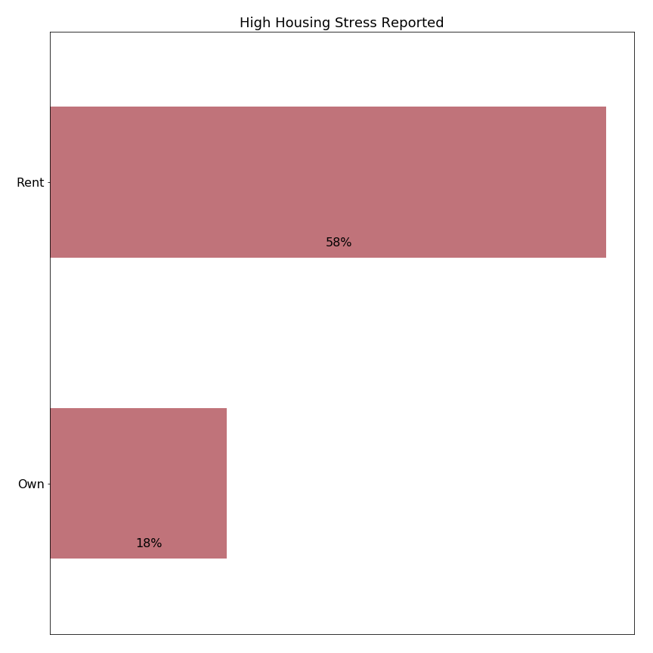

This finding argues against adoption of the State’s Residential Exemption (SRE), because the SRE would increase taxes on owners of rental properties which may be passed through to renters. Additional indirect effects of increased tax rates on rental property may include apartment conversion to condominiums (to avoid the higher tax rate and let individual condominium owners take advantage of the exemption) and increased apartment rental rates (due to lower supply of apartments).

### 

### 2. High housing stress is reported at all ages, lengths of residence, incomes, and home values.

This finding argues against adoption of the SRE, because the SRE would provide relatively low precision: many of its beneficiaries report medium or low levels of housing stress. At the same time, an SRE would increase property taxes for those owning homes above the breakeven point; some of these owners already report high levels of housing stress.

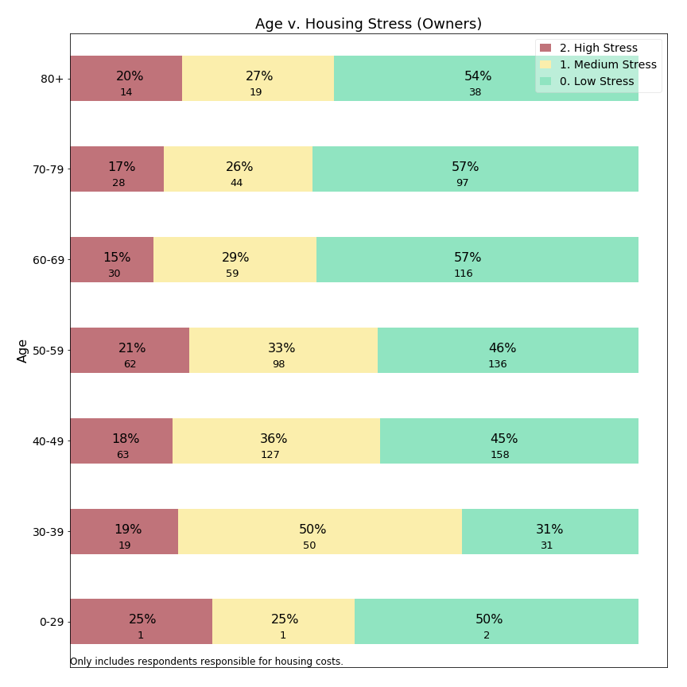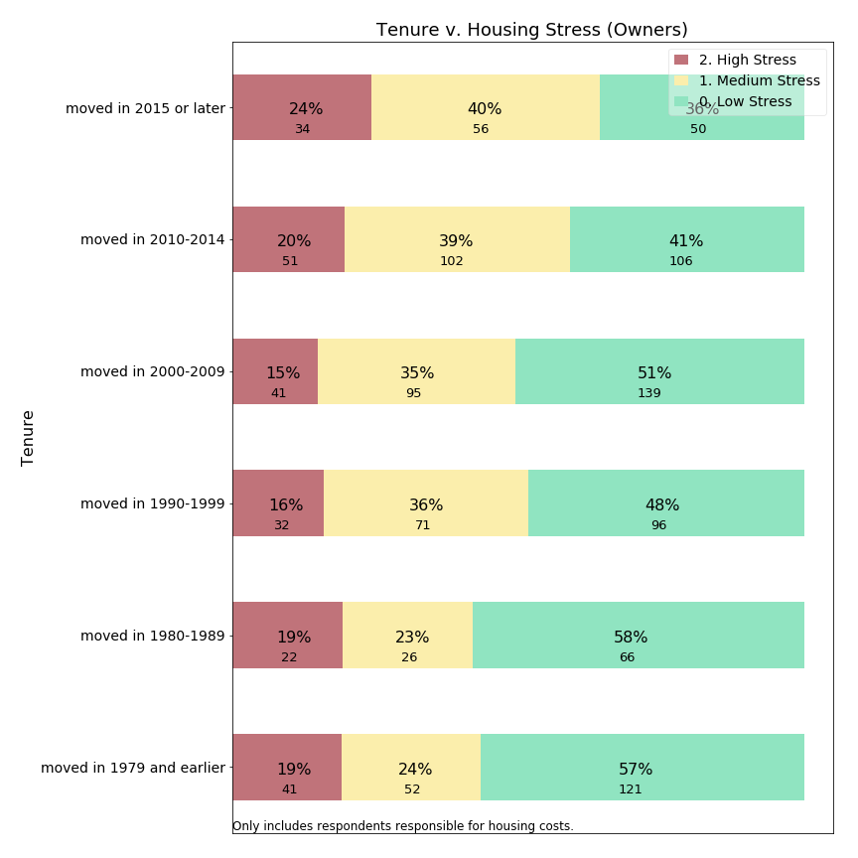

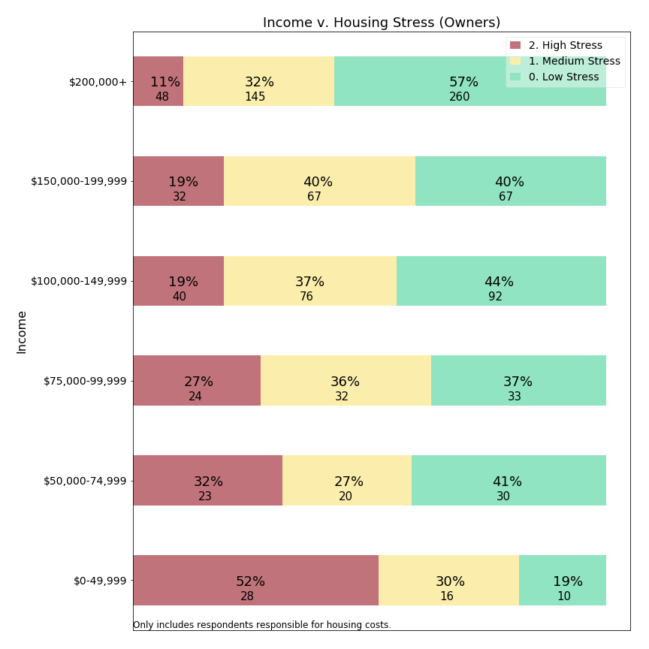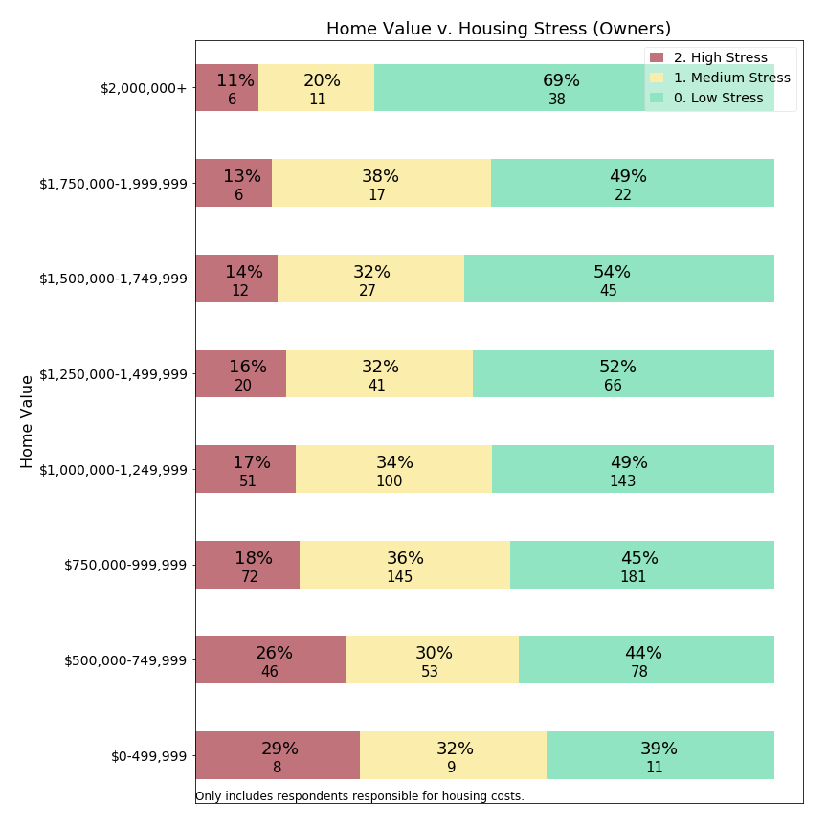

|  |
| --- |
| *A note on interpreting stacked horizontal bar charts on stress and migration:*  Colors: colors have been chosen to represent levels of the parameter being measured, in most cases “housing stress” or “forecast of intent to move”. Stress and intent to move were measured on a five or six point scale, but these are grouped into adjacent categories so an easily interpreted using a three color scheme.  Stacked bars: Each row corresponds to the entire number of respondents meeting the criteria labelled on the left (100%). A colored bar is shown with area proportionate to the respondents in that category (percent). Below the primary label showing the percent value is an integer value, representing the actual number of respondents. This actual number can be used to interpret the significance of the finding, as small counts (<20) have less reliability than higher number counts.  Interpreting percentages: these charts indicate the frequency with which respondents report a sentiment of the questioned intensity, which is different from the intensity. The language in the report uses the term “frequency” to reference how often respondents indicated an issue. |

### 3. Income is a better predictor of housing stress than is home value.

This finding (bottom left figure in the prior section) illustrates that a means-tested residential exemption based on income would provide for the higher precision than a SRE based on home value. *Note the higher rates of housing stress at lower income levels (bottom left) in comparison to rates of housing stress at lower home values (bottom right).*

### 4. Means tested targeting offers higher precision than the State’s Residential Exemption (SRE), but low recall.

This chart uses survey variables to construct an approximation for eligibility to a generic means tested exemption, and shows stress levels for those with value 1 (eligible) v. 0 (ineligible):

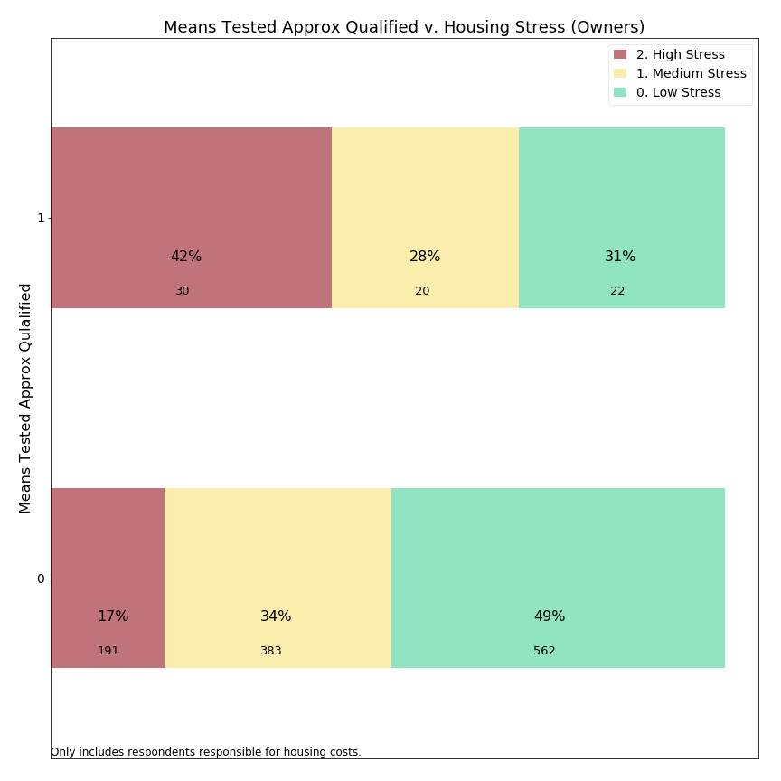

Only a small portion of households that responded to our survey would benefit from an MTRE (low recall), but a means-tested exemption would have higher precision. High precision means that most beneficiaries have the target criteria (high housing stress). However, an MTRE would have low recall, because only about 10-15% of homeowners experiencing high housing stress would be eligible. We conclude that neither the SRE nor an MTRE offers both high precision and high recall: helping many who need assistance while ensuring help lands mostly with those who need it.

## Migration potential

A second set of key insights relates to a question about future migration. Residents were asked whether they anticipated migrating from Lexington in the next ten years. The survey allowed us to examine the relationship between high likelihood of departing Lexington and demographic variables.

### 5. Renters are more likely to migrate than owners.

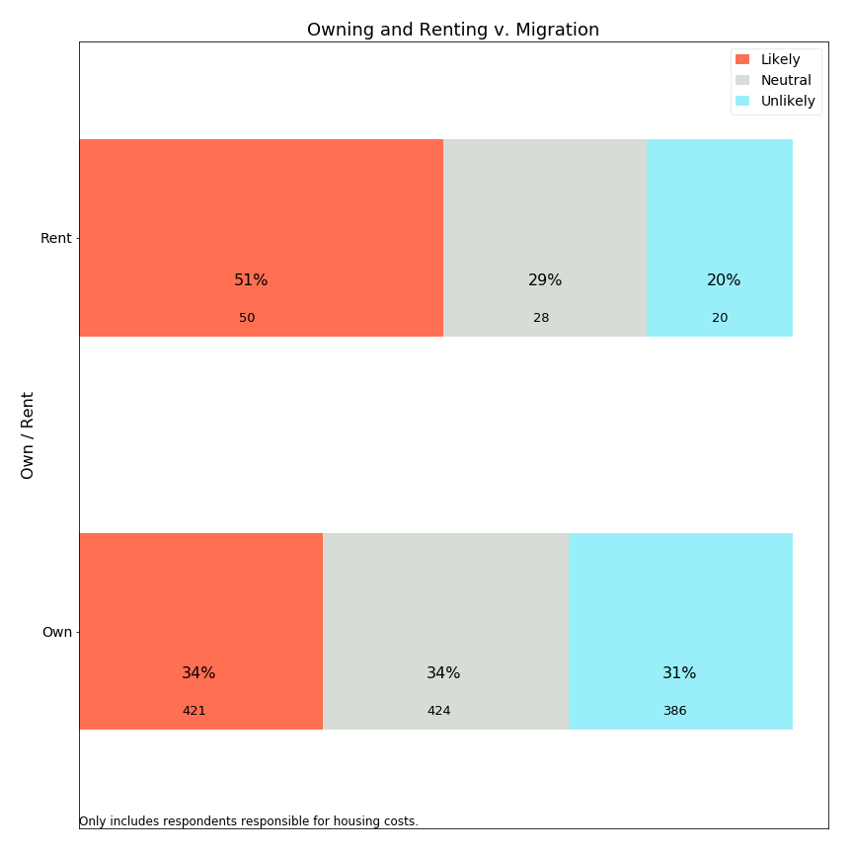

51% of renters forecast leaving in the next 10 years compared to 34% of owners. We would expect renters to constitute a more transient population, and yet find it noteworthy that 34% of owners also anticipate leaving Lexington. The Committee has no benchmark to evaluate this percentage, but notes that it seems a high rate for anticipated migration, as actual migration would also include unexpected life changes and events beyond what survey residents can forecast.

### 6. Housing stress significantly drives migration for homeowners.

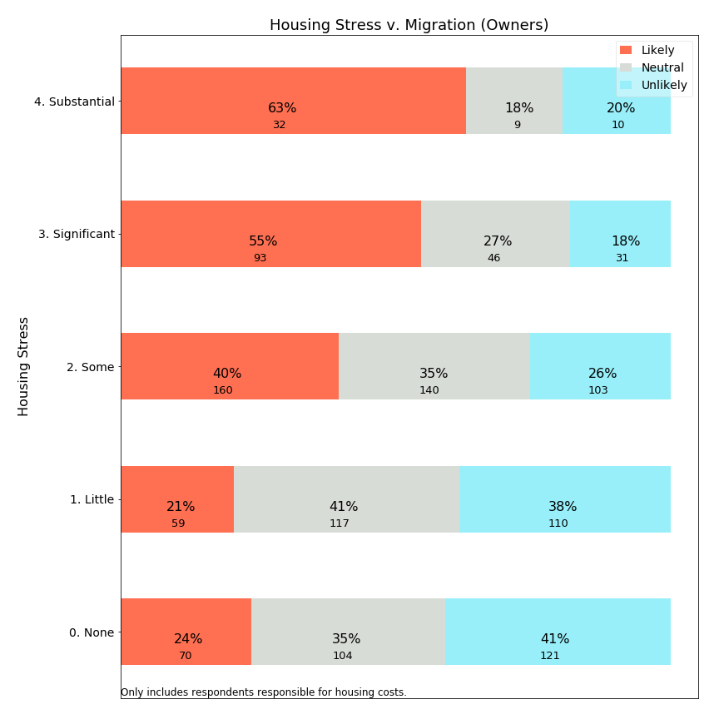

We see a strong relationship between housing stress and forecasted out-migration. This survey does not prove that a causal relationship exists, only a correlation is demonstrated between housing stress and anticipated migration.

### 7. Home value and income are not significant predictors of migration for homeowners.

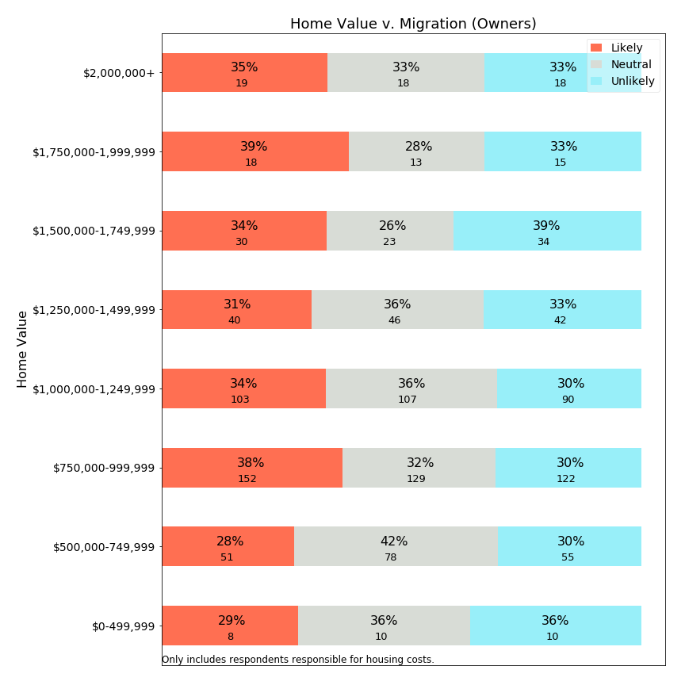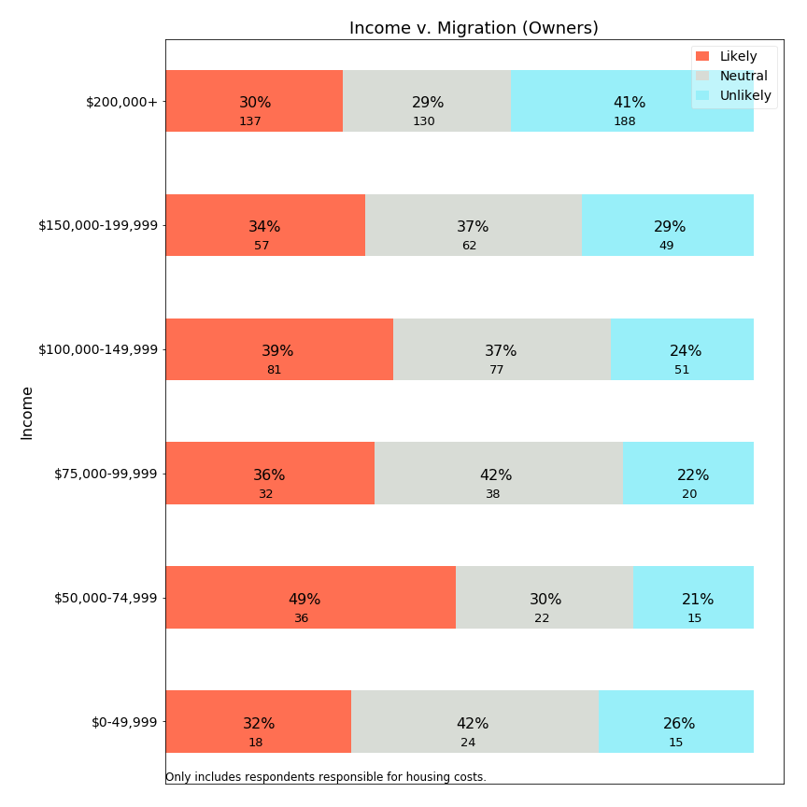

The finding that home value and income do not predict migration demonstrates that an effective public policy to address migration concerns would have to *address housing stress without simply relying on home value or income as proxies for stress*. Surprisingly, those with the lowest income levels or home values have *depressed* levels of migration relative to those with median incomes and home values. One conclusion is that owners with the lowest incomes and home values may feel precluded from relocating by economic considerations. Another conclusion is that a direct application of SRE or MTRE might not be expected to reduce migration significantly.[6]

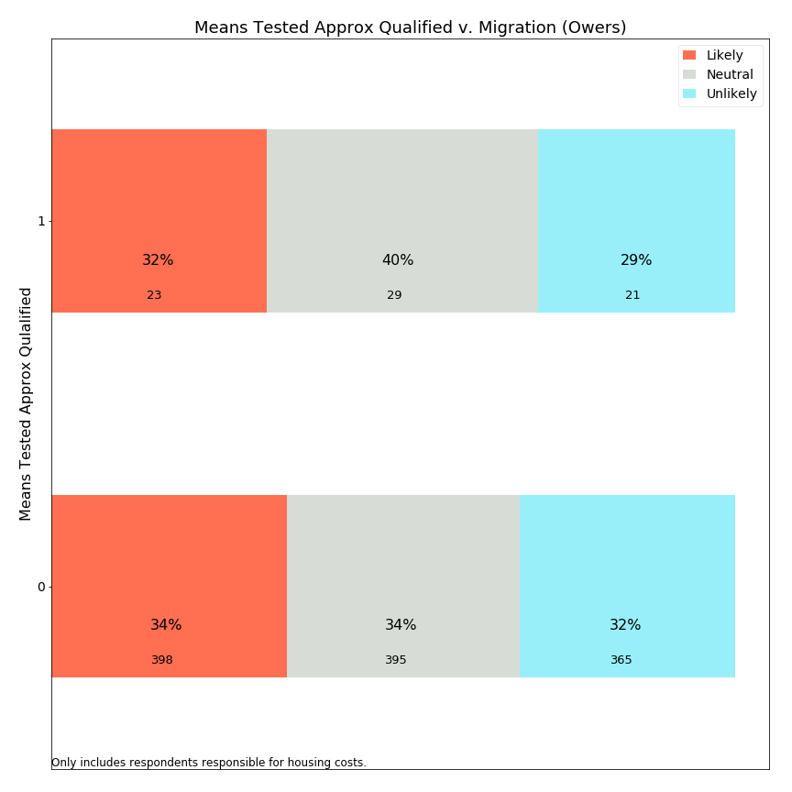

The chart above categorizes survey respondents into those which are quite similar to (approximately qualified) for a typical means-tested exemption (1) and those which are not qualified (0). This chart shows very little difference in migration forecasts between the qualified population and other respondents. Therefore, the data does not provide evidence of migration impact for the targeted group with a means-tested exemption.

We conclude that both SRE and MTRE approaches may assist in reducing housing stress for some portions of our community, but it is unclear that these programs would change how long people stay in their homes.

### 8. Middle aged populations have the highest forecast of migration.

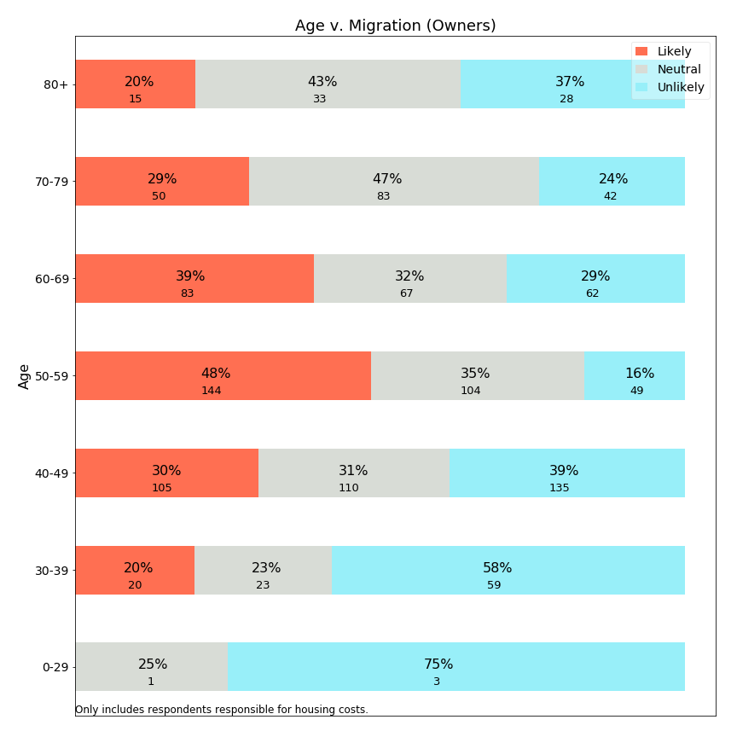

The survey data shows that expectation to leave Lexington is highest among 50-59 year olds, with about half of residents in this age category expecting to leave Lexington within 10 years. A residential exemption with a requirement of age 65+, such as most existing models for MTRE, would not benefit this population. Instead, an age 65+-targeted exemption would help a group that is self-forecasting lower levels of migration. It appears that senior residential exemption programs target populations which in Lexington have lower levels of forecast migration or mobility.

## Open Response Comments

### 9. Lexington residents are quite concerned about the steady increase in local taxes

The survey was constructed to focus initially on town services, and yet residents used the first open response question to raise concerns about property taxes *even before the first explicit mention of taxes* in the survey. Many respondents expressed gratitude at the opportunity to share their feelings about taxes and about housing stress, and appreciate that the Town is listening. The appendix provides an enumeration of the most frequent words used in open response comments and sample quotes.

Key repeated points from open response comments:

* High property taxes are on the minds of many Lexington residents.
* Fixed income residents or those approaching retirement are concerned about how to manage large and increasing property tax burdens.
* Residents do not understand why taxes continue to escalate at a high rate, and some feel Lexington government spends beyond what is necessary.
* Residents would like to stay in Lexington, but some find the cost prohibitive.
* Some residents feel the town services are great, while others feel they are too few for the high property taxes that they pay.
* Medium and long term residents report that their taxes have tripled or more since moving to Lexington.
* Residents in unimproved, small homes do not understand why their property taxes are substantial.
* Property taxes increase much faster than inflation.

## Statistical Study

Our multivariable study suggests that property taxes may impact propensity to move via housing stress, but the effect is minimal and really only exists for those for whom property taxes constitute the preponderance of monthly housing costs.

## Summary

In summary, Lexington residents are concerned about housing costs and property taxes across a wide demographic spectrum. Fixed exemption programs like the SRE which shift taxes from low assessed value homes to those with high assessed values would have low precision as many beneficiaries do not have high housing stress, and such a program would shift higher taxes on to other residents--including numerous residents who experience high housing stress. Those receiving a higher tax burden may include those at a life stage and with financial resources to respond to a tax shift by migrating from Lexington. A residential exemption could exacerbate migration patterns. Thus, the survey data does not provide support for the state residential exemption.

A Means Tested Residential Exemption could be structured to provide higher precision, with many beneficiaries who experience high housing stress. The limitation of such a program is low recall: fewer than 15% of residents reporting high housing stress would benefit from such an exemption. As a targeted program it may seem more attractive than the SRE, but it will have very limited scope and yet carry higher implementation costs (see later chapter).

Residents have voiced concern about the overall level of property taxes in Lexington, and neither exemption provides across-the-board tax relief to all residents. To address these needs, the Town would have to look to actions outside the scope of this Committee.

The stress of owning a home in Lexington may not be evenly shared; a high stress burden occurs across a wide spectrum of Lexington’s homeowners. Any public policy which addresses the needs of some homeowners will necessarily shift this burden onto other homeowners or onto renters, who may also feel burdened. Policy makers need to take resentment and burden shifting onto already-burdened populations into account when making such a shift.

# 

# 3. Property Tax Relief Measures Currently Available to Lexington Residents

## Town Programs

### The Committee examined programs in place in Lexington today to assist homeowners with property taxes.

### Property Tax Exemptions

The Town of Lexington has adopted most local-option tax exemption programs enabled by State legislation and has expanded all program benefits to the maximum extent allowable by statute. Most programs are designed to aid veterans, blind people, surviving spouses of firemen and policemen killed in the line of duty, or income-qualified seniors. An exemption from the Town’s Community Preservation Act Surcharge is the only local property tax program that applies to income-qualified property tax payers of any age.

Tax Exemptions are a cost to the Town, partially reimbursed by the State. The cost of FY2018 property tax exemptions is estimated to be approximately $201,000. The State reimbursement is estimated to be approximately $89,000.

|  |  |  |  |
| --- | --- | --- | --- |
| **FY 2019 Statutory Property Tax Exemption Programs as Adopted by Lexington** | | | |
| **Massachusetts General Laws**  **Chapter 59, Section 5 Exemptions**  **Clause and Name** | **Abbreviated Description**  More qualifications and details  will apply | **FY 2019 Exemption Amount** | **Exemptions Granted**  **In FY 2018**  (latest available data) |
| 17D Surviving Spouses, minors or persons 70 years or over | Total assets other than house of less than $40,000. No income limit | $350. | 2 |
| 18 Hardship. | Hardship due to age, infirmity and poverty. At discretion of Board of Assessors | 100% | 0 |
| 18A Temporary Deferral- limited duration | Financial hardship due to change to active military status | 100% | 0 |
| 22(a-f) Veterans | Purple Heart recipients, or service-related 10% disabled or more, Gold Star Parents, and others | $800. | 65 |
| 22A Veterans & surviving spouses | Service-related loss of one foot, hand, or sight in one eye, or certain military service decoration award winners | $1,500. | 0 |
| 22B Veterans & surviving spouses. | Service-related loss of use of both feet, hands, sight in both eyes | $2,500. | 0 |
| 22C Veterans & surviving spouses | Service-related 100% disability and living in specially adapted housing | $3,000. | 0 |
| 22D Surviving spouse | Un-remarried spouse of serviceman presumed dead, or who died due to service-related injury | 100% | 2 |
| 22E Veterans & surviving spouses | Service-related 100% disability | $2,000. | 8 |
| 22F PARA Paraplegics & surviving spouses of paraplegics | Paraplegic from service-related injury | 100% | 4 |
| 37A Blind | Persons certified blind | $1,000. | 14 |
| 41C Certain elderly persons 65 years of age or over | Low income and low assets | $2,000. | 25 |
| 42 Surviving spouses of police officers/firefighters killed in the line of duty |  | 100% | 1 |
| CPA SURCHARGE EXEMPTION  Under Massachusetts General Laws Chapter 44B | Moderate income seniors and non-seniors. Income limits scaled to household size. | 100%  of CPA surcharge  $317 avg.exemption | 176 |
| **TOTAL** |  |  | **295** |

01-17-2019

### 

### Property Tax Deferrals

Property Tax Deferrals enable seniors to postpone paying any or all of their property tax until the property is conveyed or they or a surviving spouse dies. Lexington’s Property Tax Deferral Program provides the opportunity for the greatest amount of property tax relief of all programs available to seniors. In 2006, Lexington successfully petitioned the State legislature to allow the Town to provide lower interest rates and more generous income qualifications than the State property tax deferral law allowed at that time. In the ensuing years, Lexington has incrementally increased qualifying income limits and has matched deferral interest rates to the Monthly One Year Constant Maturity Treasury Rate as published by the Federal Reserve Board for the first week in March preceding the Town’s new Fiscal Year. This rate generally runs below the Prime Rate and roughly matches the interest that the deferred amounts would have earned if the funds had been held in Lexington’s free cash accounts.[7] Seniors who defer their property tax may also defer water and sewer charges.

With a total of 877 deferrals among all Massachusetts municipalities in FY2018, utilization rates for Property Tax Deferrals are very low state-wide. Lexington is one of the top three municipalities in deferral utilization, but despite recent gains in participation, Lexington, with only 42 deferrals in FY 2018, is no exception to the low utilization rates found across the State. Anecdotal evidence suggests that seniors feel that a deferral would indicate a “desperation” that is out of proportion to their situation, or they want to leave their home unencumbered to their heirs. A small number of seniors who would like to defer have existing equity loans or mortgages and are blocked from deferring by their lenders who are sometimes unwilling to allow their liens to become secondary to Lexington’s tax liens.

Unlike tax exemptions, tax deferrals are not subsidized by other taxpayers beyond any differential between the interest rate charged and the actual cost to the Town.

### Senior Service Program

Administered by Lexington’s Human Services Department, Lexington’s FY 2019 Senior Service Program provides a property tax credit of up to $1,540 per household for seniors with household incomes of up to $70,000 in exchange for work performed at $11 per hour for the Town or the School Department. This program is paid for from a line-item in the Town budget. Twelve seniors benefitted from this program in FY 2018 at a cost to the Town of $13,733.50.

### Utilization of Property Tax Programs in Lexington

Very small numbers of Lexington residents benefit from the Town’s property tax exemption and deferral programs. With the exception of Property Tax Deferrals, which have seen a substantial increase in an otherwise extremely low utilization rate, the major programs have experienced steady declines, likely due to the lower number of veterans now in Lexington and the higher incomes of the more recent elderly population.

### 

**State Program**

### The Massachusetts Senior Circuit Breaker Property Tax Credit

Administered by the State through the income tax return process, this program provides a tax credit or a direct payment from the State of one dollar for every dollar that the owner’s property tax exceeds 10% of his or her income, up to $1,100. Renters also qualify for the State Circuit Breaker when 25% of their rent exceeds 10% of their income.

Income limits, house value limits and the maximum credit change annually by a cost of living adjustment.

This program has no cost to the Town of Lexington. In 2009, 735 Lexington taxpayers received State Circuit Breaker benefits. The number of beneficiaries has declined steadily since then. In Tax Year 2016, 447 Lexington seniors received Circuit Breaker benefits at an average of $1,032 each. The decline in utilization is likely due to the Circuit Breaker’s house value cut-off. Over time, Lexington’s median house value has become increasingly higher than the Circuit Breaker’s house value limit, which is based on State averages.

**State Circuit Breaker Parameters, Tax Year 2018**

|  |  |
| --- | --- |
| Income Limit | Single: $58,000.  Head of Household: $73,000.  Married, filing jointly: $88,000. |
| House Value Limit | $778,000. |
| Maximum Credit Given | $1,100. |

# 

# 4. Residential Properties in Lexington

The tax policies discussed in this report apply to properties classified as residential property per Massachusetts law and assessment guidelines. However, the typical taxpayer or Town Meeting Member is likely not familiar with all of the instances of residential property. This chapter provides an overview of all residential property classes, with details specific to Lexington. The information in this chapter serves as a reference for further chapters that evaluate how changes in tax policy impact residential property holders.

As a matter of policy, a residential tax exemption pertains to a **person’s primary residence.** The Committee understands that per the Massachusetts Department of Revenue, a Lexington home is considered a primary residence when it is the homeowner’s principal and legal home, where family, social, civic and economic life is centered and where the homeowner plans to return whenever he or she is away. In general this definition would be unambiguous for most citizens. However, the Committee is also aware that some citizens may live in a gray area where they could willfully adjust their town or state of residence, legally or illegally. One example, might be so-called “snow birds” which spend part of a year in Florida and part of a year in Massachusetts, and may give consideration to a variety of financial incentives in declaring residency.

Later chapters discuss both the existing State Residential Tax Exemption and possible means-tested tax exemptions. Because these models largely benefit *owner-occupied* residential properties, this chapter also provides information on which types of residential properties are likely to be owner-occupied.

This section’s data reflects Lexington residential property in Fiscal Year 2019, and what we know of significant near term projects. While these concrete examples help examine near-term impact, policy makers should consider the evolving needs of the community as well.

## Classification of Residential Properties

The State’s Residential Exemption (SRE) statute creates exemptions for particular “Class One, residential” properties. These Code 1 residential properties are distinct from industrial, commercial, and personal property and are defined as follows:

“CODE 1 M.G.L. Chapter 59 §2A: All real property used or held for human habitation containing one or more dwelling units including rooming houses with facilities assigned and used for living, sleeping, cooking and eating on a non-transient basis, and including a bed and breakfast home with no more than three rooms for rent. Such property includes accessory land, buildings or improvements incidental to such habitation and used exclusively by the residents of the property or their guests. Such property shall include: (i) land that is situated in a residential zone and has been subdivided into residential lots, and (ii) land used for the purpose of a manufactured housing community, as defined in Chapter 140, §32F. Such property shall not include a hotel or motel.

Incidental accessory land, buildings or improvements would include garages, sheds, inground swimming pools, tennis courts, etc. Non-incidental accessory land, classified and coded differently, would include mixed use properties, such as a variety store, machine shop, etc. on a residential parcel.”

## Residential Property Types

The Lexington assessment database includes the following types of residential property:

|  |  |  |  |  |  |  |
| --- | --- | --- | --- | --- | --- | --- |
| Residential Class** | Parcel Count* | Total Assessed Value | % of Assessed Total | Mean Assessed Value | Median Assessed Value | Likely Owner Occupied? |
| **Single Family** | 9,030 | $9,486,786,000 | 89.7% | $1,050,588 | $939,000 | Yes |
| **Condominium** | 1,057 | $623,512,900 | 5.9% | $589,889 | $530,000 | Yes |
| **Two Family** | 159 | $135,414,000 | 1.3% | $851,660 | $783,000 | Yes |
| **Three Family** | 11 | $9,451,000 | 0.1% | $859,182 | $810,000 | Yes |
| **Multiple Houses** | 31 | $40,179,000 | 0.4% | $1,296,097 | $1,256,000 | Yes |
| **Four Unit Apts** | 1 | $899,000 | 0.0% | $899,000 | $899,000 | Yes |
| **8+ Unit Apts** | 8 | $196,268,000 | 1.9% | $24,533,500 | $14,416,000 | No |
| **Group Living** | 4 | $7,020,000 | 0.1% | $1,755,000 | $1,329,500 | No |
| **Child care facility** | 5 | $7,027,000 | 0.1% | $1,405,400 | $1,076,000 | No |
| **Mixed Use** | 17 | $11,022,920 | 0.1% | $648,407 | $1,082,000 | Yes |
| **Miscellaneous (106)** | 35 | $6,100,000 | 0.1% | $174,286 | $78,000 | Yes |
| **Developable Land** | 53 | $30,142,000 | 0.3% | $568,717 | $519,000 | No |
| **Potentially Developable Land** | 63 | $6,864,000 | 0.1% | $108,952 | $109,000 | No |
| **Undevelopable Land** | 398 | $8,768,000 | 0.1% | $22,030 | $23,000 | No |
| **Land (adjustment)** |  | $1,185,000 | 0.0% |  |  | No |
|  | 10,872 | $10,570,638,820 |  | $972,281 |  |  |

*Parcel count is the number of assessed parcels. A single apartment parcel may provide housing for hundreds of families, and therefore the parcel count only provides a partial view of the number of impacted individuals and families.

**Classifications are described in <https://www.lexingtonma.gov/sites/lexingtonma/files/uploads/lexington_resid_dcm_fy_2018.pdf> and <http://www.mass.gov/dor/docs/dls/bla/classificationcodebook.pdf>.

From this table, a few key points should be highlighted about Lexington’s residential tax base:

* Homes which could be owner-occupied (single family, two family, three family, condominium, and multiple houses on one parcel) account for 97% of residential assessed value in Lexington.
* Condominiums account for about 10% of all residential parcels, but are also distinctive in having lower median and mean assessed values than other owner-occupied properties.
* Eight commercial apartment buildings have a combined $196 million in assessed value. A fixed residential exemption offers no real benefit to these operations, and is impossible with commercial ownership. However, as will be discussed in a later section on indirect effects, the apartments penalized by residential tax exemptions might be convertible to condominiums, which are rewarded by residential tax exemptions.
* Group living facilities and child care facilities are typically operated with commercial ownership and not owner-occupied.
* Until developed, land cannot be owner-occupied. Only 53 lots in Lexington are deemed “developable”, and tax policies could impact motivation to develop these properties.

The following sections are intended to provide additional flavor to the types of properties of each class which exist in Lexington.

### Single Family Homes in Lexington

In FY 2019, the mean single family home assessment in Lexington is $1,050,588, while the median home assessment is $939,000. The mean is higher than the median due to the long tail of high-end residential properties, some even above the $3,000,000 truncation for the following chart:

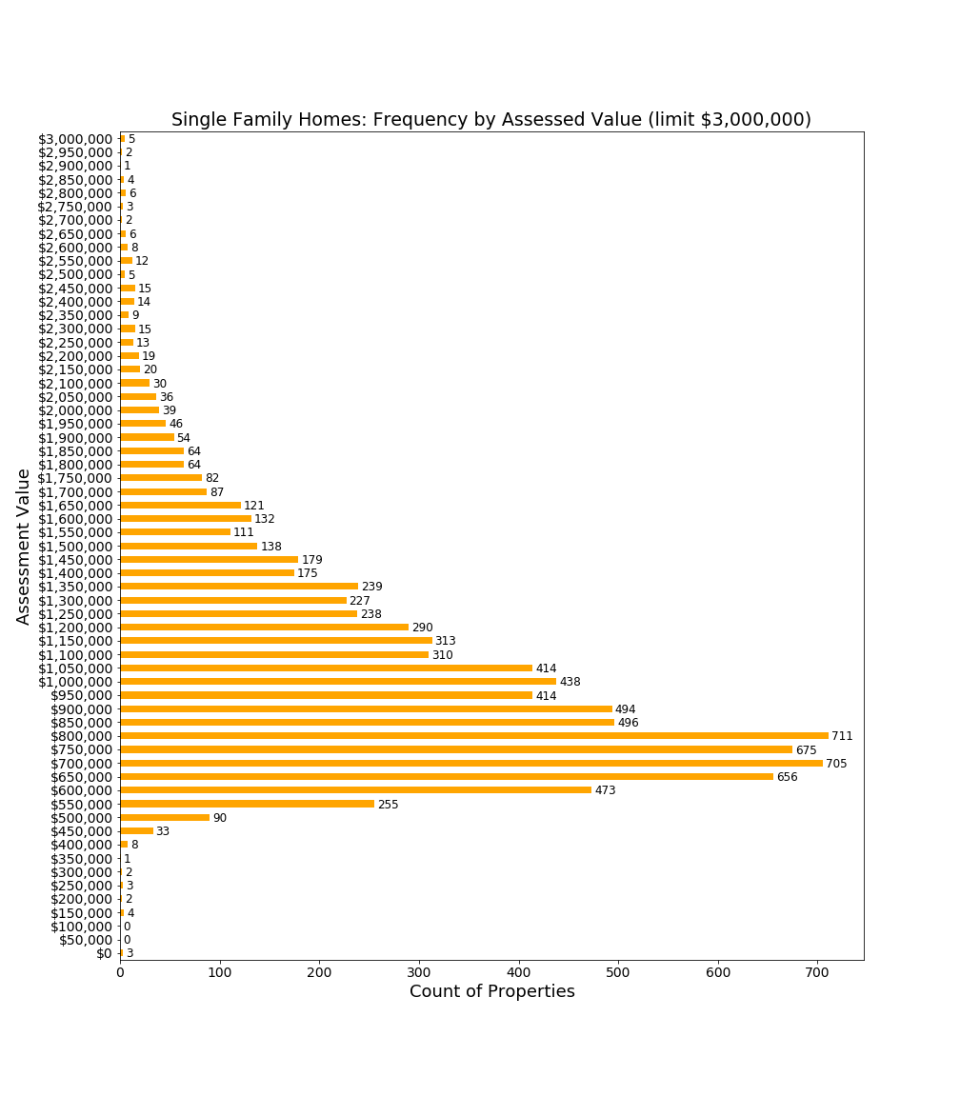

*The chart above shows the count of properties assessed by $50,000 increments. For example, 90 properties are assessed for amounts from $500,000 to $549,999.*

This chart shows that large numbers of properties are assessed in the $600,000-$900,000 range, well below the median property assessment. This means that a large cluster of single family home owners would receive some financial benefit from a residential exemption.

### Two-Family Homes in Lexington

Two-family homes are typically assessed at lower values than single family homes, and no Lexington two-family homes are currently assessed above $2,000,000.

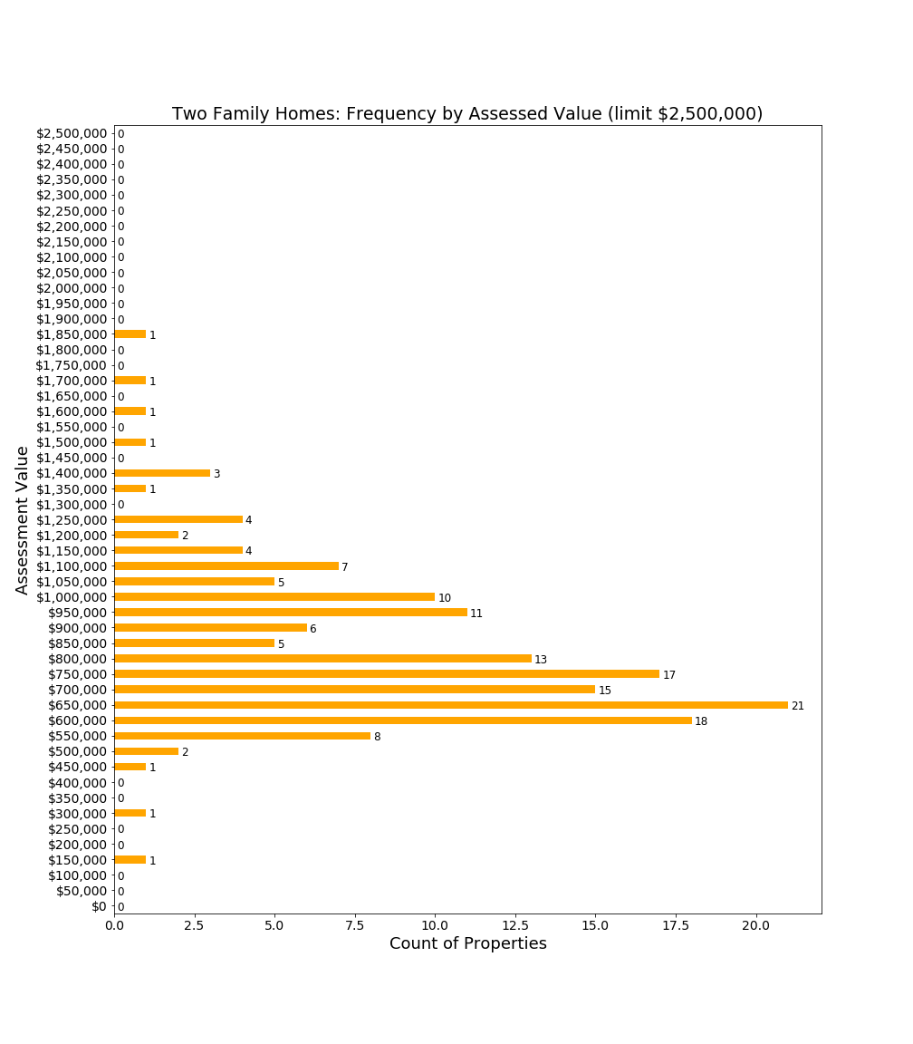

A two-family home can have only one owner occupant, and therefore the physical structure can earn only a single owner-occupied exemption. However, with sufficient tax incentives, the owner of a two-family home might convert the structure to two condominiums. The effect of the conversion would impact taxes (both condominiums could potentially receive owner-occupied exemptions thereby lowering tax incidence) and demographic (condominium owners could be expected to be a wealthier and more stable population than renters).

### Condominiums in Lexington

With a median assessed value of $530,000, condominiums in Lexington have lower values than two-family homes. Due to their lower assessed values, nearly all Lexington condominium owners would benefit from the SRE’s fixed exemption per property which shifts taxes to higher valued properties.

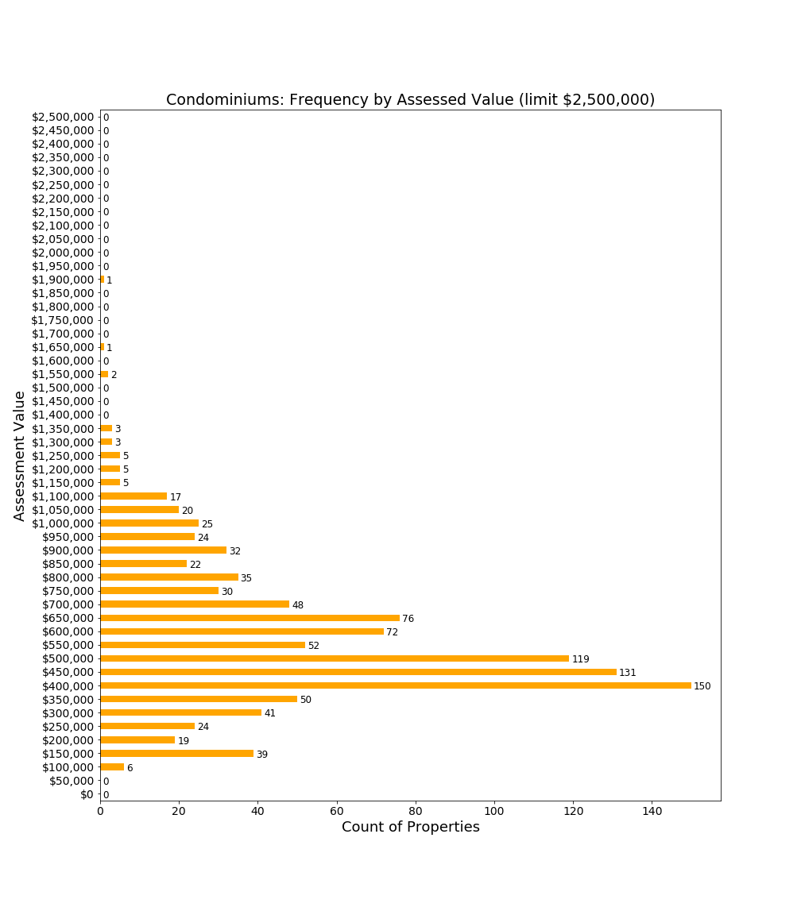

## 

### Large Apartment Complexes in Lexington

Eight large apartment complexes contribute about $200,000,000 to Lexington’s property tax base, or approximately $2,800,000 in property taxes. These properties are comprised of 984 units with an average property tax contribution of approximately $2,845 per unit.

|  |  |  |  |
| --- | --- | --- | --- |
| **Complex** | **Address** | **Assessed Value** | **Units** |
| Avalon Lexington Hills | 1000 Main Campus Drive | $82,852,000 | 387 |
| Avalon Lexington Ridge | 987 Waltham Street | $37,960,000 | 198 |
| Battle Green | 32 Worthen Road | $8,135,000 | 48 |
| Captain Parker Arms (Avalon) | 125 Worthen Road | $19,199,000 | 94 |
| Countryside Manor | 425 Woburn Road | $9,633,000 | 51 |
| Franklin School | Stedman Road | $5,491,000 | 38 |
| Katahdin Woods | 307 Wood Street | $25,382,000 | 128 |
| 1 April Lane | 1 April Lane | $7,616,000 | 40 |
|  |  | **$196,268,000** | **984** |

While the impact of residential exemptions on apartments will be covered in later sections, three noteworthy points are appropriate when one considers this class of property in general.

First, apartment buildings are commercial enterprises. Yet, Massachusetts tax law taxes commercial apartment buildings at the residential tax rate rather than the commercial tax rate. Lexington is among a number of communities which have a “split” tax rate, where commercial parcels pay a higher tax rate than residential parcels: for FY2019 the Lexington commercial tax rate is $27.69 compared with $14.30 for the residential tax rate. Therefore, while one could regret an increase in apartment building property taxes due to an SRE, another perspective is that these businesses are operating in Lexington at a deep tax discount relative to other commercial enterprises.

Second, and unlike other commercial businesses, apartments have a clear and negative impact on Lexington’s financial structure. The 2014 Enrollment Working Group Report indicated that in 2015, 43.6% of apartment units had school children with an average 1.46 students per apartment with children. Therefore, the apartments collectively house about 626 public school students. In FY2016, Lexington spent $18,003 per pupil[8]. So, at FY2016 spending levels, the impact of 626 public school students would be $11,269,878. Because the total contribution of apartments to Lexington for all taxes ($2,800,000) is less than 25% of the *educational operating* (i.e. excluding capital) costs, these apartment buildings demand substantially more from the Lexington fiscal base than is covered by their tax contributions.

Finally, while apartment buildings may support a broader demographic than single family homes, they also serve another purpose for Lexington, which is to contribute materially to the town’s goal of 10% affordable housing. Of Lexington’s 1328 Subsidized Housing Inventory (SHI) Units,[9] 802 are provided by five apartment buildings. If Lexington’s SHI were to fall below 10% affordable housing, then Chapter 40B rules would allow developers to bypass certain local zoning regulations. Therefore, these apartments serve a useful function for a town seeking to regulate residential development.

### Undeveloped Land

Land in residential districts is categorized and assessed depending on the ease with which it can be transformed into occupied residential property.

Developable land has a higher assessment (median $519,000 in FY2019) than undevelopable land. A tax policy which penalizes developable land for remaining idle (e.g. missing out on an owner-occupied residential exemption) could spur development of these assets into owner-occupied housing.

The terms “potentially developable land” and “undevelopable land” refer to properties which might not be easily developed. These properties also cannot be owner-occupied, so owners of these properties cannot benefit from exemptions for owner-occupied properties.

It seems reasonable to expect that many of the privately owned, undevelopable lands are small tracts abutting a parcel owner’s primary residence.[10]

### For-Profit Child Care Facilities

Although commercial enterprises, for-profit child care facilities are classified and taxed as residential properties. Lexington currently has five such properties:

|  |  |  |
| --- | --- | --- |
| **Facility Name** | **Location** | **FY19 Assessment** |
| Bright Horizons | 903 Waltham Street | $1,718,000 |
| First Circle Learning Center | 80 Maple Street | $879,000 |
| Goddard School | 332 Concord Avenue | $1,076,000 (under construction at time of assessment) |
| LEAP School | 210 Marrett Road | $2,445,000 |
| Lexington Knowledge Beginnings | 429 Marrett Road | $909,000 |
|  |  | **$7,027,000** |

For-profit child care facilities are not owner-occupied, and therefore would not benefit from a residential exemption. Again, as these are commercial enterprises in practice, one could reasonably debate whether the desired policy for taxes should be the current residential tax rate or the much higher commercial tax rate.

### Group Living Facilities

Group living facilities are classified as residential rather than commercial. Lexington currently has four group living facilities:

|  |  |  |
| --- | --- | --- |
| **Facility Name** | **Location** | **FY19 Assessment** |
| Artis Senior Living | 430 Concord Road | $3,181,000 |
| Supportive Living | 7 Oakland Street | $1,378,000 |
|  | 50 Percy Road | $1,281,000 |
|  | 52 Percy Road | $1,180,000 |
|  |  | **$7,020,000** |

Lexington’s fall 2018 Town Meeting approved development of two additional facilities: an assisted living facility (Waterstone) and a memory care facility (Bridges). These are for-profit enterprises which, once built, are expected to be classified as a residential group facility. The Fall 2018 presentation to Town Meeting projected that these properties would contribute $600,000 in property taxes per year to Lexington, suggesting a residential assessment of about $42,000,000. The combined Waterstone and Bridges projects illustrate how quickly new residential solutions might be adopted in Lexington, and hence the importance for policy makers to consider the impact of exemption policies on future housing initiatives.

Again, as commercial businesses, for-profit group living facilities receive favorable tax treatment in Lexington when compared with commercially zoned businesses. However, because Lexington’s residential and commercial tax rates may already differ significantly from peer communities, economic competitiveness also deserves consideration, not just fairness relative to other commercial businesses.

### Brookhaven

Brookhaven is a lifecare community for seniors that provides services ranging from assisted living through nursing home care. It is considered to be a not-for-profit community. Currently, Symmes Lifecare Inc. (d/b/a Brookhaven) makes a negotiated Payment In Lieu Of Taxes (PILOT) to Lexington rather than being taxed directly as a residential property. It is unresolved whether Lexington could tax Brookhaven directly rather than accepting this payment in lieu of taxes.

In 2017, Brookhaven entered into a memorandum of understanding with Lexington that will increase its PILOT payments. This was part of a larger agreement with Brookhaven concerning a planned Brookhaven expansion. This revised PILOT will increase Brookhaven’s payment in lieu of taxes to $573,001 in FY2022.

Because Brookhaven pays a PILOT, no change in residential exemption policy will directly impact tax payments from Brookhaven. However, a residential exemption could increase the gap between PILOT payments and what Brookhaven would pay if taxed directly. Adoption of the State’s Residential Exemption could motivate renegotiation of the Brookhaven agreement, or contribute to a revised PILOT level when future negotiation occurs.[11]

### Affordable and Subsidized Housing

Lexington has more than 800 subsidized and affordable apartment units and houses that are owned, managed, funded or overseen by a complex variety of government entities and private building owners. Units owned by the government are not subject to property tax, and would not be affected by the adoption of the SRE.

Much of Lexington’s affordable housing consists of designated apartments located within privately owned apartment buildings. While the apartment buildings themselves would see an increase in property tax if the Town were to adopt the SRE, rental rates for the affordable units are dictated by the State and would remain unaffected.

Lexington also has almost 90 units of deed-restricted affordable ownership apartments. These units are privately owned by income-qualified owners and in perpetuity may be sold only to other income-qualified owners at a controlled price. These units are required to be the primary residence of the owner and may not be rented out. With low assessments, these residences would receive a decrease in their property tax if the Town were to adopt the SRE.

## Conclusion

This chapter describes the many types of properties which contribute to Lexington’s residential property tax base. While some properties--such as single-family homes, two-family homes and condominiums--may be owner-occupied, others such as large apartment buildings and group housing facilities are generally not owner-occupied.

It is noteworthy that some properties are taxed at residential rates despite being commercial in nature. One could argue that these properties are under-taxed relative to their purely commercial peers, and in fact some might not provide sufficient taxes to cover their economic impact on the town. But Lexington does not exist in a vacuum, so these arguments should be tempered by Lexington’s competitive position in the residential housing market.

As Lexington considers changing how taxes are derived from the residential tax base, policy makers should recognize that new projects as well as zoning changes could impact how residential properties are utilized. Policy makers should think not only about short term impacts, but also what types of long term impacts are sought as well as whether Lexington will have flexibility in responding to changes in housing needs in our society, and whether tax changes would impact competitiveness for all classes of residential owners with surrounding communities.

# 5. The Massachusetts Residential Exemption

The Residential Exemption Policy Study Committee’s original charge was to study the Massachusetts Residential Exemption, a local option available to all municipalities. After weighing the pros and cons of this exemption, the Committee requested an expansion of scope to include means-tested residential exemptions as found in other communities, most of which were enacted by special legislation gained by home rule petitions. This chapter will cover Massachusetts’s statutory residential exemption, while the next chapter examines means-tested residential exemptions. To avoid confusion, throughout this document, the term SRE is used to refer to Massachusetts’ “State Residential Exemption”, while the term MTRE will refer to a variety of Means-Tested Residential Exemptions which may exist or could be created.

The State’s Residential Exemption (SRE) is a local tax option available to the Selectmen:

*With respect to each parcel of real property classified as Class One, residential, in each city or town...at the option of the board of selectmen... there shall be an exemption equal to not more than 35 percent of the average assessed value of all Class One, residential, parcels within such city or town; provided, however, that such an exemption shall be applied only to the principal residence of a taxpayer as used by the taxpayer for income tax purposes.[12]*

Only 16 of 351 municipalities in Massachusetts presently utilize the SRE, and these communities are typically cities or vacation communities, with none closely resembling Lexington in housing stock or demographics.

## State Residential Exemption Process

### Setting an Exemption Percentage and, thereby, an Exemption Amount

Each year, as part of the State regulated tax-rate setting process, the Selectmen are required to set a percentage for a Residential Exemption. Lexington Selectmen have historically chosen a 0% factor, in effect, declining to adopt the SRE. Supporting documentation for options can be found in the tax classification packet[13], which includes projections for adoption at percentages such as 10%, 20%, and 35% (typical percentages used by other municipalities). 35% is the maximum allowable percentage.

If the Lexington Selectmen select a percentage above 0%, the following processes would be set in motion:

* Lexington residents would be notified of a new residential exemption.
* The Board of Assessors and the Lexington Assessor would establish a certification process and then certify the properties determined to be eligible for a residential exemption.
* The residential tax rate would be increased to offset the projected revenue shortfall due to the exemption.

### Eligibility and Verification

Per the state law, parcels that are “*the principal residence of a taxpayer as used by the taxpayer for income tax purposes”* would receive a residential exemption. In other municipalities, identification of these parcels occurs via voluntary affidavit by the taxpayer, with required evidence such as federal tax return, state tax return, drivers license, vehicle registration, utility bills or bank statements. Practices differ on the handling of real estate transfers and whether annual recertification is required.

Once affidavits are submitted for an estimated 10,800+ parcels, Lexington would apply its own process for residency verification. Significant verification may be required given financial incentives to cheat. Verification of the more than 1,400 properties in Lexington owned by trusts, requires review of each trust’s structure, trustee status and beneficial interest assignments would be required,[14] and will entail both time and expertise.

### Exemption Amount and Tax Rate Calculation

The Lexington Assessor provides the Selectmen with the assessed value of the average *residential parcel*. As shown earlier, this average parcel value includes more than single family homes, incorporating parcels such as empty lots, non-developable land and apartment buildings. Therefore, the average parcel value is simply the assessed value of all residential parcels in Lexington divided by the number of parcels.[15] According to the FY2019 tax classification packet, the average residential parcel assessment in Lexington is **$973,804**.

The exemption percentage set by the Selectmen is multiplied by the average residential parcel to determine the exemption amount. The result would be a *single fixed exemption amount which would be applied to every residential parcel in Lexington for which eligibility is confirmed*. The exemption amount is subtracted from the parcel’s assessed value before application of the tax rate. This table identifies exemption amounts which would occur for various exemption percentages if hypothetically adopted in FY2019:

|  |  |
| --- | --- |
| **Exemption Percentage Example** | **Resulting** **Exemption Amount Per**  **Occupied Parcel** |
| 2.5% | $24,345 |
| 5.0% | $48,690 |
| 7.5% | $73,035 |
| 10.0% | $97,380 |
| 12.5% | $121,726 |
| 15.0% | $146,071 |
| 17.5% | $170,416 |
| 20.0% | $194,761 |
| 22.5% | $219,106 |
| 25.0% | $243,451 |
| 27.5% | $267,796 |
| 30.0% | $292,141 |
| 32.5% | $316,486 |
| 35.0% | $340,831 |

The Committee is aware that for many taxpayers, understanding of the SRE stops at this point. Residents are often enthusiastic supporters of the SRE based on a misconceived belief that this exemption would lower taxes for all Lexington residents.

However, perhaps the most important point is that the **total Lexington tax levy remains unchanged**. Revenue neutrality is accomplished by *increasing the tax rate on all residential class properties* to offset the loss in revenue from the properties that received the residential exemptions.

Based on 2019 figures and the Assessor’s estimate of 9,265 exempt parcels[16], the following table illustrates how the lower aggregate residential assessed value combined with fixed residential tax revenue results in an *increased residential tax rate*:

|  |  |  |  |  |
| --- | --- | --- | --- | --- |
| **Exemption Amount** | **Total Remaining Taxable Value of Lexington Residential Properties after Exemptions are Deducted from Owner-OccupiedProperty Assessments** | **Unchanging Tax Levy Amount to be Raised Through Residential Property Taxation** | **New Residential Tax Rate to Compensate for Exemptions** | **% Increase in Tax Rate** |
| 0% | $10,570,638,820 | $149,308,233 | 14.12 | 0% |
| 5% | $10,119,524,117 | $149,308,233 | 14.75 | 4.5% |
| 10% | $9,668,409,414 | $149,308,233 | 15.44 | 9.3% |
| 15% | $9,217,294,711 | $149,308,233 | 16.20 | 14.7% |
| 20% | $8,766,180,008 | $149,308,233 | 17.03 | 20.6% |
| 25% | $8,315,065,305 | $149,308,233 | 17.96 | 27.2% |
| 30% | $7,863,950,602 | $149,308,233 | 18.99 | 34.5% |
| 35% | $7,412,835,899 | $149,308,233 | 20.14 | 42.6% |

As this table shows, higher residential exemption percentages result in a reduction of residential assessed value that is subject to taxation, and a corresponding increase in tax rates on residential properties in order to make the exemption revenue-neutral to the municipality.

While the tables above illustrate the range of options available to the Selectmen, a more tangible perspective for residents may be to show the impact on homes. Such an impact illustration requires the selection of a particular SRE percentage, and this report does so using 20% merely to illustrate key relationships between property values and taxes.

The following table illustrates a 20% SRE assuming FY2019 tax rates, as above. The FY2019 preliminary tax rate is $14.12. At a 20% SRE, the tax rate is estimated to increase to $17.03. The following table shows the tax paid by the parcel owner at status quo (no SRE) (column B), and with the SRE when owner-occupied (column C), with the SRE when not owner-occupied (column D). Columns E and F show the changes in taxation.

|  |  |  |  |  |  |  |
| --- | --- | --- | --- | --- | --- | --- |
| **FY2019 Tax Illustration:**  **20% SRE** |  | **Tax With Real Estate Exemption** | |  | **Change in Tax Due to Exemption** | |
| **(A)** | **(B)** | **(C)**  **Owner Occupied** | **(D)**  **Non Owner Occupied** |  | **(E)**  **Owner Occupied** | **(F) Non Owner Occupied** |
| **Assessed Residential Property Value** | **FY2019 Property Tax** | **Tax With Exemption** | **Tax With Exemption** |  | **Change in Tax** | **Change in Tax** |
| $400,000 | $5,648 | $3,496 | $6,813 |  | -$2,152 | $1,165 |
| $500,000 | $7,060 | $5,199 | $8,516 |  | -$1,861 | $1,456 |
| $600,000 | $8,472 | $6,902 | $10,219 |  | -$1,570 | $1,747 |
| $700,000 | $9,884 | $8,605 | $11,923 |  | -$1,279 | $2,039 |
| $800,000 | $11,296 | $10,309 | $13,626 |  | -$987 | $2,330 |
| $900,000 | $12,708 | $12,012 | $15,329 |  | -$696 | $2,621 |
| $1,000,000 | $14,120 | $13,715 | $17,032 |  | -$405 | $2,912 |
| $1,100,000 | $15,532 | $15,418 | $18,736 |  | -$114 | $3,204 |
| $1,200,000 | $16,944 | $17,122 | $20,439 |  | $178 | $3,495 |
| $1,300,000 | $18,356 | $18,825 | $22,142 |  | $469 | $3,786 |
| $1,400,000 | $19,768 | $20,528 | $23,845 |  | $760 | $4,077 |
| $1,500,000 | $21,180 | $22,231 | $25,548 |  | $1,051 | $4,368 |
| $1,600,000 | $22,592 | $23,934 | $27,252 |  | $1,342 | $4,660 |
| $1,700,000 | $24,004 | $25,638 | $28,955 |  | $1,634 | $4,951 |
| $1,800,000 | $25,416 | $27,341 | $30,658 |  | $1,925 | $5,242 |
| $1,900,000 | $26,828 | $29,044 | $32,361 |  | $2,216 | $5,533 |
| $2,000,000 | $28,240 | $30,747 | $34,065 |  | $2,507 | $5,825 |

Key observations:

* SRE increases property taxes on all non-owner-occupied properties (it has no relation to the type of non-owner-occupied property). Non-owner-occupied properties always experience an increase and the most dramatic negative impact of the SRE.
* For owner-occupied properties assessed below $1,150,000, a material decrease in taxes occurs; the smaller the assessed value, the larger the decrease .
* For owner-occupied properties assessed near the breakeven point, in the $1,100,000-$1,200,000 range, an immaterial change to taxes occurs
* For property owners with values well above the breakeven point, the taxes increase a material amount, increasing proportionately to property value.

Finally, it is important to observe that the majority of residential parcels will have a reduced tax burden, offset by increases on a minority of parcels.

Using this 20% illustration, the following table shows the impact on the median property of sub-classes of residential property likely to be owner-occupied:

|  |  |  |  |  |
| --- | --- | --- | --- | --- |
| Residential Class | Median Assessed Value | Status quo: Median Tax at 14.12 | Owner occupied: Median tax at 17.02 | Not owner-occupied: Median tax at 17.02 |
| Single Family | $939,000 | $13,259 | $12,667 | $15,982 |
| Condominium | $530,000 | $7,484 | $5,706 | $9,021 |
| Two Family | $783,000 | $11,056 | $10,012 | $13,327 |
| Three Family | $810,000 | $11,437 | $10,471 | $13,786 |
| Multiple Houses | $1,256,000 | $17,735 | $18,062 | $21,377 |
| Four Unit Apts | $899,000 | $12,694 | $11,986 | $15,301 |

This table illustrates that for most of these classes of properties, the owner of the median assessed property would receive a tax reduction, provided the home is verified as owner-occupied. However, one subclass “multiple houses”[17], have high enough median value that the median property would experience a tax increase even if owner-occupied. Conversely, the median condominium would experience the largest decrease in property taxes.

The chart below further illustrates how tax level relates to property value. The chart is intended to illustrate two points:

* The term “breakeven” in the residential exemption discussions refers simply to the point at which an owner-occupied parcel experiences no difference in taxes due between the SRE and the status quo. (Red and blue lines intersect at the “breakeven” point.) Mathematically, it is the total of residential value in Lexington divided by the number of owner-occupied properties claiming a residential exemption.
* A non-owner-occupied parcel owner always pays more taxes with an SRE, and is therefore worse off in all cases under an SRE. These disadvantaged properties are not only apartment buildings, but also single family homes owned by investors or absent owners.

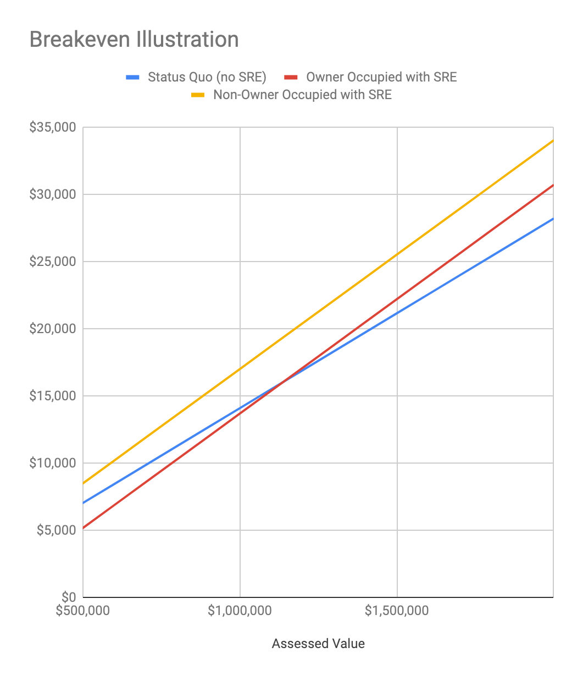

This chart is provided because the term “breakeven” often occurs in residential exemption discussions. While broader policy consideration should not focus on the breakeven point, it comes up in dialogue with taxpayers concerned about personal impact. As indicated earlier, residential, owner-occupied parcels near the breakeven point will experience nominal changes in taxes from the status quo, which could vary between years but should in no case be materially large, provided eligibility is verified each year. For all taxpayers, failure to establish owner-occupancy with the Town could result in a substantial increase in taxes.[18]

The revenue-neutrality of the tax burden shift is often confusing to residents. Clarification about some common misunderstandings regarding the SRE may assist resident understanding:

### Misunderstanding #1. A residential exemption reduces Lexington taxes

No. The total amount of revenue that is lost due to the exemptions is estimated and then the tax rate is increased to exactly offset that loss, ensuring that the revenue raised by property taxation remains unchanged. The sum of all tax relief experienced by residential parcel holders will be offset by an equal new tax burden experienced by other residential parcel holders.

### Misunderstanding #2. A residential exemption simply shifts tax burden onto apartments

It is not that simple. Two types of residential parcel holders would see an increase.

* Those owning residential properties above the breakeven point.
* Any parcel which is not certified as owner-occupied, whether it is the smallest piece of undeveloped land or the largest apartment building. The variety of parcels which would experience a tax increase is detailed in an earlier chapter .

### Misunderstanding #3. A residential exemption is progressive by shifting the tax burden from low price homes onto high price homes

A definition of a progressive tax from Investopedia reads:

A progressive tax is a tax that imposes a lower [tax rate](https://www.investopedia.com/terms/t/taxrate.asp) on low-income earners compared to those with a higher income, making it based on the [taxpayer's](https://www.investopedia.com/terms/t/taxpayer.asp) ability to pay.[19]

The SRE would reward those who occupy their own homes. Owner-occupants are typically wealthier members of the community than those who rent. Landlords would see a significant increase in taxes and attempt to pass those through to tenants. Moreover, Lexington condominiums, which are generally the least expensive residential properties in Lexington, may be owned by those with significant income or other assets, who would nonetheless see a substantial lowering of tax burden. Therefore, while the SRE may appear to be progressive when considering only owner-occupied single family homes, when considering all types of residential properties and their occupants, it is not progressive.

## Direct Consequences of SRE on Homes and Property Classes

### Owner-occupied Single Family Homes and Condominiums

The chart below is introduced as a format for evaluation of Lexington taxes as well as for comparison against benchmark communities. Based on FY2018 tax values, which are the latest valuations available for all communities, this study provides a guide to understanding the impact of a SRE in Lexington and in comparison with other communities. It is introduced here to prepare the reader for comparison charts later in this section.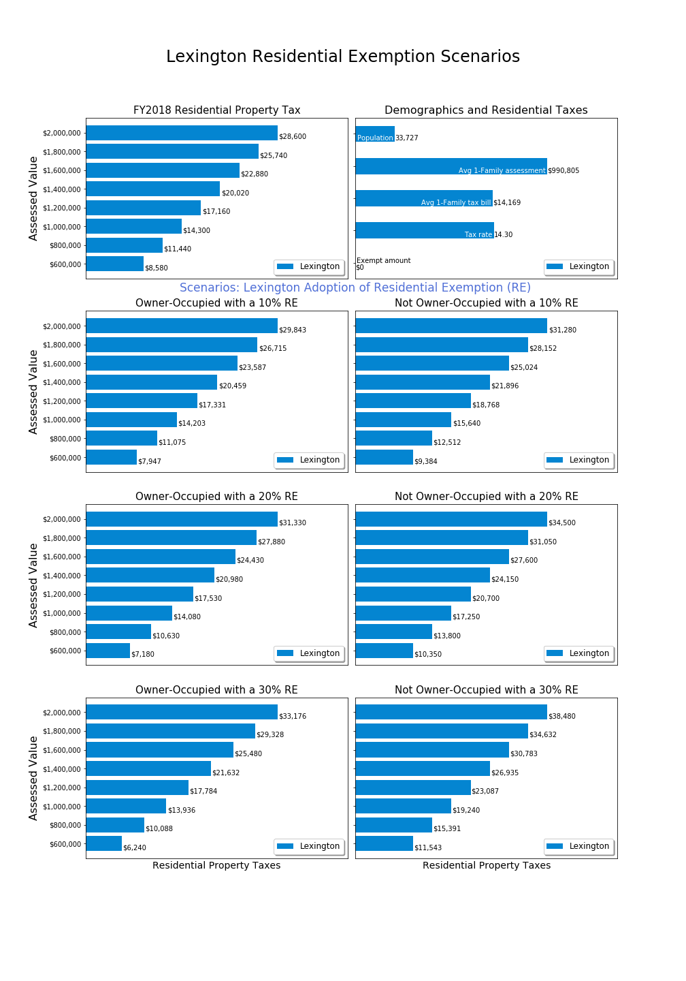

This chart series is intended to provide the status quo for FY2018 (top line) and the impact of possible residential exemption amounts on owner-occupied and non-owner-occupied properties (chart rows 2-4).

The top left chart shows the FY2018 residential tax rate applied to properties ranging from $600,000 to $2,000,000. Each bar shows the tax amount in relative proportion with a label for the tax at each assessed value.

The top right chart shows demographic data and tax rate data useful for comparing communities. Due to lack of space, the vertical legend occurs as text within the top right chart. The community population is from recent census estimates. The average single family assessment is from state data and the average single family tax bill. These figures are included because different communities may have more or less expensive single family homes, so the comparison of tax rate does not provide a complete picture for understanding relative assessments. The tax rate line shows the FY2018 residential tax rate, and for those communities with a FY2018 residential exemption, the last bar “exempt amount” will show that amount. For Lexington, there is a 14.30 tax rate and $0 exemption amount for FY2018.

Rows two through four show the impact of various SRE scenarios, ranging from 10% to 30%. The illustrated percentages are intended to represent options and are not Committee suggestions. For these rows, the left column shows resulting tax for owner-occupied properties, and the right column shows resulting tax for non-owner-occupied properties.

Example: If someone owns a $1,000,000 home, we can determine from the upper left chart that their FY2018 tax would be $14,300 without a SRE. If a SRE were created at the 20% level, their property tax would be $14,080 if owner-occupied (lower left) and $17,250 if not owner-occupied (lower right).

### Tax Burdens Relative to Peer Communities

Adoption of a residential exemption impacts Lexington’s economic competitiveness relative to peer communities. Benchmark charts are included for 17 communities selected either for geographic proximity, similar socioeconomic status, or likely out migration within Massachusetts. Three charts are included in this chapter as examples for discussion, and the remaining charts are included in an appendix.

**Peer Community: Newton**

Newton is often cited as a socioeconomic peer with similar distance to Boston:

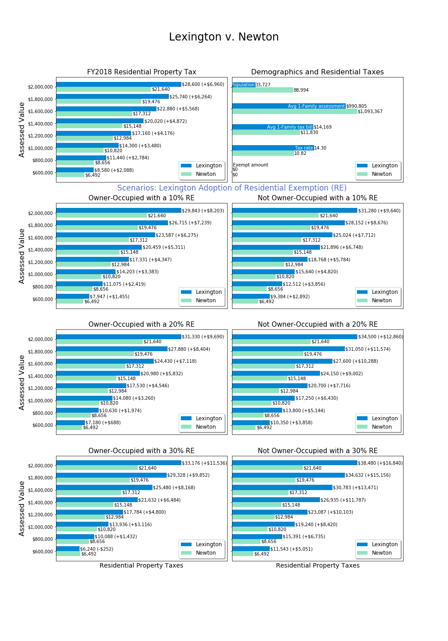

The principal difference between this chart series and the Lexington-only chart series is that two values are shown for each bar, one for Lexington (blue) and one for the comparison community (green). The difference in tax impact is shown in parentheses to assist the reader in comparing impact. Again, these charts are all for FY2018 because tax information is readily available in all communities for the completed fiscal year.

The upper right chart shows that Newton has an average single home assessment that is $100,000 greater than Lexington but a lower tax rate (10.82 v. 14.30), and therefore a lower average single family home tax ($11,830 v. $14,169). The result of this tax rate differential can be seen in the upper left chart which shows that a $1,000,000 property in Newton is taxed at $10,820, which is $3,480 less than a $1,000,000 property in Lexington.

Readers with an investment mindset might appreciate the $3,480 tax difference, which is a drag on the value of a $1,000,000 investment in a community. Other readers might focus on the fact that a $1,000,000 Lexington home might be nicer than a $1,000,000 Newton home, and therefore the comparison is not apples-to-apples. Because communities and housing stock are not identical, we encourage considering the differences in average single family home values and average single family tax bills when evaluating tax differentials across communities.

Next, one would consider how a residential exemption in Lexington would impact competitiveness against Newton, which currently does not have a residential exemption. Examining the hypothetical 20% SRE row, one can see that a $1,000,000 home would hardly be impacted in Lexington if owner-occupied, but if not owner-occupied the tax gap between Lexington and Newton would grow to $6,430. Thus, a residential exemption would have an obvious impact on retarding investment ownership and rental of Lexington homes relative to Newton homes.

Looking at the $600,000 level (condominium end of market), a 20% residential exemption would substantially reduce the tax disadvantage relative to Newton ($688 v. $2,088 at status quo), provided the home is owner-occupied. In examining newer homes at the $2,000,000 level, a 20% residential exemption would increase the tax disadvantage relative to Newton from $6,960 today to $9,690 if owner-occupied and to $12,860 if not owner-occupied.

**Adjacent Community: Burlington**

Burlington is an example of a geographically proximate community where some Lexington residents have moved for the purpose of downsizing and/or reducing their property tax burden. Retention of residents requires Lexington policy makers to ensure that taxes and services are competitive with communities such as Burlington, Waltham, Arlington, Woburn and Bedford.

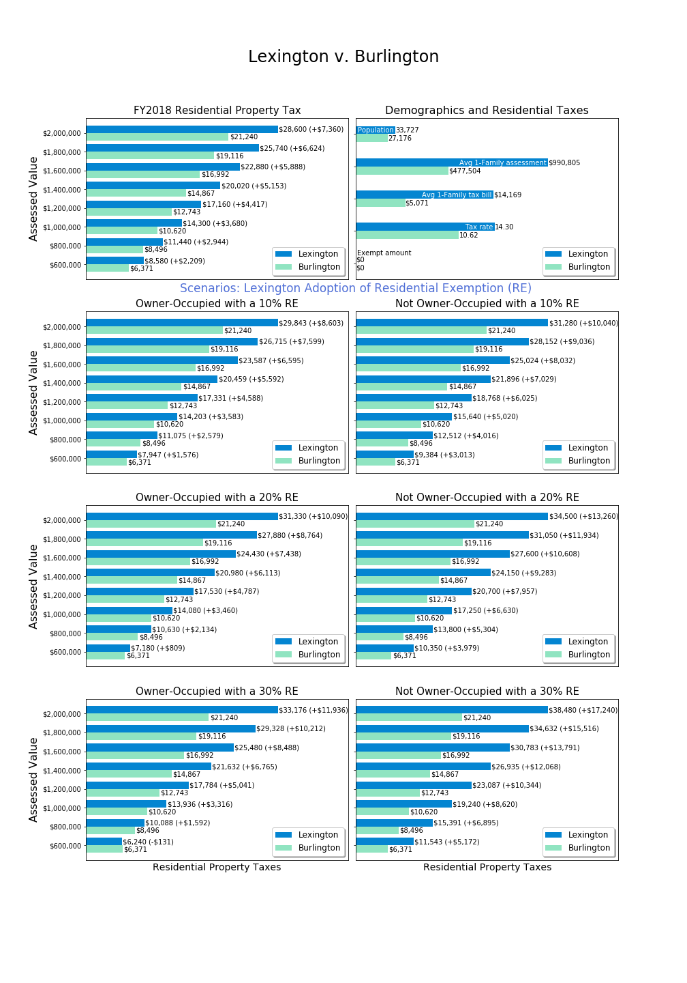

The upper right chart shows that Burlington not only has a lower tax rate than Lexington ($10.62 v. $14.30), but a substantially lower average single family value (at $477,504, less than half the Lexington average). The result of these two factors is that the average single family tax bill in Burlington is $5,071 compared with $14,169 in Lexington.

Starting with such disparate property values and tax bills, it becomes more difficult to evaluate the impact of a residential exemption. A wide gap exists today. A residential tax exemption could lower the tax gap for a $600,000 property, although one would continue to expect to pay less tax in Burlington because of lower property values. Conversely, the owner of a $2,000,000 home would be further penalized by an SRE relative to Burlington, and could find greater reward in shifting ownership to Burlington with lower home valuations and taxes.

**Migration Target: Boston**

Anecdotally, some Lexington residents choose to downsize to condominiums or townhouses in Boston. What is the impact of a residential exemption for Lexington upon competitiveness with the Boston market?

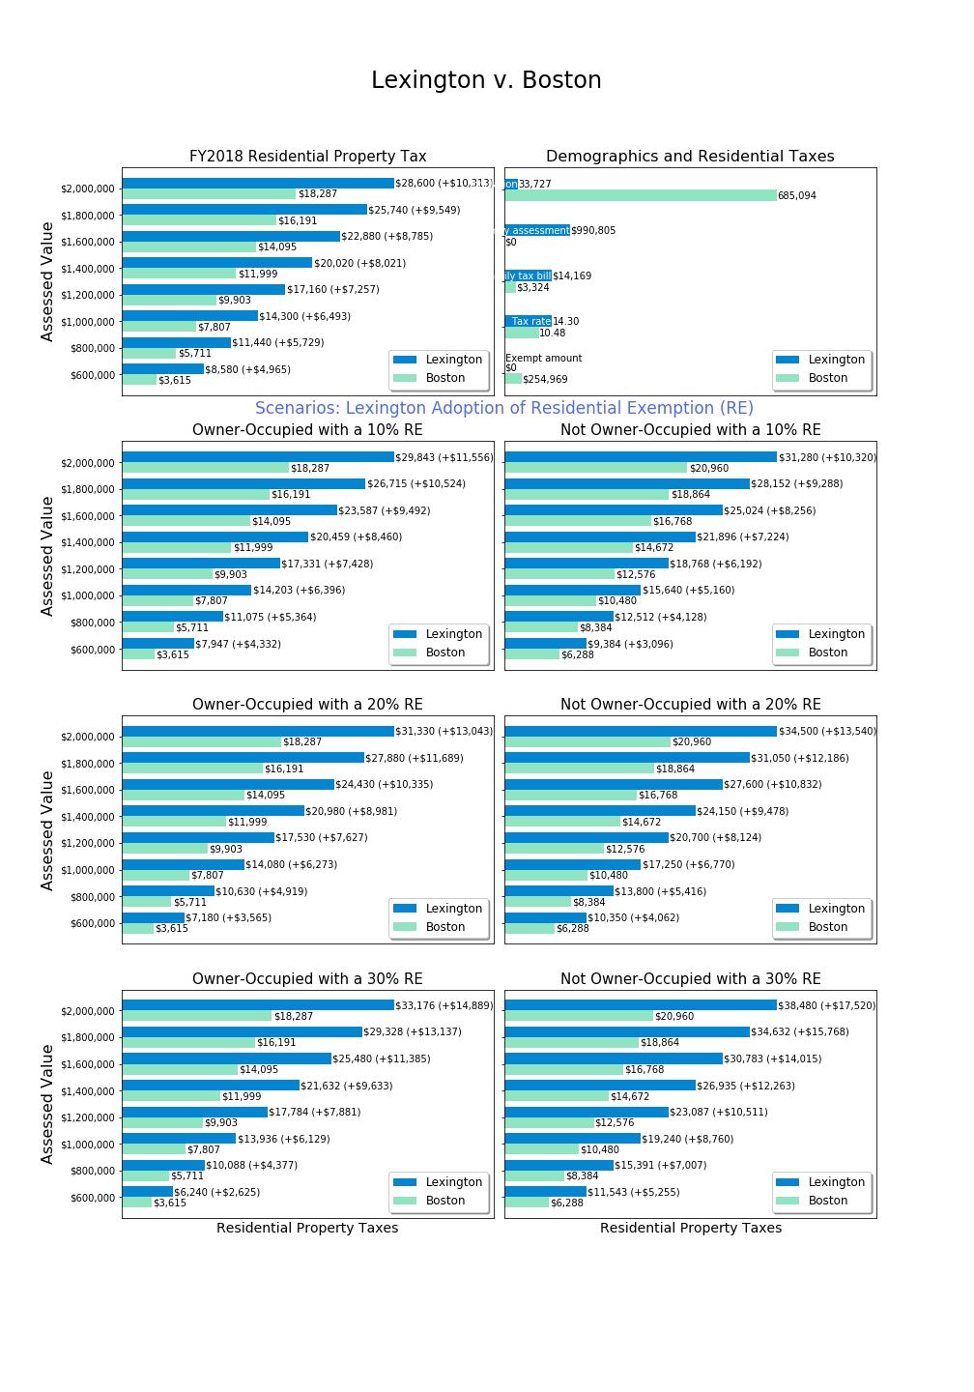

Unfortunately, the state does not provide data on the average single family assessment and tax bill for municipalities such as Boston which have adopted the Massachusetts Residential Exemption (SRE).[20] The upper right chart shows that Boston’s tax rate is $10.48 (relative to $14.30 in Lexington), and that rate applies after an exemption of $254,969. Thus, the effective tax rate in Boston is far lower than Lexington, because as demonstrated earlier, the $10.48 tax rate is the scaled up tax rate that makes that exempted amounts revenue neutral. If Lexington were to provide an exemption of $254,969, then its tax rate would be about $18.00, thus it appears that Lexington’s tax rate is effectively about 70% higher than the Boston residential tax rate.

The status quo chart (upper left) shows that for a $1,000,000 property in Lexington the taxes are $6,493 per year greater than Boston. For a $600,000 property the gap is $4,965, which is 137% greater than the Boston tax bill because the latter has a residential exemption, and therefore tax ratios do not scale linearly. For a $2,000,000 property, a Lexington taxpayer pays $10,313 more, which is only 56% more than a Boston taxpayer owning such a property.

With a 20% residential exemption, the $1,000,000 owner-occupied property owner in Lexington pays $6,273 more than a Boston property with the same valuation, about the same as the status quo. If the Lexington property were not owner-occupied, the gap grows to $9,443, 121% more than their Boston peer. Because a 20% SRE benefits lower value properties, the $600,000 property owner would see their relative tax burden shrink to an additional $3,565, in this scenario -- “only” 99% more than a Boston taxpayer. But the $2,000,000 property owner would then pay $13,043 more, an increase to 71% above Boston taxpayers.

Because Boston has a residential exemption, the Boston property tax values shown in the left column assume an owner-occupied home and in the right column assume a non-owner-occupied home. The Boston tax for a non-owner-occupied $1,000,000 property is $10,480. A Lexington non-owner-occupied home is today taxed at $14,300, almost $4,000 more than the Boston home. This gap is smaller than other gaps because Boston’s non-owner-occupied residences pay the scaled-up tax rate without benefitting from the exemption. If Lexington were to adopt a residential exemption, the property tax gap to Boston’s tax on non-owner-occupied properties will increase as exemption levels rise.

**Non-Owner-Occupied Impact**

As described earlier, residential properties might be non-owner-occupied because they are undeveloped land (low value) or because they house a commercial-style operation (medium to high assessed value). With an SRE, non-owner-occupied properties will experience the scaled-up tax rate which is required to make the exemptions revenue-neutral but will not benefit from the exemption.

The chart below illustrates a previous table, showing the percent increase in residential property taxes which would apply to a non-owner-occupied parcel, based on the residential exemption percent set by the Selectmen (zero to 35%).

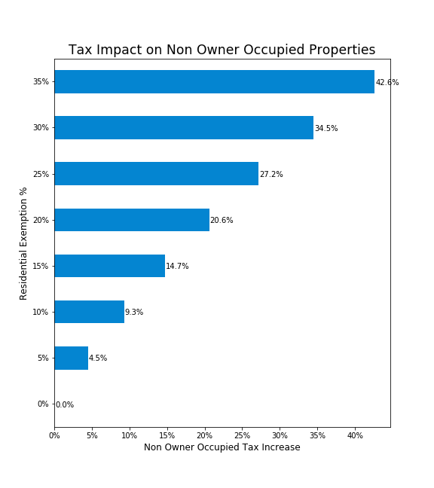

## 

## Indirect Consequences of the State Residential Exemption

While the logistics for verification and calculation of taxes can be easily described, the Committee focused on learning about the indirect and long term consequences of adopting an SRE. Little academic research appears to have been published on this topic, and therefore the Committee interviewed various experts and undertook its own survey and data analysis. In this section, we will first introduce the opinions of experts that framed the Committee’s analysis, the concerns raised, and ultimately the conclusions reached in this area.

### Perspectives from the Lexington Real Estate Community

The Committee invited Real Estate Brokers with experience in Lexington residential real estate. Participants were Diamond Hayes (William Raveis Real Estate), Robert Cohen (Coldwell Banker), and Beth Sager (Keller Williams Realty). These subject matter experts were asked questions about property tax stress and how people make decisions to buy and sell Lexington residential property.

**Do High Lexington Property Taxes Drive Migration?**

The brokers agreed that downsizing has been the primary reason for migration from Lexington in recent history, however downsizing square footages doesn’t necessarily mean downsizing financial investment in real estate.

Brokers had a mixed view of the role of property taxes as a motivation to sell. One broker indicated that buyers who are trading up within Lexington don’t care about taxes, but for sellers who have lived in their homes for 40 years, taxes are a primary issue. Other brokers saw property taxes for this older group as secondary to the personal challenges of stairs and upkeep. Property taxes were discussed as part the overall financial picture for some senior homeowners, factoring into whether they can afford to maintain their houses. After paying their property tax, fixed income home owners may not have enough funds to maintain the home and things start to fall apart. Houses in need of much repair are more likely to become tear-downs, which present an easy exit plan.

The brokers discussed whether tax breaks, even as much as $3,000 would change the selling decisions of homeowners who are considering leaving Lexington. The brokers felt that this was not likely and that, overall, many residents support the higher taxes. The brokers felt that Lexington’s existing tax deferral program, which could improve a senior homeowner’s cash flow by the entire amount of their tax bill, is not taken advantage of by most who would qualify. They indicated that most residents do not know about the tax deferral program.

**Lexington’s House Rental market**

Brokers indicated that the Lexington house rental market is very strong, with even some high-end houses being purchased for the purpose of renting them out. Some house purchases are made as an investment vehicle , where Lexington residential property may be seen as a more reliable investment than liquid capital markets.

Not all renters are families with children. The desirability of living in Lexington, aside from the value of the public schools, drives motivation to live here. Monthly rents of $3,500 are typical of single family home rentals, although some rents are much higher.

All brokers agreed that any property tax increase would be passed on to renters.

**Property Tax as a Disincentive to Buy in Lexington**

The brokers had varying responses about the level of concern expressed by home purchasers regarding property taxes. All agreed that Lexington schools are the top motivating factor and that many buyers will “do whatever it takes” to make it work. One broker pointed out that for every lower priced home on the market, there are 10 to 12 potential buyers.

Home buyers looking to move from Boston or Cambridge for better schools often question the tax rate because Boston and Cambridge property taxes are significantly lower. However other towns close to Boston and Cambridge with highly regarded schools, such as Winchester, Concord, Newton, Brookline and Belmont, also have high property taxes. Property tax concerns for school-motivated buyers are mitigated by the high cost of paying private school tuition which exceeds what could be saved by moving to a town with lower property taxes and less desirable schools.

**Other Effects of the State’s Residential Exemption in Lexington**

The brokers agreed that increased taxes on higher cost houses would not change the business model for developers. Developers pay property tax on the knocked down house’s assessed value, not the value of the newly built house. The buyer is the one who pays the new, higher tax rate.

The brokers also agreed that the SRE property tax reductions at the lower end of house values would not be material enough to slow out-migration, and the increases at the higher end house values would not be material enough to discourage buying.

### Perspectives from Economists and Housing Policy Experts

The Committee invited four experts on housing policy and economics to a round table discussion which took place on October 5, 2018. The participants were Peter Enrich (Northwestern University law professor), Jonathan Haughton (Suffolk University economics professor), Chris Herbert (Managing Director of Harvard University’s Joint Center for Housing Studies), and Chris Kluchman (Housing Choice Program Director, Massachusetts Housing Partnership/Department of Housing and Community Development).

The panel agreed that the intended primary effect of the Massachusetts Residential Exemption (SRE) is a tax burden shift among homeowners from lower valued homes onto higher valued homes and onto non-owner-occupied residential properties They noted that an underlying assumption behind this shift is that people with lower value homes also have lower incomes and experience more financial stress—exacerbated by continually increasing property taxes. However, the panel also noted that that income and property value are not perfectly correlated.

Another effect of an SRE that was discussed would be an indirect shift of some of the property tax burden onto renters, who may be a financially vulnerable, asset poor population in Lexington. Increases in the property tax on apartments and multi-family homes may create an incentive to convert rental units into condominiums, capturing more tax benefit from the residential exemption. This could reduce the size of the rental market in Lexington, depending on the size of the exemption (incentive) and the market response.

Owners of rented-out single family homes may prefer to sell the home because market conditions may not allow them to pass along the increase. Because the Lexington rental market is already very small, shrinking the rental market could increase monthly rental rates. If the goal of this Committee’s exploration is retention of financially strained current residents, the panel discussion indicated that shifting more of the property tax burden onto renters could increase migration.

It was pointed out, however, that property taxes can also be viewed as a services fee—which would reasonably be passed on to renters. Lexington provides excellent services, which is part of why it remains a desirable place to live.

Panelists observed that implementation of the SRE would have implications for all facets of the housing market. An important hypothesis is that property tax changes would be capitalized into home value, increasing the property value for lower valued homes and decreasing the value of higher value homes. Capitalization can occur both because a buyer is shrewd in analyzing the impact of taxes on an asset purchase, or because a buyer has a budget and the sum of mortgage and property taxes determine the maximum amount which can be invested in a home purchase.[21]

A first ramification of capitalization is that *future homeowners would not receive any benefit or penalty from a residential exemption*, and the effect of the SRE is twice impactful to existing homeowners. For example, a typical Lexington condominium owner would be *twice blessed*: first with a property tax reduction and second with an increase in property value due to the fact that potential buyers could bid higher when a lower tax bill applies. Conversely, the owner of an expensive home would be *twice cursed*: they would face a higher tax bill and their property would be less attractive in the housing market, lowering sale price. The future home buyer confronts these higher and lower prices, respectively, and therefore would experience an investment/mortgage cost which offsets the impact of the tax policy change. *The tax policy change is a one-generation effect with no specific benefit to future homeowners*.

This first ramification is reasonably well understood, and anecdotally can be observed in Cambridge and Boston where entry level units have risen in price, reflecting their low tax rates.[22]

A second ramification was introduced by Dr. Haughton, which is that the initial capitalization would change the home price and that in turn would erode the property tax impact promised by static analysis.

Example: A condominium owner is told that their $600,000 assessed value condominium will have a decrease in property taxes from $8,580 to $7,180 ($1,400 less) with a 20% SRE. However, within a few years and a full assessment valuation cycle, their $600,000 condominium has increased in value to $640,000 while more expensive properties have not increased as much or may have declined. This same homeowner sees their $7,180 tax bill increase to $7,582 due to the fact their property is now more attractive. (Ironically, they are dissatisfied about their updated property tax bill which reflects the fact that the tax policy has upgraded their home value with no effort of their own.)

Dr. Haughton developed a multi-step model and estimated that about 28% of the residential tax exemption effect would be lost due to change in property values in the opposite direction from the tax effect.[23] *For policy makers and Committee members concerned about supporting Lexington residents remaining in their homes over a longer term, it is especially disconcerting to realize that a residential exemption is a double handout to existing homeowners with no expected long term benefit for affordability by future residents.*

There was a clear consensus among panel members that the State Residential Exemption is a blunt instrument, affecting the entire residential housing market in both potentially desirable and potentially undesirable ways.

None of these experts advocated adopting the State Residential Exemption to address the challenge of assisting lower income seniors with remaining in Lexington, though two panelists said they could support it being implemented at a low level (i.e. a 10% exemption) as either a progressive tax or a symbolic consideration for passing a contemporaneous override. To address the core challenge, the guests preferred the Means-Tested approach and urged increased promotion of Lexington’s Tax Deferral Program.

### Aggregate Residential and Commercial Property Value in Lexington

Under Proposition 2 ½, the total tax revenue in Lexington cannot grow faster than a calculated rate[24], and for the last 20 years, voters have opted to tax at the maximum levy limit permitted by passing operating overrides and debt exclusions.[25] In practice, the town calculates the maximum tax levy and then proportionally assigns it to classes of property (residential, commercial, industrial, and personal) that exist within the town. Each class absorbs a proportion of the increase, but this proportion is driven by the change in assessed value for each class. Because residential properties have been appreciating in Lexington more rapidly than commercial properties, a “tax shift” occurs where residential properties in effect absorb most of the town tax increase, and therefore homeowners experience tax rate increases beyond the aggregate levy limit increase.

Adopting a residential exemption will impact home values in Lexington, but the Committee has not determined whether the aggregate impact of the dynamic system would be to increase residential aggregate value or decrease residential aggregate value. Any change in aggregate value would further impact the taxes paid by each class of property. A change in aggregate value is a secondary effect and should therefore be small, but to homeowners stressed by a 5% increase, a change to 4% or 6% might be seen as psychologically material.

### Condominium Conversions

Neither the Committee nor the roundtable experts have conducted empirical studies of the factors which drive Massachusetts condominium conversions. It could be that market forces beyond property tax policy largely drive this phenomenon. However, in observing the extent to which condominiums have replaced apartments in formerly large rental markets, one should be concerned how tax policies impact conversion.

Under a residential exemption, a two family home would have a single homeowner and at most one residential exemption. At a 20% SRE, an exemption exempts $195,000 against a revised tax rate of 17.03, saving about $3,321/year in property taxes. At a discount rate of 5%, each exemption has a net present value (NPV) of $66,417.

For a owner of a two-family home, conversion to a condominium should allow the capture of this $66,417 NPV. By itself, this might not be sufficient motivation for conversion, but when combined with other benefits it could serve as a tipping point. Inevitably some two-family home owners would convert to condominiums in response, decreasing rental availability and changing Lexington demographics.

For a larger property, the incentive to convert to condominiums could yield a significant asset, as illustrated here:

|  |
| --- |
| **Assumption:** Lexington Select Board Adopts 20% SRE  **Illustrated Impact**: Katahdin Woods (128 units).  **Direct, Immediate SRE Effect**: 20.6% increase in taxes ($362,963 to $437,732).  No exemptions would exist for this apartment complex as it is not owner occupied.  **Conversion Benefit**: If all 128 units were converted to condominiums, each owner occupied unit would be entitled to a 20% exemption ($194,761). The total exempt property would be 128 * $194,761 = $24,949,408. At a 17.03 tax rate, this is a reduction of $424,888 in property taxes.  This illustrated exemption amount would substantially equal all property taxes due from the apartment, and a greater amount than paid by Katahdin Woods today.  In practice, market forces would be expected to increase the value of these new condominiums, so it seems likely that property taxes would be paid by condominium owners. However, accepting this argument means recognizing that Katahdin Woods would be rewarded with a substantial increase in property value as a result of a condominium conversion under SRE.  **Net Present Value (NPV)**: The simplest valuation process is to calculate the NPV of the $424,888 net exemption. The NPV of this reduction depends on the discount rate used:  3%: $14,162,933  4%: $10,622,200  5%: $8,497,760  Katahdin Woods assessed value in FY2018 is $25,382,000.[26] This illustration shows that SRE adoption could create a material incentive for condominium conversion. |

Significant condominium conversions may increase rental rates by reducing supply and change the demographics of Lexington by excluding renters without the resources to purchase a condominium. These newly owner-occupied conversions will erode the benefit of a residential exemption for existing beneficiaries because the tax rate will have to be further increased to cover the cost of the new exemptions.[27] The Committee is therefore concerned that direct implementation of the SRE could negatively impact Lexington’s diversity and housing goals, and even fail to provide the forecast financial benefit once second order effects occur.

### Income Profile of Winners and Losers with the SRE

Those who lose most with an SRE are owners of parcels which are not owner-occupied. We do not have detailed information profiling owners of single family homes. However, using the Committee’s survey of residents, insights can be offered about who benefits with adoption of an SRE.

Using self-reported income, this chart shows the frequency distribution for homeowners:

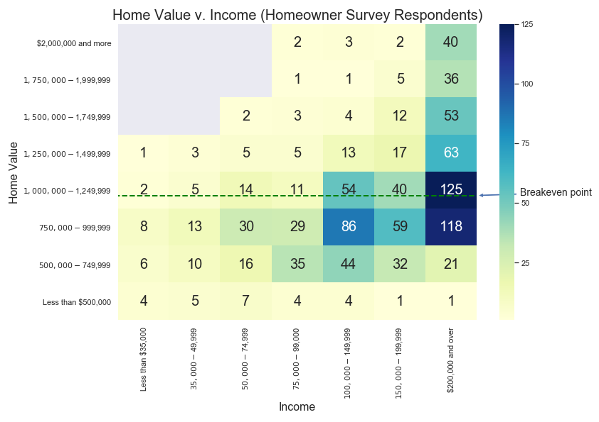

In each cell, the number represents the count of respondents who had the income and home value at the intersection shown. The coloring of the cell is simply a heatmap (bar on the far right) with darker blue colors showing more frequent occurrences.

A few observations are noteworthy:

* Below the breakeven point (about $1,150,000 for this chart), all income levels are represented and most households report incomes over $100,000.
* For those living in homes assessed below $750,000, only a minority have household incomes above $200,000, while this income level is more prevalent among higher valued homes.
* Some households live on very limited incomes (under $75,000) in homes valued as high as $1,749,999. Households above the breakeven point with limited income may struggle to pay increased taxes under an SRE.

One might also review the ability to pay property taxes directly for homeowners versus the indirect payment of property taxes by renters. Among survey respondents, owners reported household income as follows:

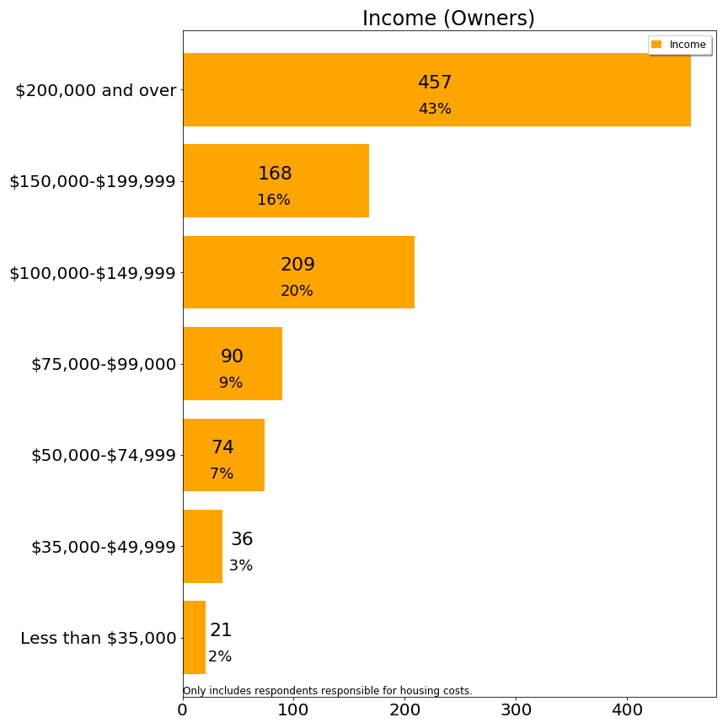

The majority of owners have household incomes above $100,000 per year.

Renters reported household income as follows:

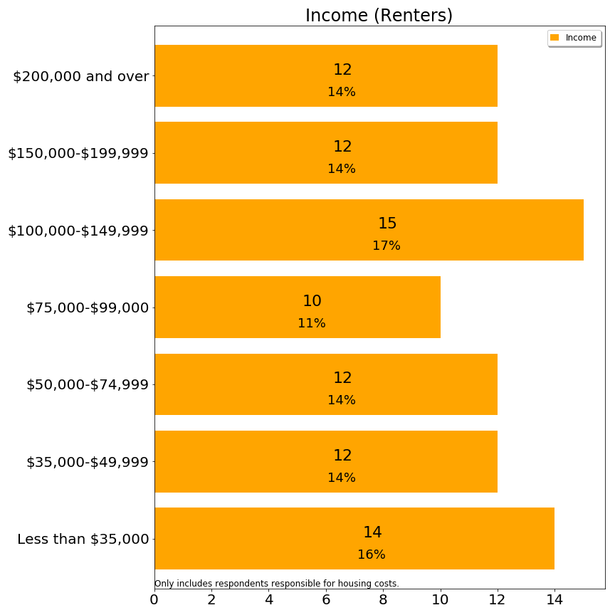

Slightly less than half of renters have household incomes above $100,000 per year. As shared earlier, renters pay far less property tax than owners, even on a pass-through basis. However, these statistics demonstrate both a somewhat lower ability to pay property taxes among renters, and also that renters range the spectrum from very low to high income. The Committee’s hypothesis is that some portion of increased property taxes could be passed through to renters, except for renters living in rent-controlled housing set at regional rates. However, if owners react by converting to condominiums, such change could be especially difficult for those with incomes below $75,000 (with presumably low asset levels), a group which represents 44% of renters as compared with 12% of owners.

## 

## Residential Exemptions in Massachusetts Communities

The Committee examined towns which have adopted the SRE to understand their procedures and whether they are solving issues similar to Lexington. This table shows the municipalities in Massachusetts which have adopted the SRE:

|  |  |
| --- | --- |
| **City** | **Residential Exemption:**  **Percentage Factor Adopted (FY18)** |
| Boston | 35% |
| Brookline | 20% |
| Cambridge | 30% |
| Chelsea | 27.5% |
| Everett | 25% |
| Malden | 30% |
| Somerville | 35% |
| Waltham | 25% |
| Watertown | 23% |
|  |  |
| **Town** |  |
| Barnstable | 20% |
| Nantucket | 20% |
| Provincetown | 20% |
| Somerset | 10% |
| Tisbury | 18% |
| Truro | 20% |

The first set of communities are cities, which have large rental populations. For these communities, the SRE serves the purpose of shifting the tax burden from homes to apartments. Unfortunately, it may also have the effect of contributing to condo conversions, and therefore the attempt to increase taxation on apartments could backfire by reducing housing in these communities for people with few financial resources.

With the exception of Somerset, the set of towns are vacation communities on the Cape or islands with significant numbers of absentee owners of second homes. The effect of these exemptions is to shift financial burdens from the year-round owners to the seasonal owners. This shift could also have the indirect effect of giving preference to year round owners who may impose greater costs on these towns.

The Committee has not found any published studies from these communities justifying a residential exemption.[28] Two municipalities have discontinued the SRE: Marlboro and Weymouth. Only anecdotal information has been gathered on the reason for these discontinuations.

## Summary

This chapter describes the implementation of the State’s Residential Exemption (SRE) including the anticipated verification process. It provides a static analysis of which property owners would pay more and which would pay less, and provides three series of charts benchmarking Lexington to other communities with and without a residential exemption, with further examples in the appendix.

Beyond static analysis, many issues are raised about indirect and long term effects of adopting an SRE:

* A tax shift is expected to be capitalized into home values, providing a “double impact” on existing homeowners and eliminating any economic benefit for future Lexington homeowners.
* A dynamic analysis of the property tax effect suggests that 28% of the static change would be eroded by a shift in property values. The actual impact on homeowners will be less than stated in the static analysis because properties at the lower end would inflate some amount while high end properties would suffer some deflation.
* There is speculation on whether these tax changes would be passed through to renters. In the short term, most Committee members feel that landlords charge the maximum amount possible, and Lexington rates are not materially higher than neighboring communities at present. It is possible that rental rates would increase, but inconsistently.
* Over the long term the rental market might be reasonably expected to shrink with an SRE. Absentee landlords would be less likely to invest in Lexington real estate for investment purposes (due to differential to peer towns) and two-family homes and apartment buildings would have material incentive to convert units to condominiums. Conversion to condominiums would shrink rental inventory and likely drive rental rates upwards, changing Lexington’s demographics.[29]

# 6. Massachusetts Model Means-Tested Residential Exemption Laws

Five towns in Massachusetts have adopted a local alternative to the State Residential Exemption (SRE) known as a Means-Tested Residential Exemption (MTRE). Unlike the SRE, which applies an exemption to all owner-occupied residential properties without regard to the income, assets, age or residency length of the owners, MTRE’s grant property tax exemptions to seniors which meet income, asset, and residency criteria. MTRE’s are subject to specified caps on house value and overall cost to the town’s budget. Most MTRE’s are revenue-neutral to the town, with the cost of the benefit redistributed among all residential taxpayers by a commensurate increase in the tax rate.

The appeal of means-tested exemptions is their higher precision in targeting residents in need of assistance. Moreover, providing tax relief to a more limited population reduces the magnitude of tax shifts, and may be expected to have a smaller impact on housing markets.

## Existing MTRE Laws in Five Towns

Through a Special Act of the State Legislature in the year 2000, the Town of Wayland adopted the first means-tested Residential Exemption in Massachusetts. Under Wayland’s MTRE, homeowners who meet the State Circuit Breaker’s eligibility criteria (see second table below) receive a match of up to a 100% of the Circuit Breaker limit (presently $1100). The towns of Reading and Hopkinton have adopted a similar version of this model, providing a benefit that is between 50% and 200% of the Circuit Breaker benefit.

In 2012, Sudbury created a new model of means-tested exemption, which has its main elements copied by Concord (see table, below, with distinguishing details among these models). Under the “Sudbury model”, a taxpayer who is 65 or more years old, possessing home and asset values below a modest level, and at least ten years residency could receive a property tax reduction calculated to bring their property tax obligation down to 10% of their income.

## Massachusetts Model Means-Tested Exemption Laws

|  |  |  |  |  |  |
| --- | --- | --- | --- | --- | --- |
|  | **Sudbury** | **Concord** | **Reading** | **Hopkinton** | **Wayland**  **“Circuit Breaker Matching”** |
| Income Limit | Per Circuit Breaker | Per Circuit Breaker | Per Circuit Breaker | Per Circuit Breaker | Per Circuit Breaker |
| Asset Limit | “Excessive” | “Excessive” | “Excessive” | “Excessive” | “Excessive” |
| Age | Per Circuit Breaker | Per Circuit Breaker | Per Circuit Breaker | Single 65+, joint 60+ allowed | Per Circuit Breaker |
| House Value | Average Single Family Home (SFH) +10% | < Median SFH | Per Circuit Breaker | Per Circuit Breaker | Per Circuit Breaker |
| Residency | 10 year consecutive | 10 year consecutive | 10 year consecutive | 10 year consecutive | 10 year consecutive |
| Benefit | Exemption of the amount that property tax exceeds 10% of income, less the amount that the homeowner qualified for under the Circuit Breaker income limits. | Exemption of the amount that property tax exceeds 10% of income, less the amount that the homeowner qualified for under the Circuit Breaker income limits. | 50% to 200% of the amount that the homeowner qualified for under the Circuit Breaker | Set annually by Selectmen- benefit is 50% to 200% of State Circuit Breaker | Up to 100% match of the Circuit Breaker.  Tax may not be reduced to less than 10% of household income.. |
| Benefit Cost Cap | Maximum total of benefits is .5 to 1 % of levy, pre rate-setting per Selectmen | Maximum total of benefits is .5 to 1 % of levy, pre rate-setting per Selectmen |  |  | none |
| Who funds? | Residential reallocation | Residential reallocation | Residential reallocation | Residential reallocation | Municipal Budget  not reallocated |

**Massachusetts Circuit Breaker Parameters, 2018 Tax Year**

|  |  |
| --- | --- |
| Income Limit | Single: $58,000.  Head of Household: $73,000.  Married, filing jointly: $88,000. |
| House Value Limit | $778,000. |
| Maximum Credit Given | $1,100. |

## 

## Adoption

Creating an MTRE requires a town to write a home rule petition asking for a Special Act of the legislature. Because the Committee was inclined towards action, our initial intent was to construct a local proposal drawing on elements from these models. However, as we delved deeper, we discovered that assessors were dissatisfied with aspects of adopted legislation, and these models had critical drawbacks which concerned the Committee. The next section provides additional details about existing implementations, while the following chapter proposes possible models for Lexington.

## Offsetting Loss of Circuit Breaker Tax Credits

As the Committee learned more about MTREs, we encountered evidence that both the SRE and MTREs would be funded locally but that some benefits would be offset by *reduced* State-paid benefits that local residents would have otherwise received. For example, 447 Lexington household might already be receiving a property tax rebate on their state income taxes from the [Massachusetts Senior Circuit Breaker Tax Credit](https://www.mass.gov/service-details/senior-circuit-breaker-tax-credit) (2016). This rebate applies if a household’s property taxes exceed 10% of their income, up to a maximum of $1100 (2018 tax year).

For some households which are close to the 10% threshold, a reduction of property taxes would reduce benefit from the tax credit. Current recipients of the tax credit may be in one of two situations, with these effects:

|  |  |
| --- | --- |
| **Prior Property Tax Situation** | **Effect of Local Property Tax Reduction on State Credit** |
| Property taxes *far above* 10% of income | No offsetting reduction |
| Property taxes *just above* 10% of income | Reduction in benefits as much as $1100 |

The concerning effect is that Lexington would provide property tax reductions to a household just above the 10% income threshold, and the household would not receive full benefit because it would lose some or all of the state circuit breaker credit from the state. Thus, a portion of local tax relief monies are wasted as offsetting reductions occur.

The Committee does not have direct information on how many households are near the 10% threshold. Indirect information suggests that households may be near the 10% threshold. The number of Lexington recipients of the circuit breaker has been steadily declining, and a possible cause is proximity to the 10% threshold.

In discussing the MTRE with the implementation expert in the Wayland Assessor’s Office, it was confirmed that several taxpayers receive a Wayland Circuit Breaker match on an every-other-year basis, as the local funds not only displace the State funds, but in fact make the taxpayer ineligible for local reduction on an alternating year basis. Thus, legislation could reduce predictable cash flows for residents and cost the town money which serves no net benefit for residents.

## Funding

An MTRE can be funded by reallocation to the residential property tax class (as the SRE does), to all property tax classes, or funded within the tax levy. Because MTREs typically require less than 1% of a town’s revenue, either approach might prove practical. As the MTRE comparison chart above demonstrates, communities following the Sudbury model have funded their exemptions by increasing the residential tax rate, while Wayland funds exemptions from their Overlay Account.

## An Assessor’s Perspective on Means-Tested Residential Exemptions

Lane Partridge, the Concord Assessor and the Chair of the Massachusetts Assessor’s Association, met with the Committee on November 16, 2018 to share Concord’s experience with the implementation of a Special Act that granted Concord their own version of a Means-Tested Residential Exemption.

The Concord law is based on Sudbury’s means-tested exemption with the exception of capping Concord’s eligible house value at the town’s median single family occupancy (SFO) value rather than the *average* SFO plus 10% limit utilized in Sudbury. Otherwise, both Concord and Sudbury’s eligibility parameters match those of the State Senior Circuit Breaker Property Tax Credit.

The first year of Concord’s implementation was FY 2018 which based applicant income and property value on Calendar Year 2017 figures.

### Implementation Issues Experienced by Concord

Some Committee members felt means-tested exemptions would depend on adjusted gross income (AGI) reported on the applicant’s state tax return, and would therefore be easily calculated. Instead, the Circuit Breaker application and Massachusetts models use the Circuit Breaker income worksheet which adds Social Security and other distributions not taxed on the State tax return. The Concord assessor hired a CPA to assist their office in understanding the Circuit Breaker process. In their experience, taxpayers routinely make errors in filling out these complex worksheets, and the assessor’s office has a duty to review each application for accuracy, which is a time consuming process.

As with other means-tested exemptions, asset limits are not specified by Concord’s law. Instead, the law gives the Concord Board of Assessors the authority to set policy on the level of assets they determine to be “excessive.” The Concord assessors exclude applicants with more than $250,000 in additional assets. The assessor shared with the Committee that external asset testing was made difficult by the lack of accurate reporting by applicants. The Concord assessor specifically highlighted that the population that a means-tested exemption is designed to target may have lower levels of financial literacy and an inability to self-assess eligibility or provide accurate information to an assessor without further support.

In the end, a large effort on the part of Concord assessment staff was required in the first year of implementation which yielded a small number of property tax exemptions. While 250 Concord residents were approved for the State Circuit Breaker in 2017, only 59 applied for the Concord MTRE. The assessor indicated that multiple announcements and mailings had been distributed, so their office believed that most eligible residents had been notified. They hypothesized that the $250,000 asset limit had discouraged many applications. Of the 59 applicants, just 49 were approved in FY2018. Thus, the Concord effort reached only 20% of Circuit Breaker applicants in the first year. This provides a benchmark should Lexington adopt similar provisions.

## Perspectives from Economists and Housing Policy Experts

As referenced in the SRE section of this report, the Committee invited a panel of four experts on housing policy and economics to a roundtable discussion on October 5, 2018. The panel noted that MTREs differ from the SRE in that the benefit is based on the taxpayer’s need rather than on the value of the taxpayer’s property. It benefits a smaller, but more targeted group of beneficiaries and, unlike the SRE, it doesn’t have the significant unintended effect of impacting home values. The MTRE approach can assist lower income seniors at thresholds determined by Lexington itself.

The panel described a few drawbacks of existing MTREs as well. One is that the ten year residency requirement in place in some communities may violate federal standards on mobility. (A second issue with this residency requirement was voiced at the Lexington public hearing, which is that a long residency requirement might have the unintended side-effect of promoting Lexington’s existing racial and ethnic demographic over groups outside Lexington.) On the other hand, a residency requirement can satisfy taxpayers that an exemption intended to help residents struggling to remain in their homes would not be consumed by newcomers who might deliberately purchase properties calculated to take advantage of these programs.

Panel members also discussed the Lexington Tax Deferral Program as an important property tax relief tool that seems to be under-utilized. The panel felt that effort spent on promoting and explaining this program might be the most effective approach for assisting lower income senior residents.

## Summary

In short, the Committee examined the five existing means-tested residential exemptions (MTRE) in Massachusetts. The direct consequences of these programs were not always efficient, with local tax reductions offsetting the State Circuit Breaker. These discussions made the Committee aware that *even the SRE would result in decreased local eligibility for the State Circuit Breaker*, another example of how local exemption dollars could fail to land in the hands of local taxpayers and relieve tax burden.

The Committee felt that none of the existing programs were ready for direct replication. Interviewed assessors and staff shared that they had wished their communities had studied legal provisions in detail before adopting legislation. Therefore, the Committee undertook to provide broad outlines to legislation which could be created for Lexington, a subject to which we next turn.

# 7. Lexington Means-Tested Exemption Proposals

An early straw poll found that the Committee had mixed reactions to the SRE but were generally enthusiastic about Lexington adopting a variant of a means-tested residential exemption. The Committee recognized that existing means-tested statutes have certain gaps or flaws and broached the idea of creating a Lexington-specific means-tested measure. A first obstacle was that the Committee does not have a specific charge for which segment of the population should be assisted, and opinions varied about who should be helped. Should a Lexington proposal help lower income or house-poor? Should it help the homeowner or the renter? Should it treat the long term resident the same as the newcomer?

After initial research, the Committee modeled two examples of possible means-tested exemptions, recognizing that the development of legislation appropriate for Lexington would first require an extensive public process to determine the will of the community, including who should benefit, the level of benefit, and who should pay for it. Only then could legislation be drafted, analyzed, and pursued for enactment.

The Committee gave the Selectmen an interim update in January 2019, and based on their input have decided to outline these two exemption *models* without drafting exact legislation. Therefore, this chapter is not intended to be a comprehensive blueprint or legislative draft. It will require community participation to determine a course of action and then additional work from a future body to evaluate and propose the details of the final legislation.

This chapter will first review the eligibility criteria found in typical means-tested proposals, and share what the Committee has learned or recommends in each area. Then the chapter will describe two types of proposals: one proposal focused principally on residents with limited means and a second focused primarily on residents who have reached a certain age. An overview of what these proposals could contain and simulated financial impact provides policy makers a starting point for these models.

Drafting legislation and pursuing support for these proposals is expected to be time consuming. The need for these proposals stems from inadequate property tax relief for Lexington, and it should be noted that an alternative path would be for the Lexington Selectmen to lobby for changes to existing State laws (such as the Circuit Breaker tax credit and tax deferrals).

## Lexington Proposals

Many considerations impacted the design of possible proposals. Here we outline rationales which informed the Committee. Following the rationales, two proposals are introduced and evaluated against criteria.

## Rationales for Eligibility

**Age:** With an aging population that is staying healthy longer and retiring later, using age 65 as an age cutoff has the unfortunate effect of making so many residents eligible that levels of financial assistance become diminished. It makes sense to start financial assistance at age 70 or later to balance the desire to provide assistance with the number of individuals who may feel that their age justifies assistance. As an individual ages further beyond 70, access to new sources of income may generally diminish.

**Home Value:** Capping eligibility based on the *median* Lexington home value may make political sense, so that taxpayers are not subsidizing those who choose to remain in better-than-median homes.

**Asset Level:** Households with material asset bases may be reasonably expected to tap into those asset bases before receiving a Town subsidy. We may reasonably expect younger retirees have need of more assets than older retirees because it is assumed that their assets will have to last them for a longer period of time. However it is not clear that this would require applying higher thresholds for younger retirees. Maintaining a consistent asset level across ages would have the effect of providing more relief for senior retirees and less to younger retirees who should have a larger asset base.

**Income Level:** Combined with assets, lower income is commonly thought to represent need. However, with the advent of Roth IRAs which do not have required minimum distributions (RMDs) from IRAs, households may be able to better control the years in which they receive income and through financial planning create evidence of a need for financial subsidy. Therefore, income should not be the only means-testing criterion. We have also learned that the Circuit Breaker income formula includes non-taxable sources of income, and therefore it also seems important to follow that pattern rather than using adjusted gross income (AGI) from a tax return.

**Ownership:** The guiding principle is property tax relief, so the notion advanced is that someone paying property taxes is (by definition) an owner and would be the one receiving relief. Therefore these criteria collectively focus on access to income and assets for the actual beneficial owner(s). This also avoids a “rent-a-senior” situation where a senior citizen participates in the household specifically to provide relief for an otherwise unqualified owner. The Committee also discussed whether Lexington should follow the state Circuit Breaker pattern in providing tax relief to renters as well. From the Wayland Assessor’s Office we learned that providing financial assistance to renters involves assisting a resident who does not pay local property taxes, which then is neither a direct rebate nor refund of taxes. Therefore the Committee does not recommend directly undertaking *property tax relief* for renters despite survey evidence indicating significant housing stress.

**Residency Length in Lexington:** An argument for longer residency requirements is to benefit those individuals who have been supporting the Town by “paying into” the local tax system and not simply moving into town for tax benefits. An argument to waive residency requirements was a concern raised by Peter Enrich that such residency requirements might be considered discriminatory under federal law. All towns with existing means tested exemptions have residency requirements. The Committee feels that a 5 year residency requirement is a compromise between contributing locally and yet maintaining openness and support for newcomers. Proposed legislation should specifically address whether the length of residency should additionally be required to be contiguous or recent.

## Rationales for Benefits

**Materiality:** Benefits should be material enough to have an appreciable effect on the beneficiary’s financial decisions. A program with immaterial benefits and significant administrative costs makes no sense.

**Supplemental:** The benefits received should be assumed to accompany other remedies and breaks available to a household, such as the State Circuit Breaker and Lexington’s Tax Deferral Program. Lexington’s proposal should avoid displacing other financial assistance available to the homeowner, and instead be crafted to add to existing financial supports.

**Justifiability to other residents:** The survey indicates that a large part of the population has difficulty with housing costs, so any benefits should be justifiable even to another resident struggling with housing and not receiving a benefit.

**Targeted:** Benefits should be targeted to individuals with demonstrated need.

**Housing Price Impact:** Benefits should be designed so that they attach to the individual rather than the property, and thereby avoid adding material distortion to housing prices.

**Financial cliffs:** Critics of existing State and local policies point to financial cliffs, causing a household slightly above a criteria to lose all financial assistance. Legislation should provide smoothing as possible, yet avoid excessive complexity.

**Predictability:** Total benefits offered to a household should be relatively consistent from year to year, avoiding every-other year effects or other oscillations due to interactions with other systems.

**Widow-Protection:** The benefit system should avoid penalizing those who become widowed. (Existing systems tend to lower income and asset thresholds upon death of a partner, and fail to reflect that many household costs continue beyond that event.)

**Understandability:** Taxpayers and beneficiaries should be able to comprehend the benefit system being proposed.

**Flexibility for Government:** As benefits are indexed to other legislation (such as the Circuit Breaker), enough flexibility should exist that town government can respond when material changes occur to demographics or to related legislation, such as elimination of the Circuit Breaker or significant changes to it.

**Flexibility for Individuals:** Avoid restrictions that impose undue burdens for beneficiaries who seek to relocate within Lexington or remodel their home, especially for home modifications which allow homeowners to age in place.

**Impacts on Town Budget:** The beneficiary pool should be small enough that material support to targeted individuals could be absorbed with a relatively small impact among non-beneficiary taxpayers or within the town’s annual budget.

## Proposal #1: Circuit Breaker Style Means-Tested Exemption

This proposal was developed with the intent of reflecting the goals of other MTREs while adjusting for limitations such as addressing the needs of surviving spouses and avoiding local tax abatements which result in reduced State Circuit Breaker benefits and are therefore wasteful uses of local funds.

**Goal:** Provide material assistance to seniors with demonstrated financial need as a supplement to existing programs such as the Circuit Breaker and property tax deferrals. The objective is to lower a household’s property tax contribution closer to 15% of income for those households experiencing high levels of property tax stress, a percentage which avoids adverse interactions with the Circuit Breaker.

**Eligibility:**

*Age:* 70+ years

*Owner: Oldest owner of household, with 50%+ beneficial ownership*

*Residency:* 5 years, with 2 continuous

*Home Value:* At or below the median value of Class One residential properties

*Calculation Basis:* The State Circuit Breaker has three income thresholds. The highest income threshold is designated for taxpayers who are **Married Filing Jointly (MFJ)**. The lowest income threshold is designated for **Single Individual taxpayers (SI).** Both the MFJ income threshold, currently $86,000, and the SI income threshold, currently $58,000 form the basis for setting qualifications for the Circuit Breaker Style Means-Tested Exemption. These thresholds will be used for all households independent of filing or marital status.[30]

*Asset level[31]:* A multiple of the MFJ of between 1.0 and 5.0 as set by the Selectmen annually.

*Income level:* See formulas below.

**Benefits**

*Home owners:*

For households with residential assessed value at or below the State Circuit Breaker maximum level:

* Households with income below the SI threshold (currently $58,000) can receive up to N times the Circuit Breaker value. Selectmen set the value of this Circuit Breaker multiple annually, to be between 1.0 and 3.0. The multiple of the state Circuit Breaker is the planned reduction in an individual’s property tax bill, provided the reduction in addition to the individual’s prior year State Circuit Breaker, does not depress property tax to income ratio below 15%, and in the event this would occur, the benefit is adjusted downward to the figure which matches 15%.
* To reduce the financial cliff effect, households with income above the individual threshold but below the joint threshold (currently $88,000) would receive 1.0 times the State Circuit Breaker as a property tax reduction, provided the reduction in addition to the individual’s prior year Circuit Breaker, does not depress property tax to income ratio below 15%, and in the event this would occur, the benefit is adjusted downward to the figure which matches 15%.
* For households with assessed property value above the State Circuit Breaker maximum but below the town median: The same 1.0 level benefit is proposed as for those who are at or below the State Circuit Breaker maximum. (In effect, the town benefit extends to the town median residential value when that value is above the Circuit Breaker limit.) These households would receive the full Circuit Breaker amount rather than a multiple of it, but provided by the town.

*Renters:*

* No benefit

**Annual Action by Selectmen:**

* Determine the maximum asset threshold by setting asset multiple of joint income to a figure between 1.0 and 5.0
* Determine maximum Circuit Breaker multiple, by setting this figure between 1.0 and 3.0, for households meeting all criteria with total income below the individual threshold of the State Circuit Breaker.

**Funding:** Levy or tax rate adjustment

**Estimate of Financial Impact:**

Estimate 450 Circuit Breaker households

Estimate 50% meet asset criteria:

225 recipients

Estimate that 1.15 times Circuit Breaker is average benefit received (due to 15% threshold, and income thresholding applied):

225 * 1.15 * $1100 = $284,625

Further,

Estimate 350 households would meet Circuit Breaker income criteria but do not meet market value criteria due to $778,000 cap, but would have a home between that value and the Lexington median assessed value ($950,000).

Estimate 40% meet asset criteria:

140 recipients

Estimate that 1.15 times Circuit Breaker is received:

140 * 1.15 * $1100 = $177,100

**Total cost to town: $467,725**

**Total beneficiary households: 365**

**Average benefit/household: $1,265**

## 

## Proposal #2: Octogenarian Means-Tested Tax Exemption

This proposal was developed in response to a concern voiced in the Committee’s second public hearing about meeting the needs of older seniors. Existing tax policies do little for an aging population and do not seem to reflect the needs of *the oldest seniors*. It seems that Lexington and Massachusetts could provide more support for this population which uses few local public services at little net cost to taxpayers.

**Goal:** Life expectancy in Middlesex County, Massachusetts is 80 years. Older seniors may struggle to balance retirement savings and asset levels with increasing and unpredictable property taxes. The guiding principle for this proposal is to reduce housing stress by substantially freezing increases in residential property taxes for residents upon reaching age 80, while providing the flexibility for 80+ year olds to adjust housing within Lexington.

**Eligibility:**

*Age:* 80+ years old

*Owner:* Oldest owner of household, with 50%+ beneficial ownership

*Residency:* 5 years, with 2 continuous residency and ownership

*Property Value:* At or below median residential property

*Calculation Basis:* The State Circuit Breaker has three income thresholds. The highest income threshold is designated for taxpayers who are **Married Filing Jointly (MFJ)**. The MFJ income threshold, currently $86,000, will be used as the basis for setting qualifications for the Octogenarian Means-Tested Exemption. The MFJ will be used for all households independent of filing or marital status.[32]

*Asset level:* A multiple of the MFJ of between 1.0 and 5.0. as set by the Selectmen annually.

*Income level:* A multiple of the MFJ of between 0.7 and 1.2. As set by the Selectmen annually.

**Benefit:** Two types of benefits were discussed by the Committee. One, based on an index factor, is straightforward to calculate but does not ensure that taxes are frozen. Another would *freeze property tax contribution amounts*, but then include provisions for intra-town mobility, material reassessment, remodeling, etc. In this section, we estimate financial impact using an index factor method.

Calculate the “Index Factor” (IF) as follows:

IF = (Oldest owner age - 79) * .03

Property tax reduction = IF * property taxes

*Examples:*

80 year old owner: 3% reduction

85 year old owner: 18% reduction

90 year old owner: 33% reduction

95 year old owner: 48% reduction

**Annual Action by Selectmen:**

* Set maximum asset level multiplier
* Set maximum income level multiplier

**Town perspective:** A medium-sized property tax shift would occur in the year of implementation, but in subsequent years it would appear as if the tax increases were not landing on 80+ year olds with modest or medium means. Younger age-range households would absorb slightly higher tax increases to offset. If the program retains more octogenarian seniors or life expectancies increase, then reduced town expenses due to the non-use of public schools by the 80+ population will largely offset further benefit increases to octogenarians. If the program does not impact migration patterns, then only a nominal financial impact would occur after the initial property tax shift.

**Household perspective:** Because property taxes increase 3-5% per year, these scaled increases would have the effect of keeping property taxes relatively stable for a household after its oldest owner reaches age 80. In the year of implementation, some households would see a large drop in property taxes, which could even be more than 30%. But in future years, households with an owner aged 80+ years would no longer see property tax bills with cumulative and material increases from year to year. This would give octogenarians comfort when aging in place. Tax deferral should remain an option as well.

**Funding:** Tax Shift across all classes of property.

**Analysis of Financial Impact:**

Using town address list (see table on the following page):

2,031 Lexington residents age 80+

547 are in Brookhaven or other property where residents are not subject to individual property taxation

1,484 are possible owners and renters, and occupy 1,128 distinct addresses

Taking the oldest householder at each address, we calculate the mean age as 85.8 and the mean benefit at 20.5%.

Assume the Selectmen set the asset ratio of 5.0, for a maximum asset level of 5.0 * $88,000 = $440,000, and set the maximum income ratio of 1.0 for 1.0 * $88,000 = $88,000.

We may estimate that 65% of households would meet the requirements of residency length, maximum home value, maximum asset level, maximum income, and are owner-occupied.

733 Households = 1,128 * 65%

FY2018 average home assessment $918,772.

Assume average 80+ year-old lives in a home valued at 80% of the average assessment, then average 80+ year old home assessment is $735,018.

FY2018 average tax bill would be: $10,511.

With 20.5% reduction, average reduction: $2,155.

733 households * $2,155 per household = $1,579,398 total cost to Lexington

**Total cost to town: $1,579,398**

**Total beneficiary households: 733**

**Average benefit/household: $2,155**

**Number of *Known Non-Owner 80 Year Olds* Living in Lexington’s Residential Zoned Property (2018)**

|  |  |
| --- | --- |
| **Address** | **Count** |
| Brookhaven (1010 Waltham Street) | 297 |
| 10 Pelham Road | 90 |
| William Roger Greeley Village | 50 |
| 178 Lowell Street | 30 |
| 30 Watertown Street | 28 |
| Main Campus Drive | 27 |
| 840 Emerson Gardens | 19 |
| Katahdin Drive | 6 |
| **Total** | **547** |

This table identifies residences where 80+ year old residents currently reside. Most of these locations are either senior housing, rental, or property which is not owner-occupied.

## Property Tax Freeze Models in other States

While Massachusetts has modest programs to assist senior citizens, some states have more robust programs to protect seniors against property tax increases. While we do not advocate directly adopting any of these programs, they are cited as evidence that creating an age-based program which targets the elder population may have merit. Lexington could promote such a program at the state level, or it could seek its own Special Act through home rule petition and create an opportunity for other communities to follow.

The following chart compares potential models for tax freezes from New Jersey, Texas, and Tennessee. The age eligibility for all three starts at 65, and New Jersey and Tennessee have income limits. In New Jersey, the difference in dollars from the first year is reimbursed, while in Texas and Tennessee, the rate is frozen at the first qualifying year. Frozen tax levels are adjusted if home improvements occur.

|  |  |  |  |
| --- | --- | --- | --- |
|  | **New Jersey** | **Texas** | **Tennessee** |
| Age | 65+ | 65+ | 65+ |
| Other Eligibility Requirements | Lived there for 10+ years, income less than ~$87,000 (2017) | n/a | Income below threshold (~$29,000-$52,000 depending on county) |
| Benefits | Taxpayer reimbursed by state for property tax levels above amount paid in first qualifying year. | Property tax amount set in first qualifying year. | Property tax set in first qualifying year. |

## Evaluation

The Committee charge does not explicitly state that Lexington’s elderly are the focal subpopulation. However, the particular circumstance of retired, potentially less-mobile community members who purchased their homes when residential property values and property taxes were a fraction of what they are currently, is a concern of this Committee and of community members who have communicated to us over the course of the past year. Testimony by particular individuals highlights how vulnerable this population can be, motivating creation of Proposal #2 above.

Although a Committee concern, we must highlight that Lexington survey data does not lend support to the notion that the elderly experience greater housing stress than other age categories, nor that they are more likely to migrate away from Lexington. The Committee’s decision to focus on this age cohort instead reflects our view that these residents are less able to migrate or gain employment when financially strained, use relatively few town services, and deserve some predictability in financial expenses. For that reason, both proposals contain age thresholds.

For potential beneficiaries, the primary differences between these two proposals are that Proposal 2 restricts benefits to “super-seniors,” an older group of than specifically addressed in Proposal 1, and Proposal 2 provides a larger benefit, which continues to increase with age.

For cost and implementation considerations, the number of beneficiaries and the cost would be much larger under Proposal 2. Implementation costs are likely to scale with the number of applicants. To fund Proposal 2, in particular, a redistribution of costs among younger and wealthier residents would be necessary. These other residents may not wish to fund the preservation of their elderly neighbor’s equity in their home, equity that will be inherited by their heirs. Some degree of participation in the property tax deferral program could be added as a requirement to mitigate this issue.

|  |  |  |
| --- | --- | --- |
|  | **Circuit Breaker Style Means-Tested Exemption** | **Octogenarian Means-Tested Exemption** |
| **Property Tax Related Housing Stress: Precision** | Fair precision if objective is helping those with limited means | High precision if objective is helping 80+ year olds |
| **Property Tax Related Housing Stress: Recall** | Low recall if goal is to relieve housing stress across community | Recall high for 80+ year olds with limited income |
| **Total budgetary impact - Lexington budget** | None | Possible reduction in aggregate demand for schooling, but less than size of tax shift to occur. |
| **Short term Housing Market Impact (Prices / Rents)** | None | None |
| **Optimal Allocation of Housing (& flexibility for future) - who’s in it and ownership assumption, condoizing, tear down** | None | Goal to support 80+ in home may reduce optimal allocation of housing |
| **Equitable Taxation** | Small | Debatable |
| **Migration** | ? | ? |

# 

# 8. Conclusions and Recommendations

The Committee has appreciated the opportunity to dig deeply into the subject of residential exemptions, an area which has relevance to Lexington’s long term success as a community. We have been privileged to have the time to learn from many subject matter experts and policy makers, conduct a detailed survey, and talk with numerous residents. Through this process, we have learned that many Lexington residents are concerned about local taxes, and yet there is widespread support for thoughtfully taking the time to develop the right course of action for Lexington.

After debating the State Residential Exemption at length, the Committee agrees that no single exemption or other policy tool alone can address the existing property tax stress in our community, but rather a multi-pronged approach that includes more targeted tools could provide substantial benefit. We additionally agree on the following set of policy recommendations, and recommend continued attention to this challenge by the Select Board in view of planned debt exclusion projects.

**Local Tax Policy:**

1. **Do not adopt the Massachusetts Residential Exemption**
2. **Develop for community consideration a proposal for a means-tested or age-based residential exemption.**
3. **Promote awareness of existing programs such as tax deferrals, exemptions, and the Massachusetts Senior Circuit Breaker Property Tax Credit.**
4. **Evaluate increasing eligibility thresholds significantly for the Lexington Tax Deferral Program.**

**State Advocacy:**

1. **Advocate for expanded access to tax deferrals for homeowners with existing or future mortgages and home equity loans.**
2. **Advocate for expanded access to the state administered Senior Circuit Breaker Property Tax Credit for surviving spouses and those with home values above the current eligibility threshold, as well as expanding the level of rebate.**

**Further Study:**

1. **Further study the financial needs and supports necessary for Lexington’s population of older (80+) seniors to “age in place”.**
2. **Further study methods to retain middle-aged residents who have the highest rate of forecast out-migration.**

On March 22, 2019 the Committee voted separately, and unanimously, in support of each of these recommendations.

# Appendix: Property Tax Benchmark Charts

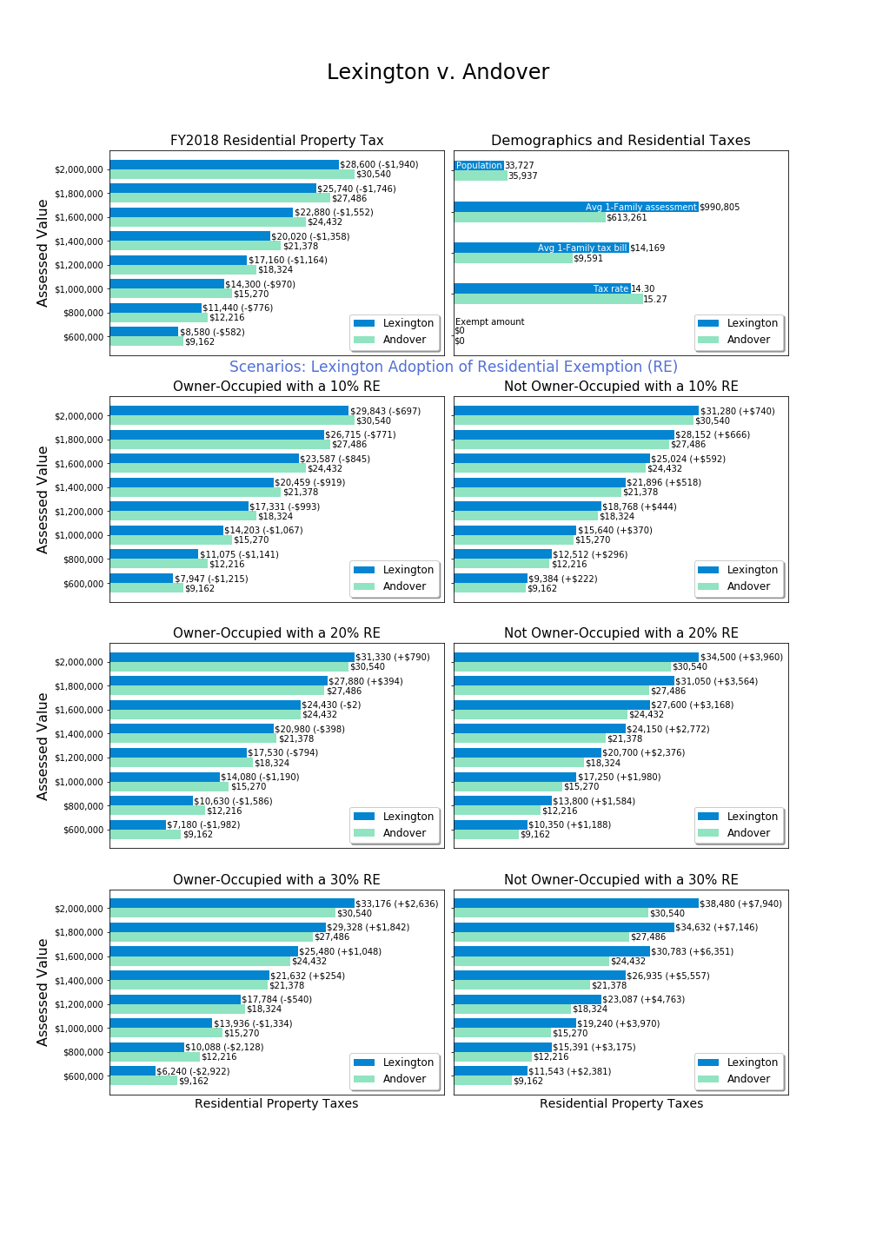

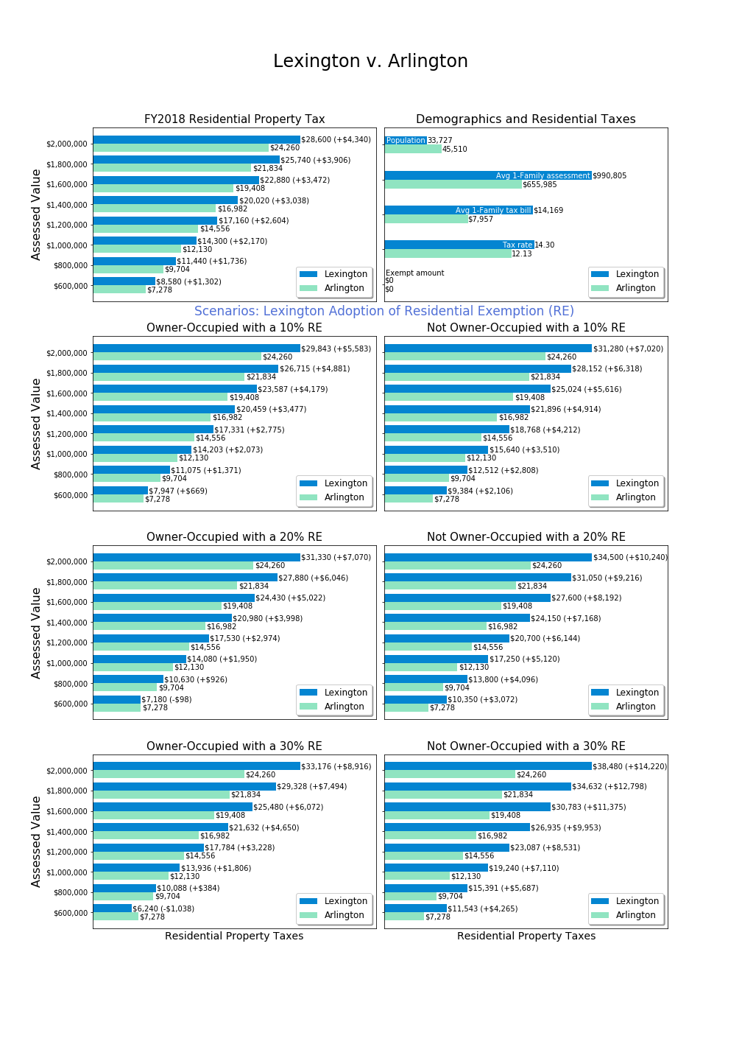

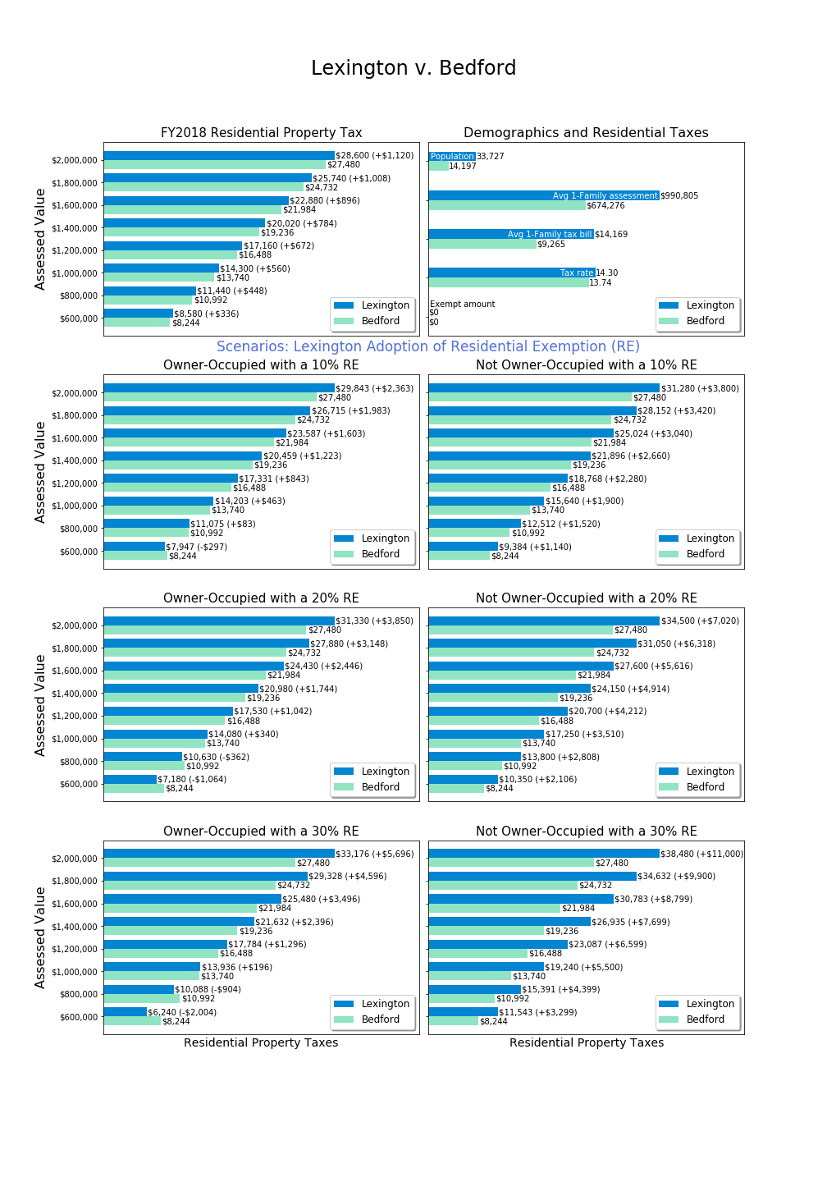

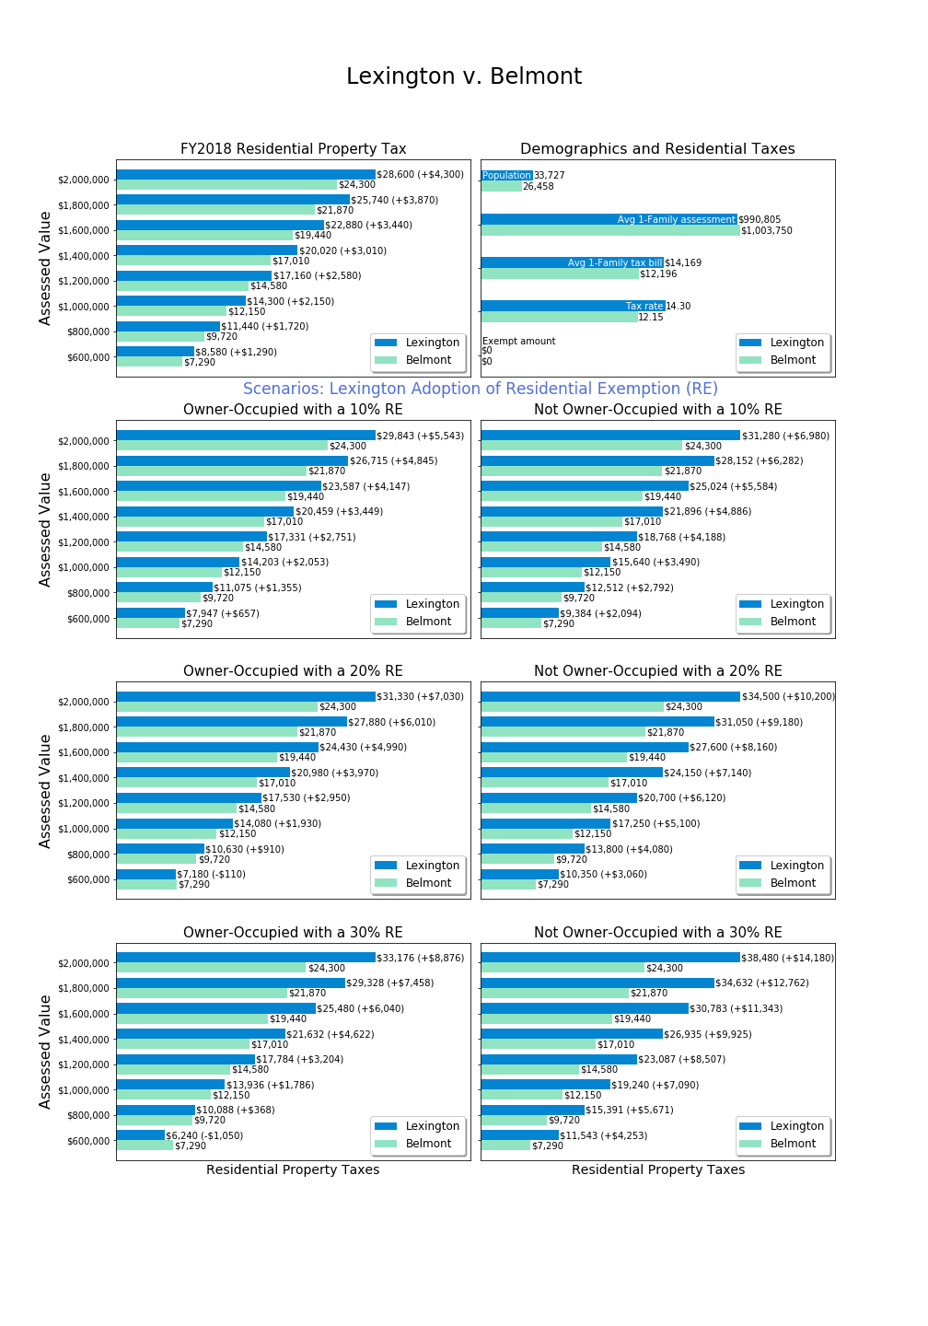



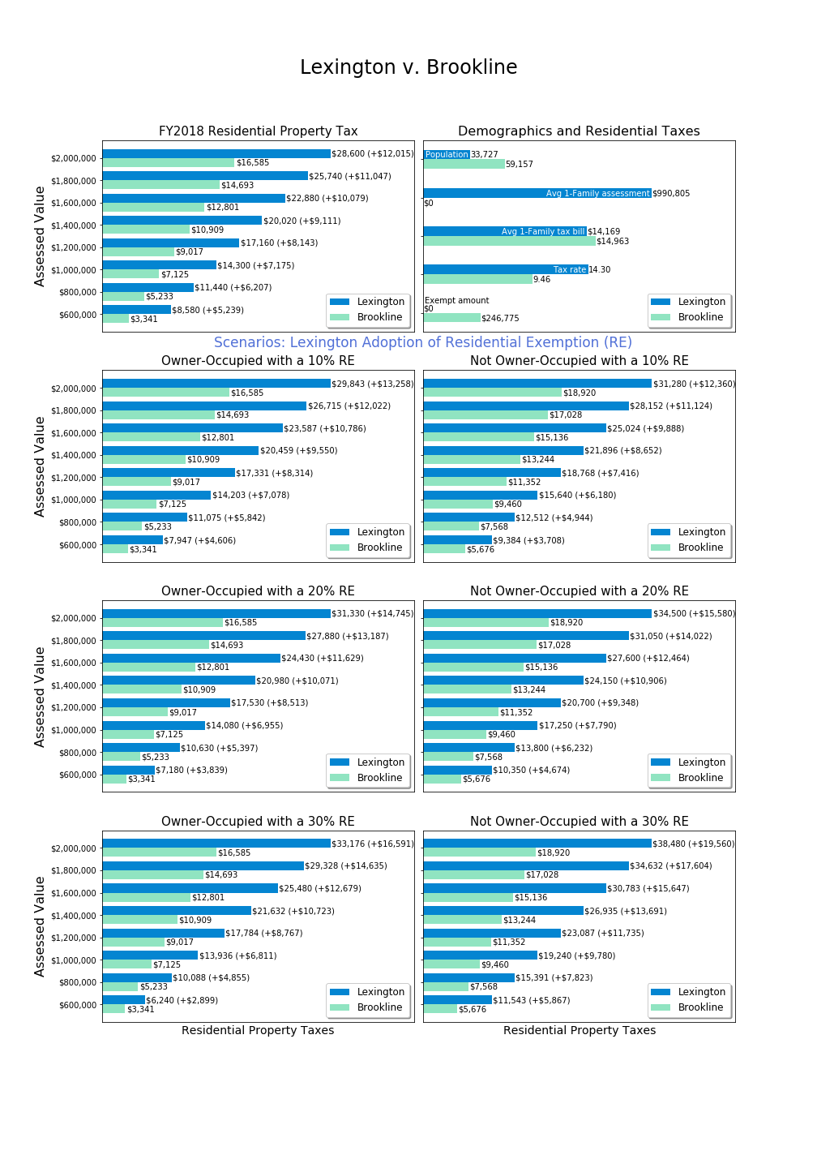

Brookline average single tax bill source: <https://www.boston.gov/sites/default/files/imce-uploads/2018-03/fy2018_facts_figures.pdf>.



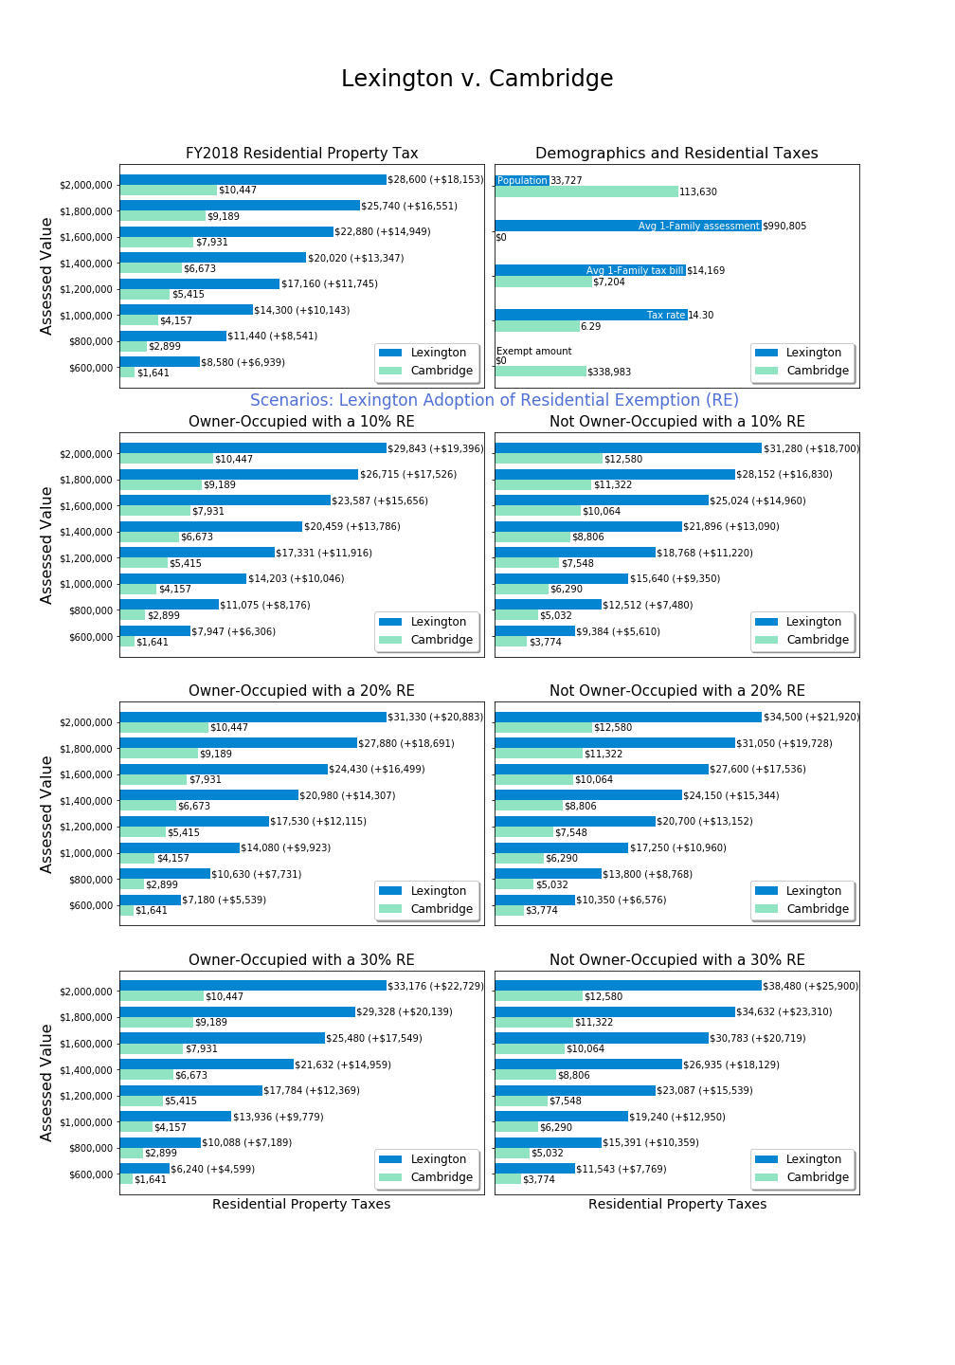Cambridge average single family tax bill for FY2017, source: <https://www.boston.gov/sites/default/files/imce-uploads/2018-03/fy2018_facts_figures.pdf>.

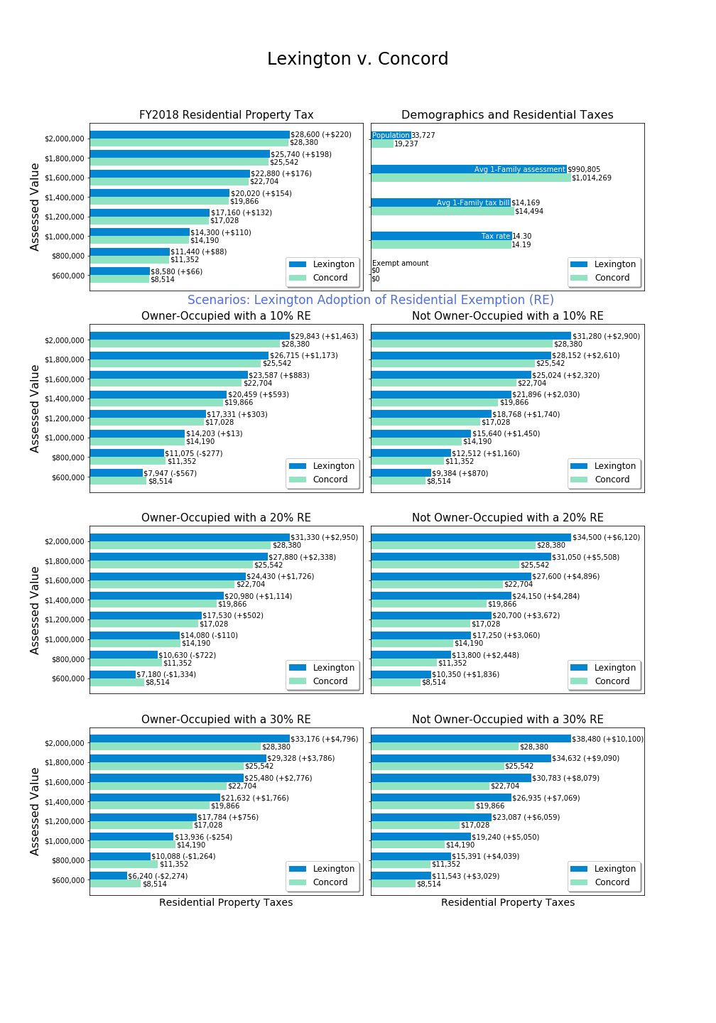

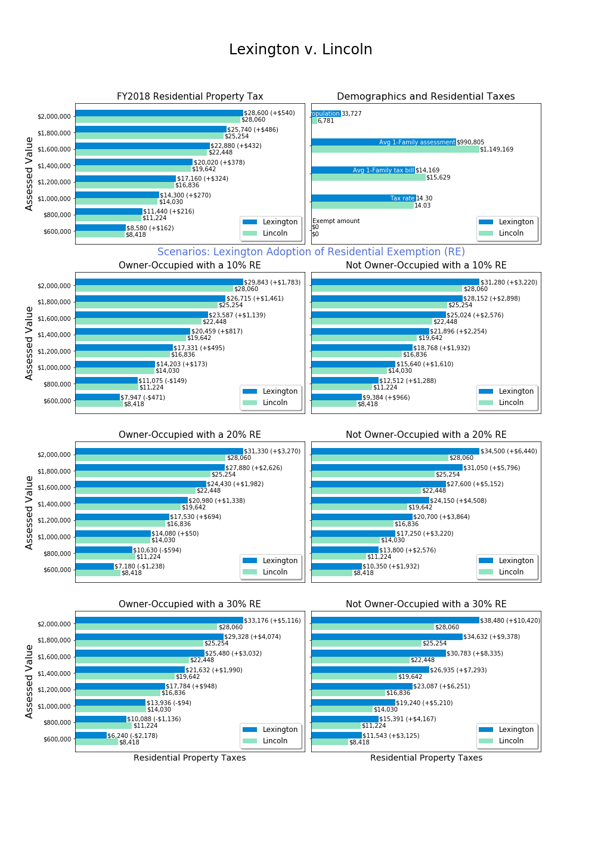

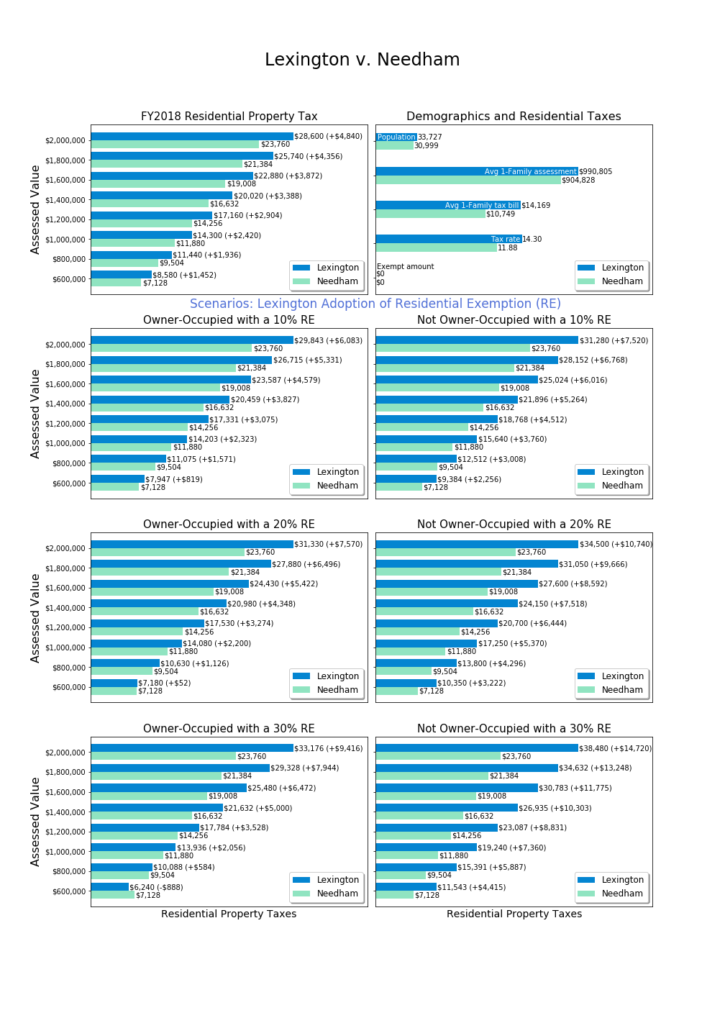



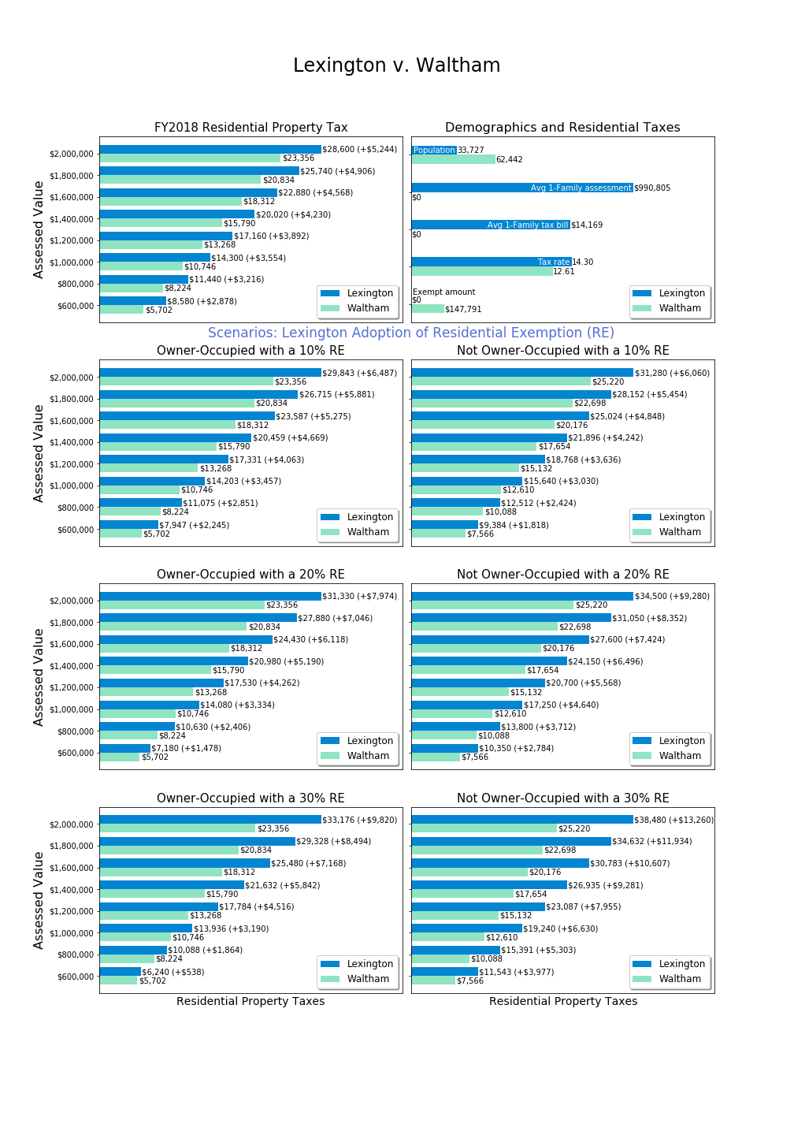

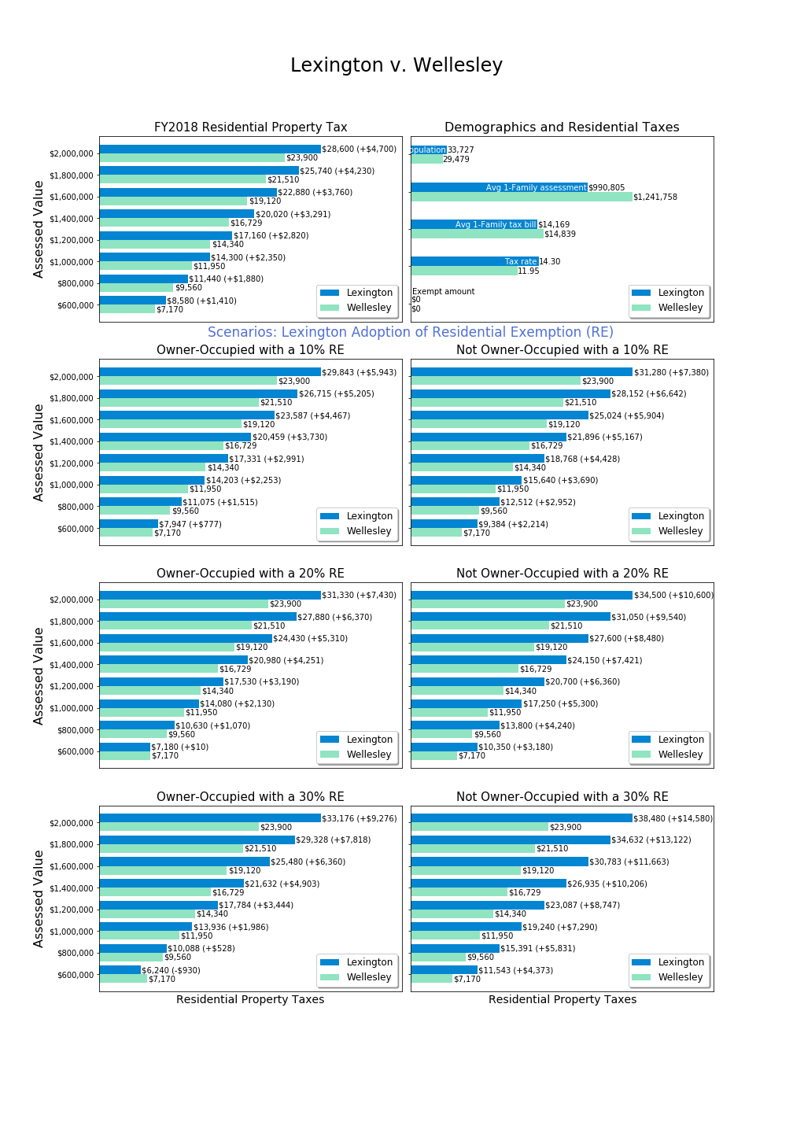

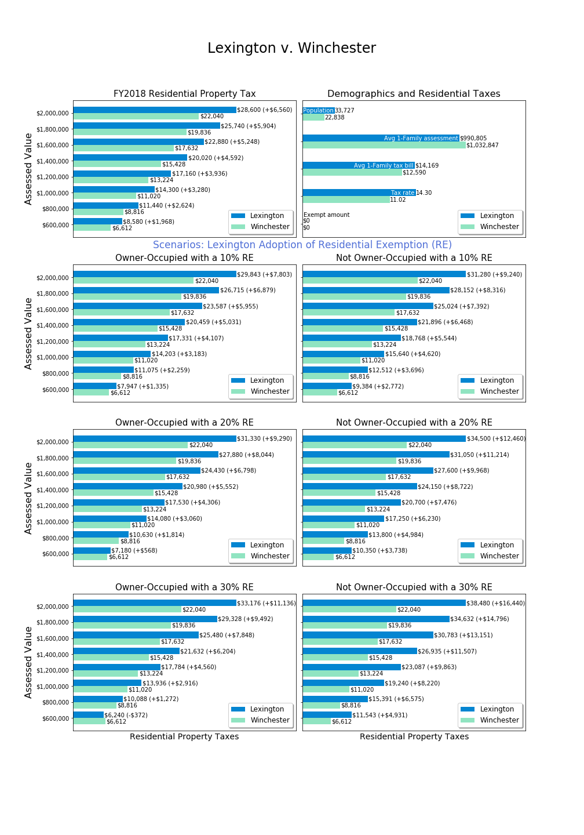

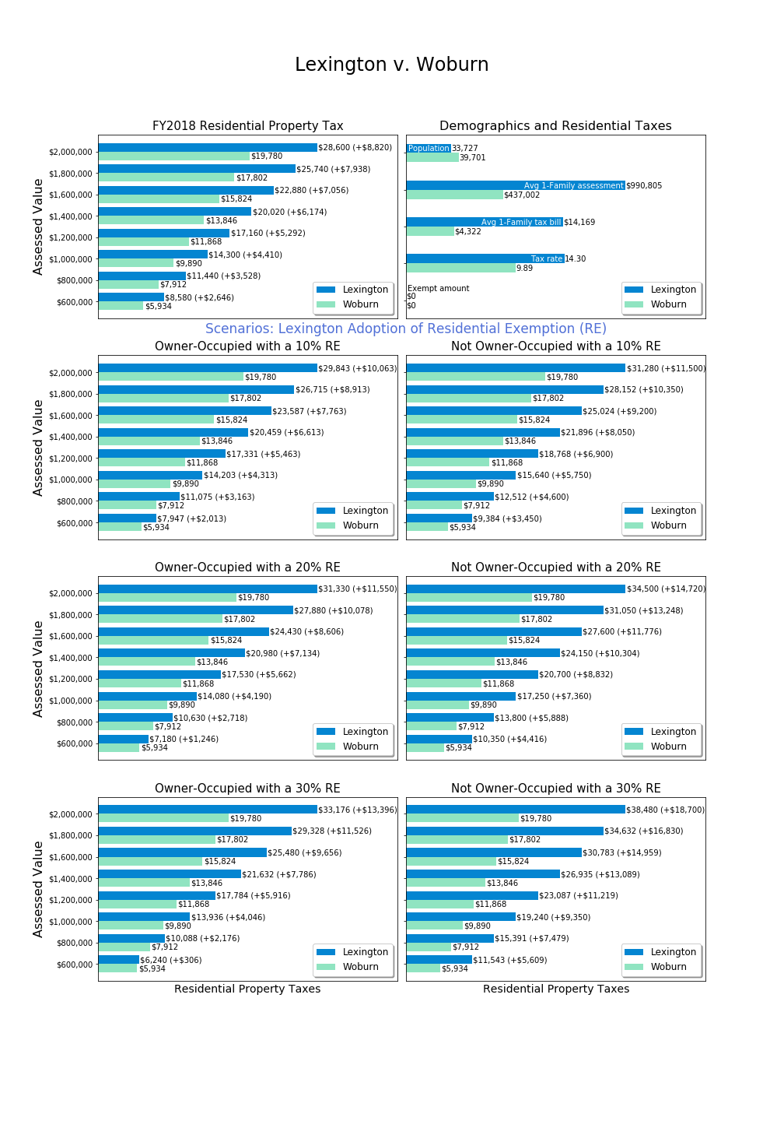

# Appendix: Services, Housing Stress and Emigration Survey

## Survey Executive Summary

A survey of the Lexington community was undertaken to assess key questions for the Residential Exemption: what portion of the community experiences high stress related to property taxes, how property taxes and high stress relate to migration decisions, and whether proposed tax exemptions would benefit members of the community with the greatest need or the least use of services. This appendix considers survey data just as a source of evidence, and by itself, does not constitute a comprehensive assessment of residential exemptions.

1,475 individuals (about 7% of the Lexington adult population) responded to the services and housing stress survey. The survey results provide insights into whether relationships exist between demographic and tax data variables and two central variables of interest: housing stress and the forecasted likelihood of leaving Lexington within ten years (migration). While both of these focal variables describe subjective experiences, the Committee believes the broad outlines of the results provide insight into residential exemption policy.

Per the Committee’s charter, two goals of a residential exemption would be to assist those with high housing stress (especially when property taxes contribute) or to impact decisions to leave Lexington. To discuss measurement of possible policies, we use the conceptual framework of precision and recall.[33] **Precision** is the percentage of those helped by a policy who are in the class of intended beneficiaries. **Recall** is the percentage of all intended beneficiaries assisted by a given policy.

Key Findings:

1. Renters much more often report high housing stress than homeowners.
2. High housing stress is reported at all ages, length of residence, incomes and home values.
3. Income is a better predictor of high housing stress than is home value.
4. Means tested targeting offers higher precision than the State’s Residential Exemption (SRE), but low recall.
5. Renters are more likely to forecast migration than homeowners.
6. Housing stress significantly drives migration for homeowners.
7. Home value and income are not significant predictors of migration for homeowners.
8. Middle aged populations have the highest forecast of migration.

Policy Implications:

1. If rental property owners pass on increased tax burdens from the State’s Residential Exemption (SRE) adoption to renters by increasing rents, it will impact a portion of the community that reports experiencing high housing stress.
2. The SRE is a blunt (low precision) policy and will benefit many individuals with higher income or without high housing stress.
3. The SRE would negatively impact middle-aged members of the community who already have the highest likelihood of migration.
4. A Means-Tested Residential Exemption (MTRE) could offer higher targeting precision, but would provide low recall as few members of the community who experience high housing stress would benefit.
5. Survey respondents across all demographic variables voice concern about high property taxes in Lexington, and residential exemptions should be considered as one potential tool within a broader approach to addressing housing stress. The open responses reported in this section should be read by policy makers seeking to address concerns of residents.

The Committee plans to post survey data and data analysis scripts on the Town website in spring 2019.

## 1. Overview

As part of our goal to gather information on what property tax challenges community members face, the Committee undertook to survey Lexington residents. We designed a survey which would collect information on services, housing stress, and migration plans, as well as demographic information allowing us to correlate responses. Furthermore, we gathered open response comments on two topics, although we ultimately decided not to correlate open responses with other questions because we had not disclosed that intent in advance and sought to protect individual privacy.

The central areas of concern for the Committee in addressing with this survey were:

**Economic and psychological stress**: What role does property tax play in resident housing stress?

**Migration**: Is there evidence that town tax policy impacts migration? For example, are individuals experiencing property tax induced psychological or financial stress more likely to leave Lexington?

**Residential Exemption effectiveness**: Can we estimate the effect of proposed exemption alternatives on either psychological stress or migration?

**Justifiability based on service use**: Can we estimate for proposed exemption alternatives whether recipients of an exemption are heavier or lesser uses or government programs?

**Means-tested estimation**: Can we estimate the number of qualified individuals for a means-tested residential exemption, and better characterize how they are differentiated from the population at large?

As a secondary benefit, we hoped these survey questions would shed insight into resident use of government services, housing stress, and other subjects which residents could raise through open responses.

## 2. Survey Process

The Committee developed and reviewed questions in open sessions. The Committee was interested in ensuring that respondents would be willing and able to answer survey questions, and that the survey questions maintained relevance to purpose.

To measure representativeness of the population as a whole the Committee promoted survey distribution verified by statistical testing. The proposed testing was to align demographic questions with census responses so one could measure whether the survey demographics aligned with known quantities about Lexington, such as age or income.

The Committee reviewed the auspices under which the survey should be conducted. We wanted to avoid asking residents directly whether they would prefer lower taxes (in order to prevent biasing responses to “yes”), and also to maintain a reasonable level of obscurity about how responses could be used. Therefore, it was important that the survey not originate solely from the Committee, yet offer sufficient legitimacy to promote responses.

We sought partnership with other Town committees and departments interested in surveying Lexington, and found that while other surveys are in process, each one has its own timetable as well as varying levels of outside resources. Aligning with committees on different timetables was not feasible as it would delay our research. For the survey, we partnered with the Lexington Recreation Department which was also interested in how the use of recreation resources correlated with demographics. As one of our questions was about resource utilization for affected populations (possible fairness criteria), this partnership aligned well with our mission, provided additional value to a Town department and offered an additional distribution channel, creating an overall “Services and Housing Stress” theme for the survey. Moreover, as the Recreation Department will undertake its own survey in 2019, the results from this survey can be input for further survey construction.[34]

Draft questions were piloted with colleagues and friends, particularly outside Lexington. Piloting provided some feedback and raised some questions for the Committee to address, such as:

What does it mean to receive fire or police services? Is getting directions from a police officer a service? How about being written a parking or speeding ticket? The Committee left this ambiguous in the survey.

Did we need to ask marital status? What did this mean for non-traditional family organization? We decided to drop a question on marital status and replace with size of household.

What was the survey “getting at” in asking about race? Because the survey was themed around services and stress, race did not strike some pilot respondents as relevant, and while there could be insight into subcommunities, the Committee determined it was not central to our line of inquiry and dropped any question on race or ethnicity.

Pilot respondents warned the Committee that intrusive questions unrelated to the theme might cause survey abandonment. Therefore, each question was carefully weighed for the value it would provide versus potential survey abandonment. Because sensitive financial questions are critical to correlation goals, we needed to include some difficult questions. We placed these questions last so we would collect information from respondents who might submit partially completed surveys should bias arise.

Because the State’s Residential Exemption is based on assessed value and not economic means, the Committee had interest in how vacation homes and snowbirding factored into Lexington residency. Did some members of the community declare residency in Florida for tax reasons, and what action would they take if their Lexington property were to be charged materially higher taxes? But the theme of the survey and appropriate length prevented us from including any question which would provide insight into how residency and multiple-property ownership operated.

The Committee also discussed the respondent’s ability to answer questions. Would a less-financially aware respondent (perhaps the household member who does not manage finances) be able to answer questions accurately about market value, assessment, mortgage, property taxes, or insurance? The State’s Residential Exemption is related to assessed value, but except for the most financially astute tax payers, we expect residents do not know their current year assessed value. Do residents know their total housing cost? Would some include cable or water and sewer, while others do not?

Our challenge in surveying these concepts in a clear manner for all residents, led to an innovation and some simplifications. One innovation was to introduce the concept of “housing stress” as an intended catch-all for the economic and psychological impact which monthly housing bills may have on a household. In keeping with our charge to support residents remaining in their homes, we reasoned inclusion of both more objective factors such as forecast migration as well as economic and psychological factors such as ease and stress, was important.

Surveying housing costs is a complex area, and the Committee accepted obvious limitations beyond a respondent’s ability to answer questions. The survey did not ask whether someone with a high housing payment would continue to have it into the future (Are they near the end of their mortgage?). Also, the causes of housing costs are unknown (Is debt required to live in the home, add a new addition, pay college costs, or pay a family member’s assisted care?). The survey asks about monthly housing costs, but does not investigate the origin, purpose, future trajectory, or total liability associated with these costs.

As the Committee was interested in property taxes specifically, we asked what proportion of housing costs are related to property taxes. Combined with market value of a home and monthly payments, these questions can give some insight into whether the respondent’s housing costs are materially driven by property taxes.

The Committee considered how to handle respondents who might not have satisfactory knowledge of core questions around housing payments and household housing stress. The Committee felt that respondents should state that they are “responsible” for housing costs to be included in final data analysis about property taxation. Most data analysis excludes respondents who are not responsible for housing costs in their household.[35]

### Survey Structure

We structured the survey to begin with questions about use of town resources, attempting to set the tone that this survey was not about property taxes specifically. Section two, on affordability, started with questions of interest to the recreation department, such as access to financial aid. The first question central to our Committee’s objective was to inquire about housing stress, and this was followed by an open response question. The open response question thus reveals what respondents are thinking about when asked about housing stress--before the topic of property taxes was introduced (although being a town survey, taxes may come to mind easily).

The survey was constructed using Google Forms. We requested that responses only be submitted by current Lexington residents, but created no residency verification process. We wanted to maximize response rates, so did not request individuals identify themselves, and therefore could not prove that each person answered the survey only one time. The final results were downloaded from Google and processed via Python.

The survey contained the following sections and questions:

**Section 1: Town Services**

All questions start with this phrasing:

In the past 12 months, has any household member done the following?

These are the question numbers for responses:

Q1. Visited the Community Center

Q2. Used town swimming facilities

Q3. Used town recreational fields or courts

Q4. Used Pine Meadows golf course

Q5. Used a school or neighborhood playground

Q6. Used the Minuteman Bikeway

Q7. Used Lexpress bus

Q8. Visited Lexington conservation areas

Q9. Directly received fire or police services

Q10. Attended Lexington public schools

Q11. Participated in any town provided program or service for seniors

Q12. Used Cary library or attended a library event

Q13. Served town government in any capacity (employee, committee member, town meeting member, elected representative)

[Response options:

All questions in section 1 allowed “Yes”, “No” and “N/A” as responses. We provided “N/A” as an option to allow respondents to explicitly skip questions, but we treated those responses the same as blank ones.]

**Section 2: Affordability**

Q1. Are you aware that the Recreation & Community Programs Department offers financial aid for programs and services?

Q2. Has a household member received this type of financial assistance to participate in a program or service?

Q3. If your primary residence is rental, please indicate your monthly rental cost:

Q4. If you own your primary residence, please indicate your total monthly housing payment (mortgage, insurance, property taxes):

Q5. Do you receive a property tax deferral or property tax credit due to limited income?

Q6. What level of stress does your household experience with payment of monthly housing costs?

Q7. Please elaborate or share any additional thoughts. (open response question)

Q8. Thinking about all the costs of living in your owned property or rental (rent/mortgage, home maintenance, condo fees, property taxes, insurance, utilities), what portion of these costs do you estimate is related to property taxes?

Q9. Are you responsible for the housing costs at your residence (i.e. owner or lessee)?

Q10. Are you considering relocating away from Lexington in the next 10 years?

[Response options:

Q3: $0-$1499, $1500-$2999, $3000-$4499, $4500+, N/A

Q4: <$2,000, $2,001-$4,000, $4,001-$6,000, $6,001-$8,000, $8,001-$10,000, $10,000+, N/A

Q6: None, Little, Some, Significant, Substantial, N/A

Q7: Open response

Q8: None, Little (1-25%), Some (26-50%), Significant (51%-75%), Substantial (76%-100%), N/A

Q10: Definitely Not, Unlikely, Undecided - Possible, Likely, Definitely, Have not considered, N/A

Others: Yes, No, N/A]

**Second 3: Demographics**

Q1. Age (respondent)

Q2. Size of household (number of people)

Q3. Disabilities within household (check all that apply)

Q4. Length of time living in town (respondent)

Q5. What type of property is your residence?

Q6. Approximate market property value of your Lexington residence (if owned):

Q7. Please indicate your approximate household income in the past 12 months

Q8. Please indicate how the survey was shared with you (any groups or lists or whether it was forwarded to you.) (open response question)

Q9. Please share any comments to the survey team about this survey. Thank you. (open response question)

[Response options:

To facilitate consistency between our survey with other population measurement tools, we chose demographic brackets used in the United States census via American Community Survey.[36] We made some adaptations to better reflect Lexington’s local population and to target demographics of interest to our focus on head of household decision-making. For example, we combined all age brackets below 30 years old. Similarly, we combined house value brackets below $500,000 because there are few in Lexington’s current housing market. We also split up the highest ACS bracket ($1,000,000+) into 5 novel brackets because of the abundance of houses above that threshold in Lexington. These were exceptions, however; most brackets remained consistent with ACS.

Q1: Under 30 years, 31-39 years, 40-49 years, 50-59 years, 60-69 years, 70-79 years, 80 years and over, N/A

Q2: 1, 2, 3, 4, 5+, N/A

Q3: Checkboxes presented so multiple section possible: with a hearing difficulty, with a vision difficulty, with a cognitive difficulty, with an ambulatory difficulty, with a self-care difficulty, with an independent living difficulty, none of the above, N/A

Q4: Moved in 2015 or later, moved in 2010-2014, moved in 2000-2009, moved in 1990-1999, moved in 1980-1989, moved in 1979 and earlier, N/A

Q5: Single family home, multi-family home, condominium, apartment, other, N/A

Q6: I don't live in a property owned by a family member, Less than $500,000, $500,000-$749,999, $750,000-$999,999, $1,000,000-$1,249,999, $1,250,000-$1,499,999, $1,500,000-$1,749,999, $1,750,000-$1,999,999, $2,000,000 and more, N/A

Q7: Less than $35,000, $35,000-$49,999, $50,000-$74,999, $75,000-$99,000, $100,000-$149,999, $150,000-$199,999, $200,000 and over, N/A

Q8 and Q9 were open response questions.]

## 3. Survey Respondents

Considering the fact that this survey had zero administrative and distribution costs, the Committee conservatively hoped for 400 responses. Expecting a relatively small sample, the Committee did not anticipate nuanced results, and emphasized alignment with census categories for representativeness.

The survey ran over the period October 9, 2018 to November 16, 2018 and netted 1,475 responses. Given the frequent open response comments, one can reasonably interpret that respondents were eager to provide their opinions on local taxes and this was an important survey. Numerous respondents thanked the surveyors for providing an opportunity for them to comment about property taxes and services in Lexington.

During the short period the survey was open, the Committee planned to track distribution channels to ensure broad reach among Lexington residents. We asked each respondent where they heard about the survey, giving us an idea of the primary distribution channels. However, as this was an open response question, the answers contained numerous variations with respect to each distribution path. Advice to future survey designers might be to provide a selection for consistency. This Committee did not select that option because distribution channels were not preplanned in detail, and we anticipated residents would share the survey link among themselves as well.

A few noteworthy adaptations helped ensure widespread distribution:

1. The survey URL was changed to have a town government URL. (Some respondents were put off by unofficial looking URLs, which is not surprising given recent privacy concerns and fake sites.)
2. Posting the survey on the town website provided assurance that it was official.
3. Department distributions (Recreation and Social Services) appeared to respondents as more credible.

One limitation was that the survey never identified which part of the town governance structure had initiated the survey nor the specific purpose for which it would be used. Some residents expressed discomfort or skipped the survey due to vague authority.

The most frequent reported sources for survey receipt were:

|  |  |
| --- | --- |
| Survey source | Count |
| email: email, lex rec, forwarded, email from town, town email, email from lexington human services, email list, email from the town, via email, from lex rec, lexington recreation | 214 |
| facebook: facebook, lexington mavens, mavens | 57 |
| lexington list, lexington listserv, lexington email list, lex list | 38 |
| lexington at home | 9 |
| lexfun | 9 |

*We summed common responses and not the long tail of isolated responses, so these numbers are all undercounted slightly.*

The responses to this question informed us that no single distribution channel dominated.

The question asking whether a respondent has served in town government in any capacity was placed to monitor whether those serving in town government survey would be overrepresented in the responses, in which case it could be argued that political elites are surveying themselves rather than the wider community. The percentage of responses affirming a household member serving in town government was 17%, which reflects the high level of town participation in Lexington but perhaps some over-representation. However, with this modest figure, the Committee feels the survey does represent Lexington in total, rather than principally the views of those in Town Meeting or other committee positions.

We took response representativeness seriously, looking at both the fraction of the Lexington population represented and the distributional similarity to demographic census data. Lexington’s population is about 31,394 residents, and it’s 30+ population is 66% of this figure or 20,720. Of 1,475 responses to our survey, 1,469 were from the 30+ population, or about 7% of the target population. Looking at how representative of the population this 7% sample was, we can look at six demographic questions and compare with known data about the population.

**Age Representation (Q1)**

The following table compares the proportion of survey responses providing age, with age 30+ with the corresponding Census proportion for 30+ year old residents:

|  |  |  |
| --- | --- | --- |
| **Age Range** | **Survey %** | **2017 Census %** |
| Age 30-39* | 9.2% | 12% |
| Age 40-49 | 29.0% | 26% |
| Age 50-59 | 24.3% | 24% |
| Age 60-69 | 16.8% | 17% |
| Age 70-79 | 14.2% | 11% |
| Age 80+ | 6.5% | 11% |
| Total Respondents 30+ | 1,351 |  |

\**Age 31-39 survey*

*Census Source:* <https://censusreporter.org/profiles/16000US2535250-lexington-ma/>

The figures from the housing survey are comparable. The most noteworthy difference is that the 80+ year old population is under-sampled in our survey, relative to the Census proportion.

**Household Size Representation (Q2)**

The table below shows the proportion of survey respondents reporting household size:

|  |  |
| --- | --- |
| **Household Size** | **Proportion of Samples** |
| 1 | 8.3% |
| 2 | 27.4% |
| 3 | 17.4% |
| 4 | 34.4% |
| 5+ | 12.5% |
| Total Respondents Reporting Size | 1,363 |
| Average Survey Household Size | 3.2* |

*\*We assume 5+ has average of 5.2 to construct this average size.*

Census data indicates the average persons per household is 2.8 (<https://censusreporter.org/profiles/16000US2535250-lexington-ma/> (2017 ACS census). Our larger average survey household size may be due to under-sampling of age 80+ years.

**Residency Representation (Q4)**

We have not correlated the length of time in Lexington with Census responses

<https://censusreporter.org/profiles/16000US2535250-lexington-ma/> (2017 ACS census), although it would be possible.

**Home Value Representation (Q6)**

Respondents were asked for their home value. Some may have interpreted this as market value and others as assessed value. We believe market values may be 10-20% higher than assessed values.

We have not gauged representation formally here, although the frequency distribution of responses shows that all segments of home value have representation.

**Income Representation (Q7)**

The following table compares survey responses for income with the 2017 Census:

|  |  |  |
| --- | --- | --- |
| **Income Range** | **Survey Sample** | **2017 Census** |
| < $50,000 | 7.5% | 17% |
| $50,000-$99,999 | 16% | 13% |
| $100,000-$199,999 | 35% | 29% |
| $200,000+ | 41% | 40% |
| Survey Respondents reporting income | 1,154 |  |

*Source:* [*https://censusreporter.org/profiles/16000US2535250-lexington-ma/*](https://censusreporter.org/profiles/16000US2535250-lexington-ma/)

This table suggests the survey under-represents the portion of the community with incomes below $50,000.

**Rent versus Own**

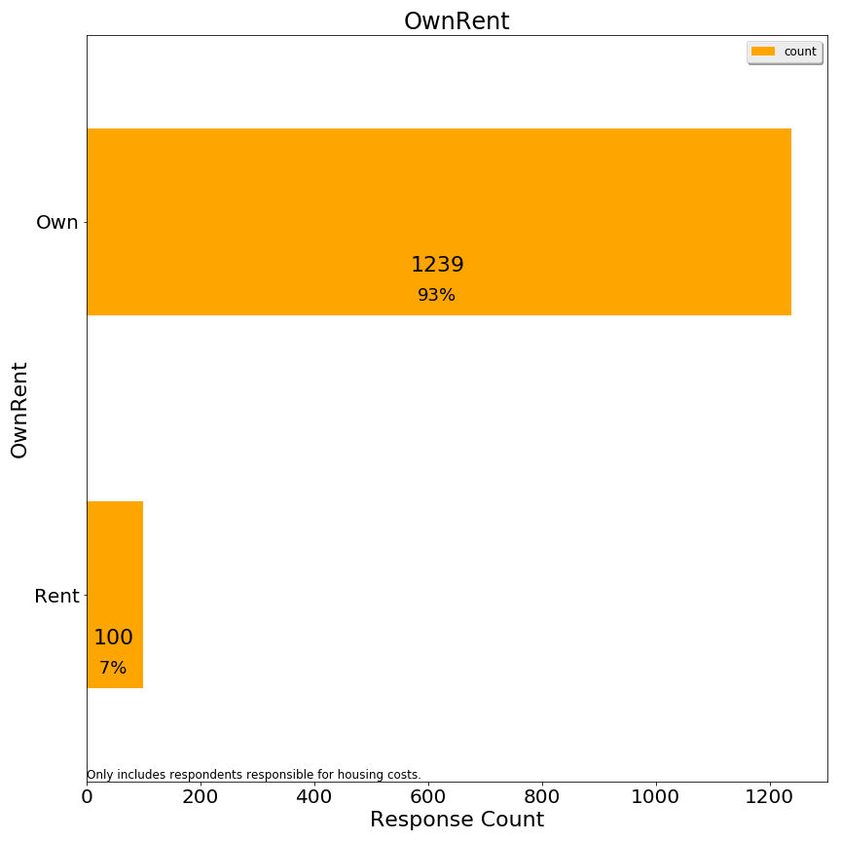

1,339 respondents responsible for housing costs provided data from which to infer whether they rent or own. For survey responses, if monthly rental cost was provided, the observation was recorded as “rent”. If the monthly rental cost was not provided, and the market value of the home was provided, the observation was recorded as “own”. If both fields were blank, then the respondent was not coded with either. The survey suggests 7% of respondents rent and 93% of respondents own.

ACS census data (<https://censusreporter.org/profiles/16000US2535250-lexington-ma/>) reports that 19% of Lexington housing units are renter occupied. However, this is not equivalent to the percentage of population living in rental versus owner units, nor the percentage of the adult population which is being surveyed. It does suggest that the survey under-represents renters to some extent.

**Error Corrections**

Twenty-nine respondents indicated housing costs in excess of $10,001/month and yet had homes valued at under $1.5 million. These cases were re-coded as “ResponseError” since it appeared that the respondent had interpreted the question as annually. For respondents with higher valued homes, this response seemed plausible and so those data were not re-coded.

**Grouping Responses**

For some analyses, grouping responses is helpful to see larger patterns. After preliminary analysis, we grouped some responses to the following questions for some analyses:

Housing Stress: Grouped into Low Stress, Medium Stress, High Stress

Market Value: Lowest two categories combined into one

Income: Lowest categories combined

Age: Youngest two and oldest two categories combined, separately

Monthly Rent: Highest categories combined

Relocation: Grouped into Likely, Unlikely, and Neutral

**Principal Responses**

Because some respondents did not answer every question, we had a choice of imputing missing data or excluding observations which were missing any one key variable.

The Committee elected to only include data in correlation analyses where the respondent was responsible for housing costs. With this constraint, correlation analyses include all observations where both relevant variables were provided. These analyses are split into owners and renters, since these two populations had largely divergent responses.

1,390 respondents answered affirmatively they were responsible for housing costs. These 1,390 observations are the maximum set of observations used to formulate the correlation charts. However, for statistical analyses, only 914 respondents provided an answer to all key variables, and therefore those analyses only used the observations with all variables. No imputation was performed.

## 4. Comparative Charts and Correlation Analysis on Housing Stress and Migration

**Renters and Owners**

The State’s Residential Exemption is an owner-occupied exemption, designed to provide benefits to owners. It has been adopted in cities and resort towns, in both cases shifting tax burden from (often voting) resident owners to non-resident owners. For vacation homes, non-resident owners absorb a tax increase, while for rentals an owner may attempt to pass through the rental increase to renters.

In analyzing the full impact of a State Residential Exemption would have for Lexington, the Committee included both owners and renters. Stereotypically, renters have lower asset levels than owners, and one should examine how the State Residential Exemption would impact renters.

### 4a. Housing Stress in the Survey

A key finding of the survey is that renters express high housing stress more consistently than owners, at all age and income levels:



*%=percent within categories owning or renting indicating high stress*

|  |
| --- |
| *A note on interpreting single color* *horizontal bar charts on stress and migration:*  For charts which only display “high housing stress” or “high migration likelihood”, we show a subset of all responses categorized by the y-axis label. The values in these charts reference the percent of respondents who meet the criteria displayed in the title (in the case above “high housing stress”) for each group. Thus, 58% on the renter bar means 58% of renters report high housing stress, and the other 42% are not shown in the bar chart. The other 42% is not shown since it obscures the ready perception of the horizontal bars.  Thus, the percentages shown do not add up to 100% vertically, but instead reference each category separately adding up with an unshown opposite response to 100% horizontally.  (Chart percentages are reported differently than frequency distribution bar charts where the percentages add to 100% vertically. A later note on stacked bar charts clarifies the color schema and grouping for stress and migration.) |

Housing stress may vary across subclasses of owners, but is less frequent than among renters in every case. For example, housing stress among owners is higher for those in lower value homes, but well below the frequency of housing stress among renters:

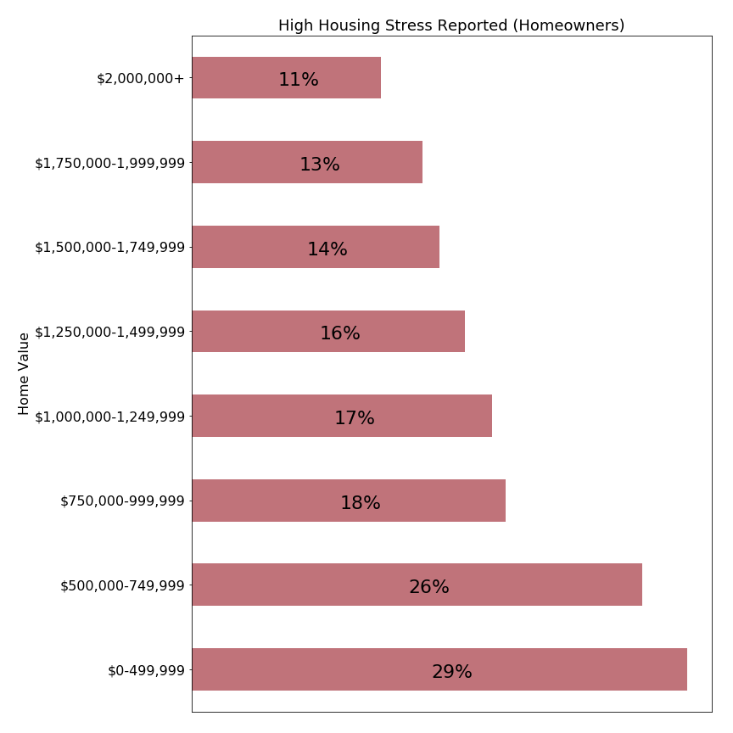

*%=percent within categories owning or renting indicating high stress*

One explanation is that renters may be stressed knowing that many are not in permanent situations. It must be incredibly stressful to be paying $3000/month in rent and trying to save for a down payment on a permanent property while housing prices escalate at high rates.

In the context of these results, policy makers considering adopting the State’s Residential Exemption should consider the social effects of potentially transferring a tax burden from owners to landlords providing housing to renters. Nationally, renters typically have lower total assets than owners, and the United States policy of subsidizing owners over renters (such as the federal home interest deductions) has been heavily criticized in recent years.

**Housing Stress versus Home Value**

Within the class of owner-occupied homes, the State’s Residential Exemption is a progressive tax which shifts tax burden from those with homes below the breakeven point (about $1,150,000 in FY2019 in Lexington) to those above that point. Our survey can help answer whether the transfer of taxes is shifting from a more burdened to less burdened population.

Again, reviewing the relationship between home value and housing stress, we see that housing stress is more often reported for those in lower valued properties:



|  |
| --- |
| *A note on interpreting stacked horizontal bar charts on stress and migration:*  Colors: colors have been chosen to represent levels of the parameter being measured, in most cases “housing stress” or “forecast of intent to move”. Stress and intent to move were measured on a five or six point scale, but these are grouped into adjacent categories so an easily interpreted using a three color scheme.  Stacked bars: Each row corresponds to the entire number of respondents meeting the criteria labelled on the left (100%). A colored bar is shown with area proportionate to the respondents in that category (percent). Below the primary label showing the percent value is an integer value, representing the actual number of respondents. This actual number can be used to interpret the significance of the finding, as small counts (<20) have less reliability than higher number counts.  Interpreting percentages: these charts indicate the frequency with which respondents report a sentiment of the questioned intensity, which is different from the intensity. The language in the report uses the term “frequency” to reference how often respondents indicated an issue. For example, in the chart above 29% report “high” levels of housing stress. But while high levels of housing stress are reported more frequently for lower market values, we cannot conclude that the housing stress is higher than those occupying more expensive homes, and we can see that in no case do all members of a given category experience high housing stress. |

How can this chart be used to understand proposed residential exemptions?

First, we note that Lexington has a high level of owner-occupancy, and therefore adopting the State’s Residential Exemption would largely transfer tax liability from those who own lower valued properties to those who own higher valued properties.

Survey responses indicate that 17-29% of homeowners with homes valued at under $1,250,000 report high housing stress. A residential exemption benefitting this all homeowners with houses valued at or below that point would have a relatively low precision, as three out of four beneficiaries did not report high housing stress. Such an exemption would be funded by homeowners with properties above $1,250,000, where 11-16% report high housing stress. While this is a smaller percentage than the lower value homes group reports, the number of respondents reporting housing stress remains significant. A transfer of tax burden on to this population might exacerbate the high housing stress which already exists for some households.

Policy makers should also recognize that the impact of a tax shift could increase the extent of housing stress among high value property owners more than it provides relief to those with lower valued properties. A property owner with a $2,000,000 property would experience a property tax increase approximately double the tax reduction experienced by an owner with a $600,000 home. The survey does not directly measure how this shift would be experienced by either group.

**Housing Stress by Income: Owners**

Unlike the State’s Residential Exemption, means-tested residential exemptions include an income criterion to target residents who have demonstrated need. The chart below visualizes the relationship between income and housing stress of our survey respondents:



Homeowners with income below $50,000 report housing stress in 52% of responses, almost as frequently as responses from all renters. The second subset, those with incomes between $50,000-$74,999 report high housing stress in 32% of responses, a rate more frequent than in any market value category (see previous chart). Comparing this chart with the prior chart comparing home value versus housing stress suggests that including an income criterion for a residential exemption could better target residents with high housing stress than relying on home value alone.

The Massachusetts Circuit Breaker provides assistance below an income cutoff of $58,000 for individual and $88,000 for married filers. These charts suggest that Lexington residents below those income levels report housing stress more frequently than those above those thresholds. However, at those thresholds only about one in three residents report high housing stress.

High housing stress is reported among Lexington residents at all levels of income, so an income based cutoff cannot ensure property tax relief to all respondents stressed by monthly housing costs.

**Housing Stress by Income: Renters**

The State Circuit Breaker and some matching programs offer tax relief to renters. How well does income correspond to high housing stress for renters?

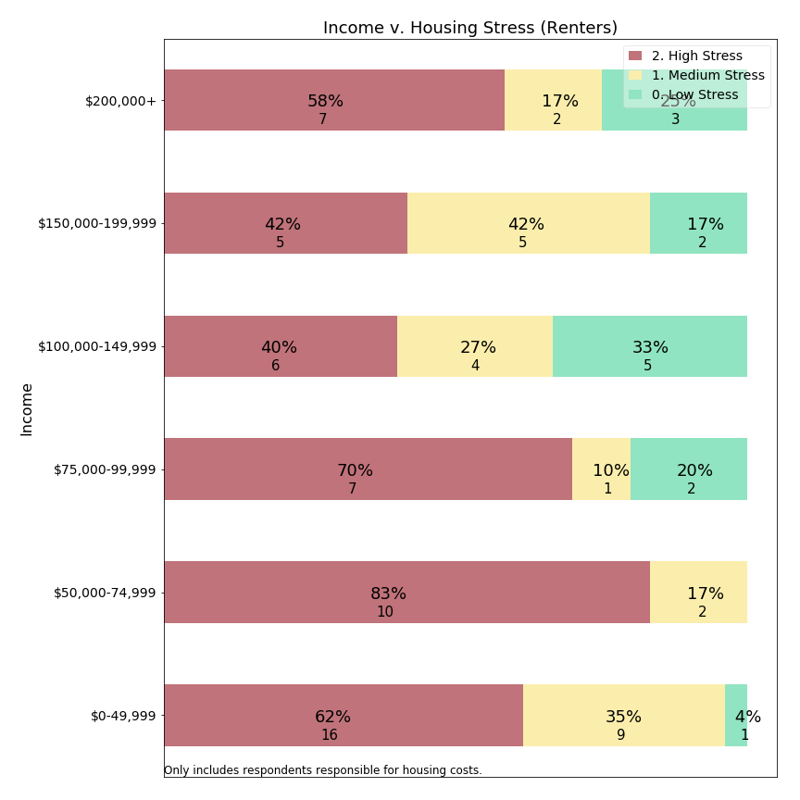

At first glance, it appears that high housing stress is prevalent for renters across all income levels. Moreover, except for a single respondent, all responses for renters earning under $75,000/year indicate high **or** medium stress. The data suggests housing stress is more consistently experienced among lower income residents than other residents.

A second observation is that some low-income individuals live in rent-controlled properties and therefore may have lower housing stress due to controls. This chart does not pull out respondents with rent controls separately. Our survey did not ask for rent-controlled unit residency status among renters.

This chart suggests that creating meaningful means-tested programs for renters may be difficult, and reminds us that policies which shift tax burden from homeowners to renters may adversely affect residents frequently reporting housing stress.

**Housing Stress and Monthly Rent: Renters**

Renters may have greater clarity about their overall housing costs, as capital costs, property taxes, water and sewer, and home maintenance are wrapped into a single rental tax presented by the property owner from whom they rent. While a renter may not know how property taxes factor into their monthly rent, they can report monthly rent and housing stress.

Moreover, the State income tax and Circuit Breaker calculations offer financial credits in relation to rent. For example, the Massachusetts Circuit Breaker compares 25% of a resident’s rental cost to 10% of their income. A means-tested exemption could use the same basis, which suggests the survey should address the relation between monthly rent and housing stress:

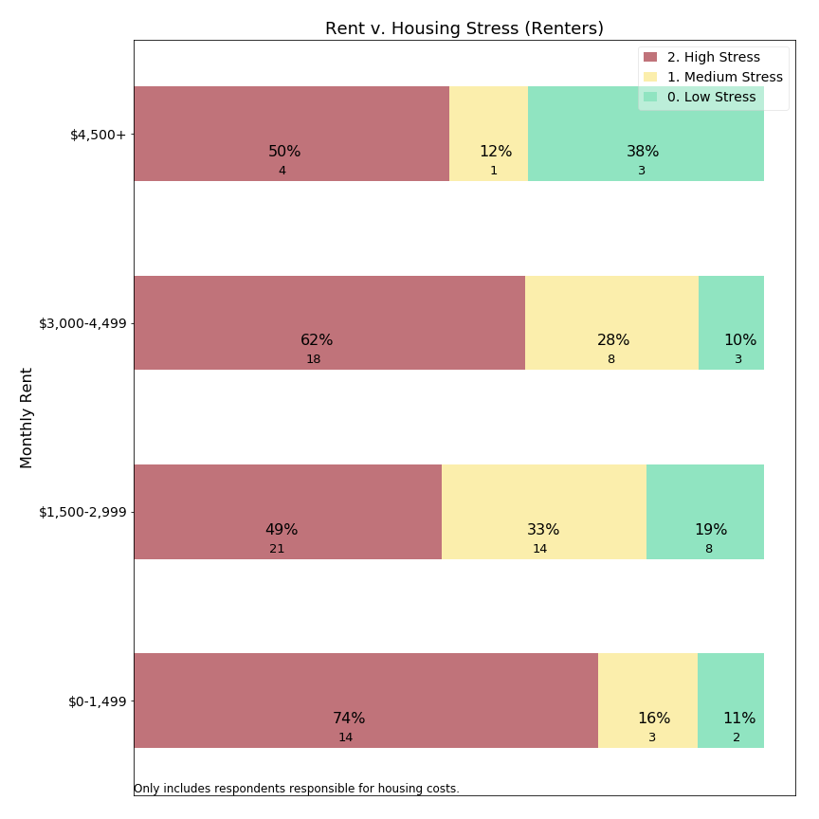

Our data suggest that housing stress levels are high, but fairly consistent across rental levels.

An interesting point of focus is respondents reporting rents below $1,500/month. This group has pervasive high stress levels, but also is renting at below market rates (unless simply renting a bedroom in a home--a rental arrangement not distinguished within our survey). This relationship suggests that households living in affordable housing are frequently reporting high housing stress. It may be that this lowest tier is immune from property tax burden shift, as residents in affordable housing are protected by regional rent controls.

**Housing Stress and Age: Owners**

Concern for Lexington’s senior population contributes to local interest in residential exemptions. Further, survey open response comments (below) explicitly mention retirement and fixed income as factors in relation to property taxes burden. The next chart visualizes the relationship between age and housing stress:



Considering both high and medium stress levels, it appears that the ages with most frequent housing stress are 30-59 year olds. Respondents between ages 60-79 reported less frequent housing stress, presumably because some households have moved past child care costs, mortgages and college bills. A small uptick may be occurring around 80+, but with limited statistical significance and with less frequent high housing stress than 50-59 year olds. The survey data suggests that housing stress may be experienced at all ages of the population, and does not provide statistical support for age-based criteria in means-tested residential exemptions.

**Housing Stress and Age: Renters**

The survey also allowed us to examine the relationship between housing stress and age for renters:

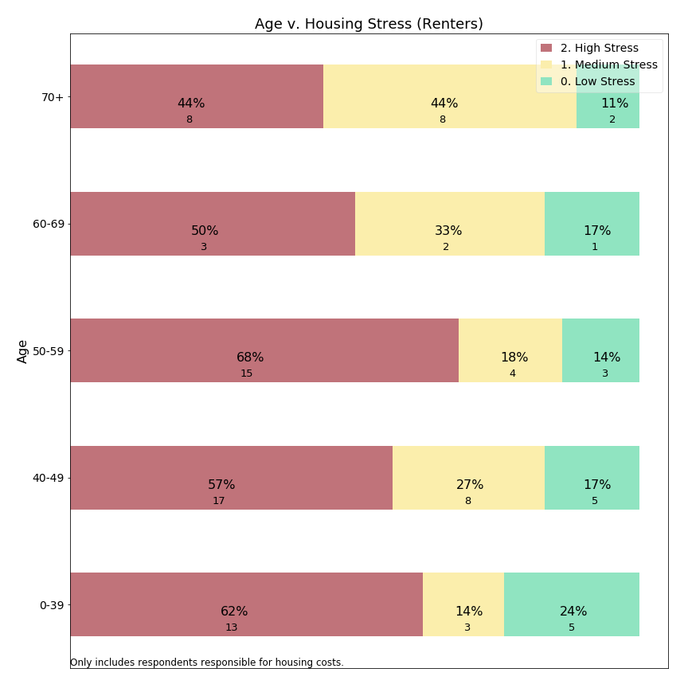

Renters in all age groups report high housing stress in half or more responses. For the oldest group, there could be a small decrease in frequency of high stress offset by responses of medium stress levels.[37] As with owners, our survey data do not support a age criterion for a means-tested exemption.

**Housing Stress and Time in Lexington: Owners**

Another criterion used for eligibility in means-tested residential exemptions is length of time in town. Therefore, we use the survey data to ask about the relationship between time in town and housing stress:



Survey data suggests that residents who have recently purchased homes in Lexington report housing stress most frequently. As these residents may have just assumed significant mortgages along with continuing housing inflation, they may have greater debt burden than more established residents.

While we do not observe that property taxes are causing this housing stress, we can state that housing stress survey data does not support a residency requirement typically included in means-tested residential exemptions.

**Housing Stress and Time in Lexington: Renters**

Similarly, the survey allowed us to examine the relationship between tenure in Lexington and housing stress for renters:

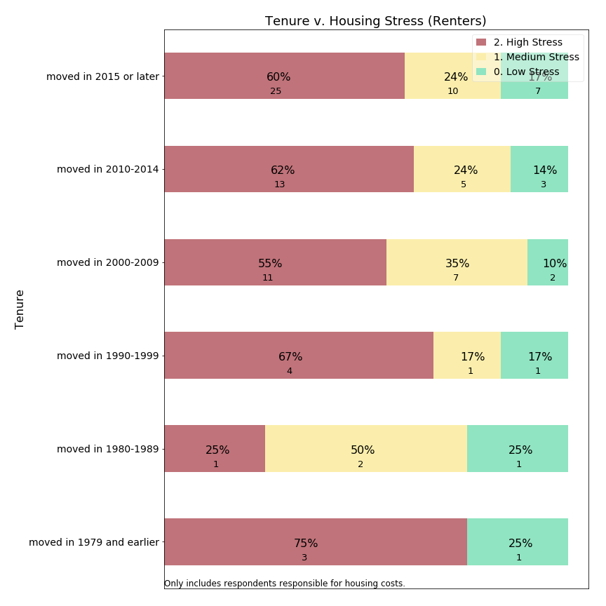

As with the prior metrics, renters express high housing stress at all lengths of tenure. The one exception appears to be renters who have lived in Lexington since the 1980s, but this group is too small to support a statistically significant departure from the larger group of renters.

**Housing Stress and Means Testing**

A typical Massachusetts means-tested exemption targets aid at residents who meet multiple criteria: senior age, low income, ten year residency, lower home value, and without “excessive” assets. Data from the survey can be used to ask whether residents meeting “Sudbury-like” criteria express high housing stress more frequently than do those who would be disqualified by one or more of the eligibility criteria. The survey responses only align with those criteria approximately because the survey thresholds were selected to match common census categories, which differ somewhat from thresholds listed in Sudbury’s “Senior Means Tested Exemption”. Furthermore, the survey request information about financial assets, nor does it ask whether the homeowner’s primary residence is in Lexington. The following table describes how Sudbury’s policy thresholds compare to the approximations we have used with regard to the survey data:

|  |  |
| --- | --- |
| **Sudbury Criteria[38]** | **Survey Approximation** |
| Age >= 65 | Age >= 60 |
| Circuit breaker income, i.e.:  $86,000 joint,  $72,000 head of household,  $57,000 single | Income <= $75,000 |
| 10 year residency | Tenure since 2005 (13 years) |
| Assessed home value < $799,600 | Assessed home value < $750,000 |
| No “excessive assets” | [None] |
| Primary residence Sudbury | [None] |

Concord’s experience with a means-tested exemption is that only about a quarter of those eligible for the State Circuit Breaker received a local exemption. Therefore the survey approximation includes more residents than would ultimately qualify and may understate housing stress.

By approximating “Sudbury-like” qualifications from our survey responses, we can compare those who meet all four criteria above (code=1) to those who did not (code=0) with respect to housing stress:



Among owners, those who met the survey means-tested approximation reported high housing stress 42% of the time, as compared with 17% of those who did not meet all the criteria.

The absolute response counts, however, lead us to a point we will develop further below: a means-tested residential exemption may have higher precision (42% of those targeted have high housing stress) than the prior series of charts (e.g. owners’ stress with regard to income, age, home value), while it would have a lower recall (30 respondents reporting high housing stress met the means-tested criteria compared to a far larger 191 respondents who did not meet all the criteria). If we had been able to include an asset test as well, one would expect precision to improve further, while recall would decline.

**Precision versus Recall, a Conceptual Framework**

As illustrated in the example above, shaping policy parameters forces us to acknowledge and evaluate trade-offs between reaching all community members who need assistance and not providing assistance beyond those with need. The concepts of precision and recall help us examine that trade-off. **Precision** is the percentage of those helped by a policy who are in the class of intended beneficiaries. **Recall** is the percentage of all intended beneficiaries assisted by a given policy.

The stacked bar charts presented above illustrates this inherent trade-off between precision and recall in the context of high housing stress among survey respondents who either would or would not qualify for a “Sudbury-like” means tested exemption. We make this evaluation by considering how each variable relates to housing stress and which portion of the population would meet the criteria. We imagine which groups would be included or excluded by adjusting inclusion criteria (e.g. adding an asset test, changing the age threshold).

A technical way to visualize these policy choices is to plot precision-recall curves. Before doing this, we need to make explicit an assumption this Committee has made about the target population and our “housing stress” proxy variable.

Assumption: high housing stress is the portion of the population we are trying to target with our residential exemption policy choice. In the charts above, we assume a purpose of adopting a residential exemption would be to alleviate housing stress. We do not distinguish among sources of housing stress (mortgage, maintenance, property taxes) but try to understand whether those experiencing high housing stress could be assisted with tax relief.

In an ideal scenario, each resident would report accurately and honestly whether they experience housing stress, and only those actually experiencing housing stress would receive assistance. But because stress is a subjective concept, typical public policies would use a more objective proxy and offer assistance in relation to this proxy variable. Thus, we represent a survey response about housing stress as “ground truth” and the proxy variable in question as a “classifier” and we evaluate which classifiers provide the best predictors of ground truth.

**Precision** = percent of beneficiaries who have high housing stress

If 18% of home owners report high housing stress, Lexington could achieve a precision of 18% simply by offering financial assistance to any random subset of homeowners. The objective of a residential exemption should be to offer tax relief in a more targeted manner, significantly improving on an 18% random sample.

**Recall** = percent of those with high housing stress who are beneficiaries

If Lexington were able to offer tax relief to all residents, then 100% of those with high housing stress would be addressed. But if a random 10% of residents were selected for tax relief, then only 10% of high stress residents would receive aid, a recall of 10%. The objective of a residential exemption should be to offer sufficient recall that residents believe the program is meaningful and worthwhile in comparison to its implementation cost.

**Precision v. Recall Curves**

Each of the variables evaluated (home value, income, age, tenure) offer a distinctive trade-off between precision and recall in identifying those with high housing stress. Considered separately a policy maker could select a cut-off for each variable and use that cut-off to determine an optimal trade-off between precision and recall. Comparing these curves is useful in helping policy makers determine which criteria provide the most targeted means to address housing stress in the community.

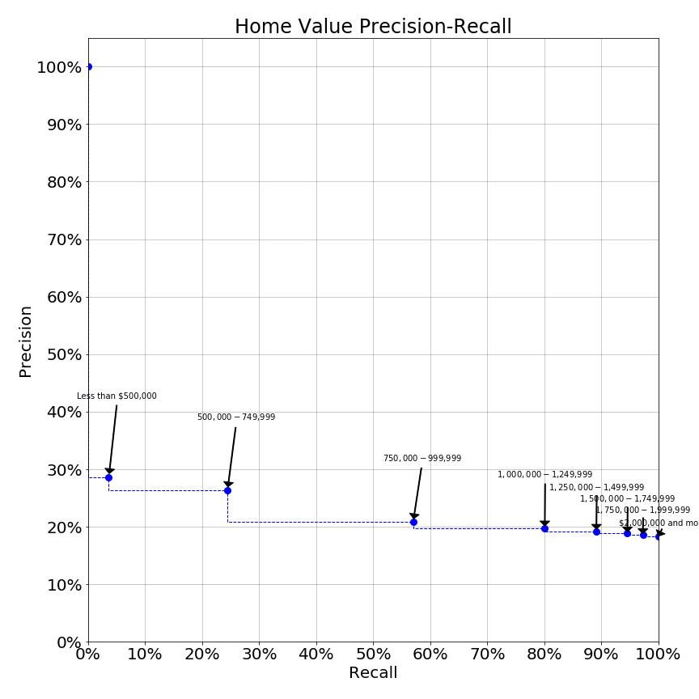

*Note on Precision-Recall Curves*

Each chart shows trade offs between precision and recall for the variable listed in the title of the chart.

Annotated points correspond to survey thresholds which could be used for policy cut-offs. Each potential cut-off has a separate balance of precision and recall, shown as the plotted point. Dotted lines provide rough connectors and are not represented by survey questions.

Ideal public policy would be represented by a curve offering high precision and recall simultaneously.

The home value precision-recall curve shows that an exemption policy targeting those with home values below $500,000 would have a precision of 29% (see corresponding stacked bar chart above) but the recall (% of high housing stress respondents reached) would be under 5%. Increasing the home value inclusion threshold to $750,000 greatly increases the reach (recall) of the program while only slightly diminishing targeting precision. Further increases in the threshold beyond $750,000 degrade precision such that the program would not be much better than random sampling of the population. Thus this curve would suggest that the SRE (which may benefit those up to ~$1,200,000) is correctly labelled a blunt instrument, but in fact appears to be only slightly better than random.

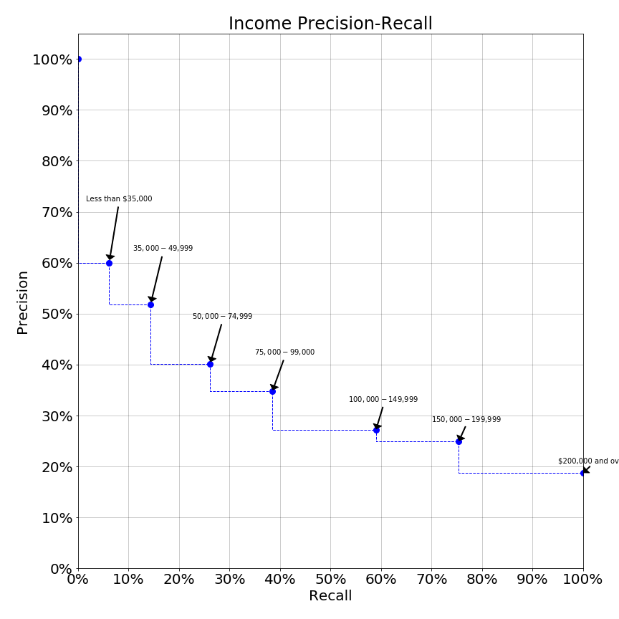

In contrast, the income precision-recall curve is significantly sloped. Here, we see a curve which offers significantly higher levels of precision at a variety of thresholds. At income levels up to $50,000 an income exemption would have precision over 50%, such that over half the beneficiaries have high housing stress. Yet at the $50,000 income threshold only about 15% of the population in need would be reached. Raising the income inclusion threshold to $75,000 reduces precision to 40% while expanding recall to one-quarter of those in need. While both precision and recall at either $50,000 or $75,000 income levels might not be as high as one might desire, use of precision-recall curves quantifiably demonstrates the superiority of income as an eligibility criterion over house value. These charts demonstrate why a state residential exemption may be viewed as inferior to a means-tested residential exemption.

Other variables we examined produce precision-recall curves which indicate they would make poor inclusion criteria:

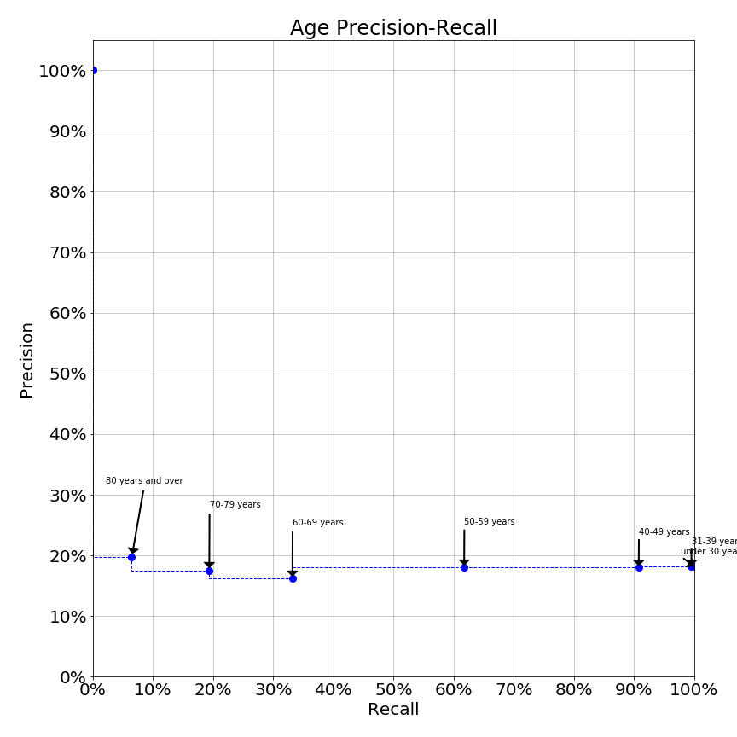

The age precision-recall curve suggests that some age thresholds may in fact perform worse than random selection (18% precision). Yet, means-tested exemptions often include age criteria for eligibility.

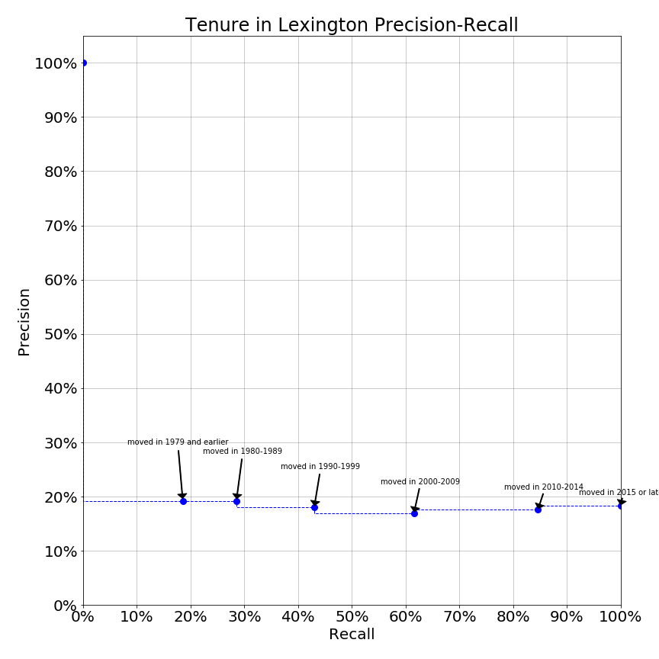

The tenure in Lexington precision-recall curve also suggests that length of time in Lexington provides no value in classifying residents’ high housing stress. Again, means-tested exemptions often include residential tenure as an eligibility criteria.

**Housing Stress and Monthly Housing Costs: Owners**

Lexington homes range in value from condominiums as low as approximately $500,000 to single family homes priced as high as $3,000,000. Individual assets vary, as some owners purchase homes outright while others have substantial mortgages. The survey data can shift from home value to monthly housing cost, and determine whether housing costs drive perceived housing stress:

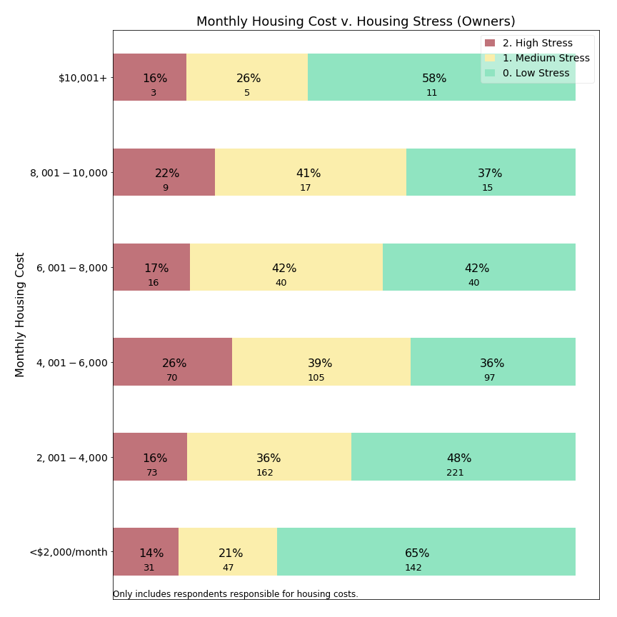

It appears that housing stress is similar across a wide range of monthly costs from $2,000 to $10,000 per month. Among the handful of residents paying more than $10,000 per month, housing stress may occur less frequently. A caveat is that some individuals in the $10,000+/month group were excluded from our this examination due to what appeared to be response errors explained earlier in this appendix, and these individuals registered high stress more frequently. Among those paying less than $2,000/month in total housing costs, suggesting no mortgage and modest property taxes, residents less often reported housing stress.

**Housing Stress and Property Tax Percentage: Owners**

One way to look at whether property taxes relate to housing stress is visualizing the relationship between property tax share of housing costs and housing stress:

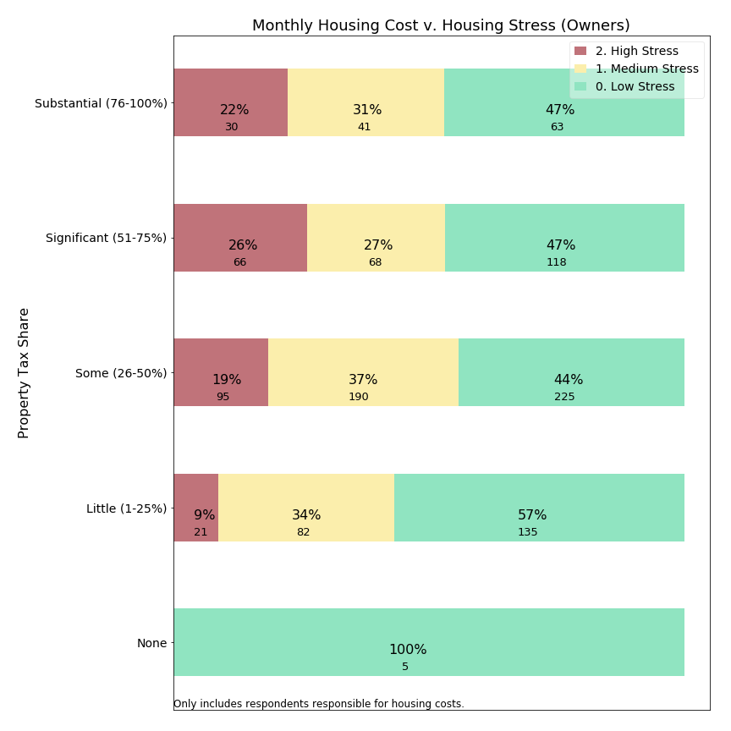

Among respondents reporting property taxes in excess of one-quarter of their housing costs, similar high stress levels exist to the general owning population. However, for those for whom property taxes are less than one-quarter of the monthly housing bill, high housing stress is reported only 9% of the time, or about one-half the rate for owners in general. This suggests that homeowners might be less stressed when property taxes are only a small portion rather than the dominant portion of their housing costs.

### 4b. Migration in the Survey

The Committee’s charge to support residents remaining in their home not only covers stress, but also whether residents appear “forced out” of Lexington. The survey asked whether the respondent is considering relocating from Lexington in the next 10 years. Arguably this is a subjective forecast, and actual migration occurs due to changes in life circumstances (such as employment relocation, marriage, grandchildren, divorce, limited mobility or injury, and death of a partner) at least as much as due to property tax burden. These questions measure whether the respondent gives serious thought to leaving Lexington, rather than whether they actually will move away. Moreover, a decision to migrate by itself might not indicate the respondent feels “forced out”. The sections below examine whether respondents forecast departure in the next ten years, using the term “migration” in charts for this subjective prediction.

**Migration versus Owning and Renting**

As we have seen, the largest divide in housing stress is between owning and renting. Given the transaction costs of home ownership, it should not surprise us to see a divide in migration as well:



Perhaps the most surprising aspect of this chart is that one-third of owners indicate intent to depart Lexington in the next ten years. Given actual migration patterns, which include moves due to unanticipated circumstances, this figure might seem higher than expected. What is driving half of Lexington’s renters and one-third of it’s owners to forecast migration? Is it related to property taxes?

**Migration versus Housing Stress**

If property tax burden can affect migration, then we should expect to detect a relationship between monthly housing stress and migration intent. Some individuals with high monthly housing stress might seek to leave Lexington to reduce housing stress. Alternatively, it is possible that even residents with lower levels of housing stress might forecast departures of Lexington to earn a better return on their housing assets. A $10,000 property tax differential between Lexington and Cambridge, for a similar priced home, could simply tip the scale.

Below is the relationship between housing stress and migration in survey responses:



For owners, the survey data shows a strong relationship between monthly housing stress and whether respondents are considering migration from Lexington. For those experiencing significant or substantial levels of housing stress, over half are likely to depart Lexington. (We assume causal direction from housing stress to migration.)

Is there a similar relationship between housing stress and migration for renters?

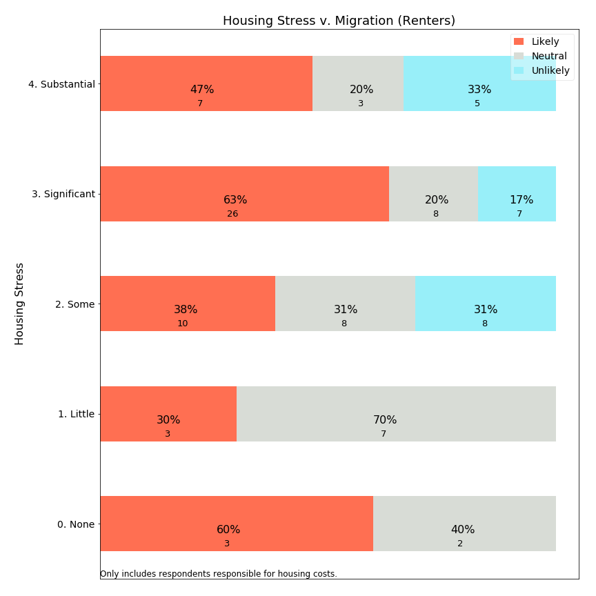

Discerning a pattern for renters is hindered by the small number of respondents for most level housing stress. Renters reporting significant housing stress are a sizeable group, however, and almost two thirds of them are likely to move away. Unlike home owners, renters may have lower transaction costs in changing housing and are able to migrate in response to service and cost considerations. It could be that higher migration is typically expected for renters, and rents respond more quickly to compensate renters for Lexington’s relative value in the rental market.

**Migration versus Home Values: Owners**

The SRE provides relief to owners of lower value homes. Is this group of residents more likely to migrate?



The survey data suggests that those living in lower valued homes forecast migration at slightly *lower* rates than those with medium or high value homes. If forecast migration rates are lower for those in low value homes, then survey data suggests raises doubt about whether a residential exemption protects residents from being forced out of Lexington.

**Migration versus Income (owners)**

On the other hand, a means-tested exemption would use income as a criteria. Are lower income owners more likely to migrate out of Lexington?



The survey data suggests that migration forecast is highest in the $50,000-$74,999 range and slowly declines with increasing income. While not a strong relationship, a means-tested exemption reaching up to $75,000 would benefit those in this subgroup. We cannot predict whether that benefit would change their migration choices.

An interesting exception to the general trend presented in this chart is respondents with income under $50,000. This group forecasts a lower likelihood of departing. Is it possible that some of these residents are in affordable housing and unable to realize similar value elsewhere? Alternatively, do their financial circumstances (including transaction costs associated with moving) make it difficult to leave, so that rather than being “forced out” they are “locked in” involuntarily?

**Migration versus Income (renters)**

Means-tested exemptions can provide tax relief to renters based on income. What does the survey data show about income versus migration forecast for renters?

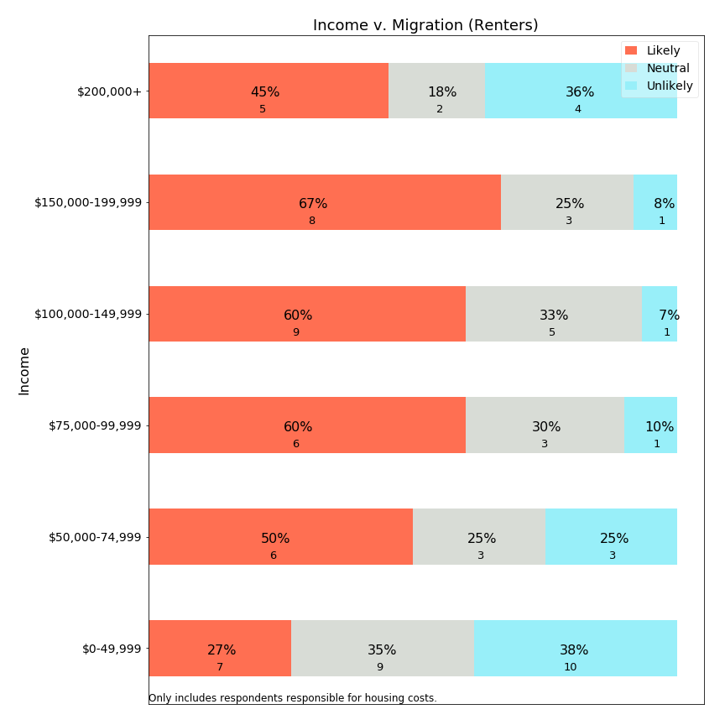

It appears that migration likelihood increases with income until $200,000, while the small sample above $200,000 may elect to continue renting in Lexington--though these sample sizes are quite small. At the lowest income level, renters may be much less likely to migrate, however. A review of affordable housing limits ($51,150-$78,900 for households sized 1-5), suggests that some portion of this group may reside in affordable units with rent control. Beneficial rent control could support a renter staying in place for a longer time.

**Migration and Monthly Rent (Renters)**

If low income renters forecast migration less frequently, is that pattern repeated when examining monthly rent?

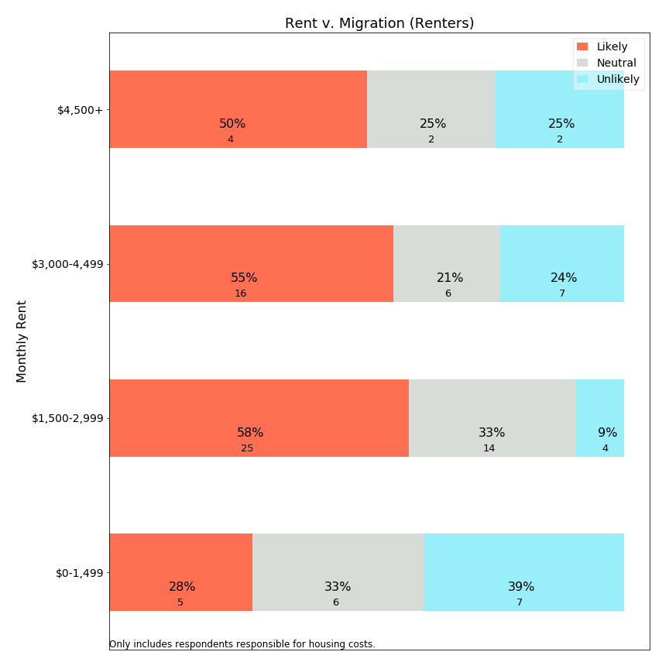

Yes, examining the relationship between rent and migration, we see a dramatic drop in migration expectations for renters with rents below $1,500/month. Because rents at this rate would typically be rent controlled (affordable) or only a room in a house,[39] it appears that renters in affordable housing are more likely to remain in Lexington than those with higher rents. This finding is particularly interesting because we (earlier) found that housing stress is higher for those with lower rents.

**Migration versus Age: Owners**

The Committee examined whether senior citizens are being forced to leave Lexington. Below is a visualization of age versus forecast migration:



The survey identifies that owners in the range age 50-69 forecast the highest likelihood of relocating from Lexington. Especially troubling is the 50-59 age category, where about half of residents indicate high likelihood of leaving Lexington in the next 10 years. For those educating their children in the public schools, this age group represents those typically with older children who can expect to complete public school education in the next 10 years. This age cohort is also planning retirement and determining whether Lexington is a community in which they could remain through retirement.

As expressed in comments to this Committee (see Public Hearing appendix and survey open-ended responses below), many community members are frustrated that so many residents would educate their children in the public schools and then quickly leave. This 50-59 cohort is valuable to keep in town, as they would typically have the financial resources to contribute to town budgets while they continue to earn income. A poorly designed residential exemption could have the effect of “pushing” this vital age cohort out of Lexington, or ensuring that the half who are likely to leave will leave. While the SRE is designed to benefit those in smaller homes, it is unclear whether the 50-59 year old population is living in those homes. Moreover, most means-tested implementations, like the State Circuit Breaker, have a minimum age of 65 and offer no benefit to the 50-59 year old respondent. Data from the survey suggests that, if Lexington has a migration “problem” among homeowners, it is across the 50-69 year age range. It is possible that neither type of residential exemption would benefit this population of mobile professionals, and could increase motivation for them to leave Lexington. Further study beyond this Committee’s work may be needed to understand migration motivations for this specific population.

**Migration versus Age: Renters**

While renters are more transient than owners, what does the survey data tell us about the relationship between age and forecast migration?

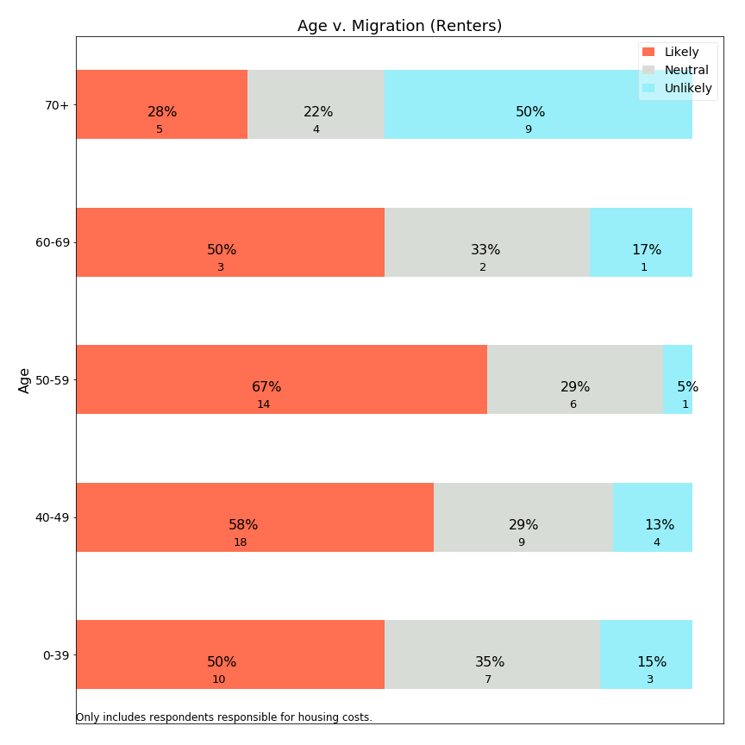

As with owners, higher forecast rates are seen for renters aged 50-59. High rates of mobility exist for all ages, except the 70+ age population which shows a decreased intention to leave. These charts suggest that seniors are not being “forced out” of Lexington, or that those reaching retirement age assess their financial resources before deciding to remain in Lexington through old age.

**Migration versus Time in Lexington: Owners**

Means-tested exemptions often include a residency requirement. What does survey data tell us about the relationship between residency length and forecast migration?

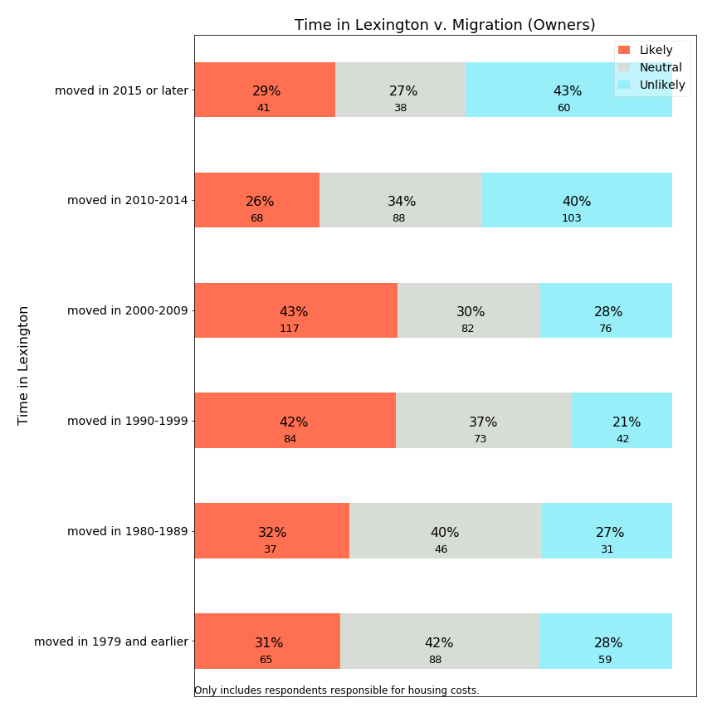

Not surprisingly, the most recent owners in Lexington forecast the lowest rate of planned migration. Those who have just arrived plan to stay. Those who entered Lexington between 1990-2009 forecast the highest rates of departure. This may correspond to the age range charts shown earlier and include many residents who may have entered Lexington for education of their children and are now considering next steps as retirement approaches.

**Migration versus Time in Lexington: Renters**

How does time in Lexington relate to migration for renters?

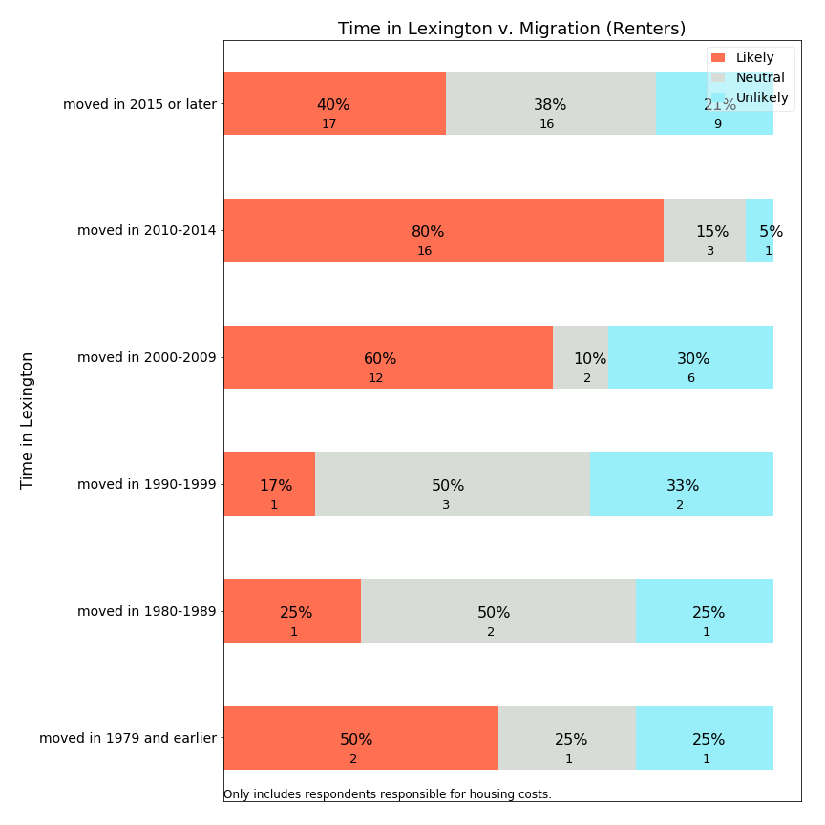

The majority of renters entering Lexington from 2000-2014 expect to leave Lexington in the next ten years. In contrast, those who have been living in Lexington for more than twenty years and are presently renters are more likely to continue living in Lexington--but these long term renters are an extremely small group.

**Migration versus Means-Testing**

Using survey data, we can examine whether respondents approximately qualified for “Sudbury-like” means-testing have lower or higher tendency to forecast migration.



Surprisingly, the small percentage of residents meeting all means-testing eligibility criteria report migration likelihoods at similar frequencies to those who do not. It is possible that those who need the most financial assistance have depressed levels of mobility due to their financial circumstances. This suggests that the impact of a residential exemption may impact psychological stress more than migration.

**Migration v. Monthly Housing Cost: Owners**

How can the survey provide insight into whether overall monthly housing costs are encouraging residents to migrate?

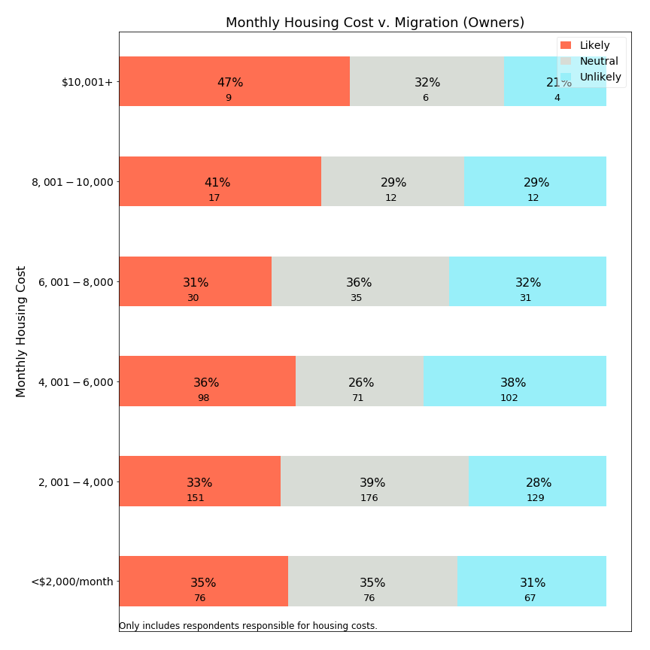

Monthly housing costs around $8,000 appear to be an inflection point, above which residents are more likely to leave Lexington and below which they are less so. It seems likely that these values represent mortgages and other costs more than property taxes, given their high levels.

**Migration versus Property Tax Share**

If property tax share is associated with housing stress, is it also predictive of migration?

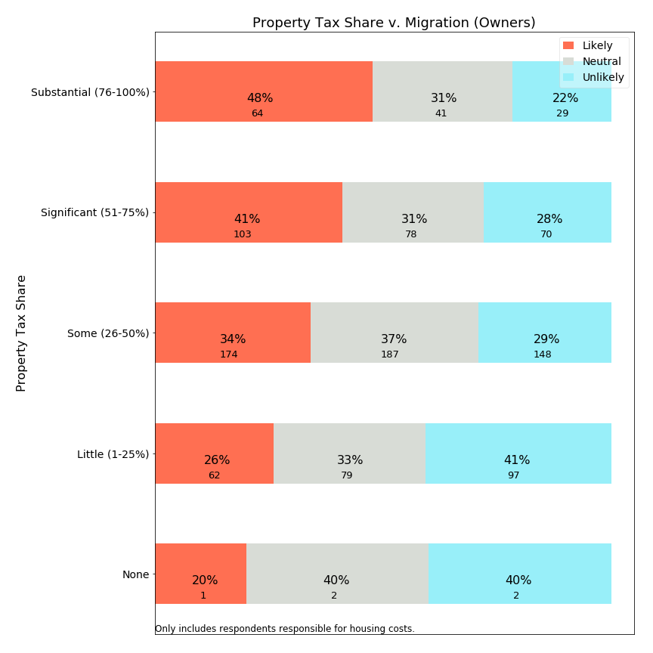

The survey data shows a fairly clear relationship between property tax share and frequency with which respondents indicate they expect to leave Lexington. Among those with under 25% of housing expenses due to property taxes, about one-quarter likely to leave. At the other end, those with more than 75% of housing expenses as property taxes indicate fewer than one-quarter expect to stay in Lexington for ten more years. Since high property tax percentage is driven by mortgage age or perhaps subjective perception, it is unclear whether public policies would specifically target residents who have large property tax share of housing costs.

## 5. Correlation Charts

The following charts identify the frequency relationship between independent variables. These charts provide a picture of Lexington demographics, and those who would be net beneficiaries or contributors to a residential exemption.

This chart shows the relationship between home value and income, two variables which are often used as eligibility criteria for a residential exemption:

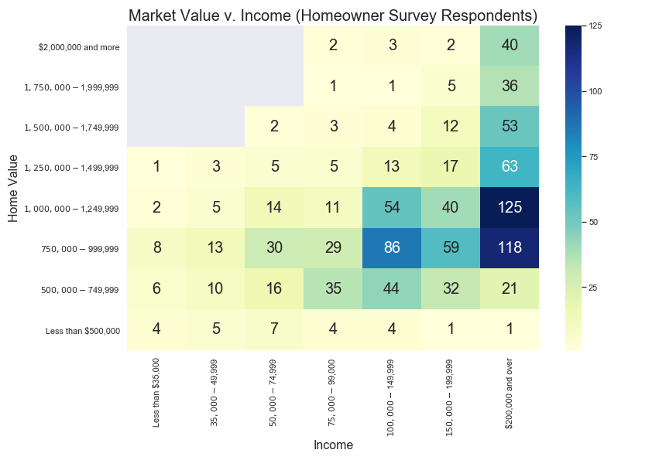

The gray boxes represent intersections which had no respondents in the survey, such as owners of $2,000,000 homes with incomes below $75,000. Because the SRE would help those below a horizontal breakpoint (around $1,200,000), a substantial numbers of respondents with incomes above $100,000 would be helped by this exemption (dark blue boxes on the right). On the other hand, a means-tested Residential Exemption would help a subset of those on the left portion of the chart (a vertical breakpoint), typically around $75,000.

Additional charts examine the subset of these respondents who own single family homes and condominiums:

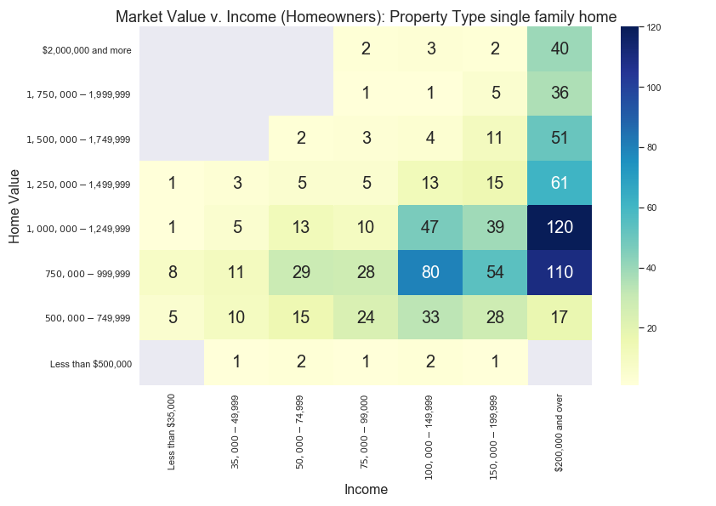

Above is a chart showing market value v. income for single family homes, to be contrasted with a similar chart below for condominium owners.

Survey respondents with reported home values below $500,000 typically owned condominiums (lower chart). Additionally, the condominium chart highlights that the largest group of condominium owners have properties valued between $500,000-$749,999 and are supported by incomes between $75,000-$149,999. This large cluster of owners would benefit from a SRE, as this exemption would benefit nearly 100% of condominium owners--including those earning over $200,000 income. However, this same group would typically not qualify for inclusion for typical means-tested exemptions.

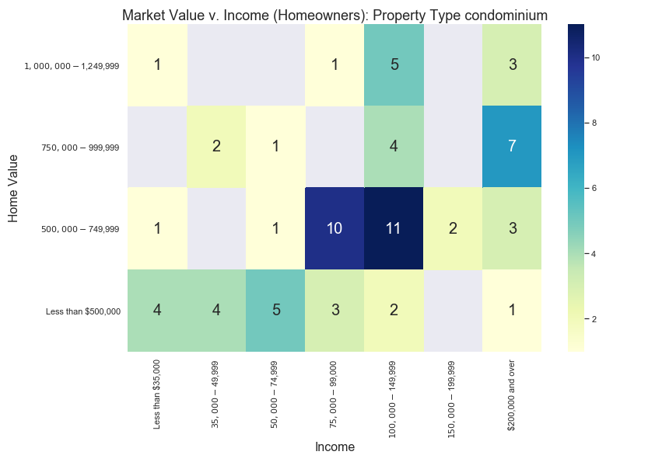

How does housing stress relate to these income and home value intersections? For this calculation, we assigned a value=1 for each respondent with significant or substantial housing stress, and value=0 for lower stress categories. The cells in the chart below show the ***percentage*** *of respondents reporting these “high” stress levels*:

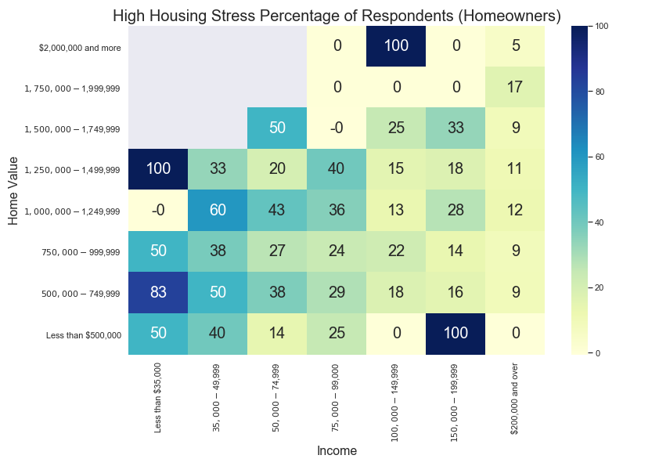

As this chart shows, high housing stress exceeds 25% of respondents for incomes below $100,000 and approach 50% of respondents incomes below $50,000. However, housing stress is not uniform for home values, as those with higher income levels do not consistently report high housing stress at any home value level.

## 6. Open Responses to Survey

Two open response questions were designed to solicit further information. The first open response question asked for additional information or elaboration after asking about monthly housing stress, with no prompting about property taxes. The second question was at the end of the survey, requesting any additional information respondents wanted to offer. The section below enumerates the most frequent phrases elicited in response to these questions and provides samples of comments using these phrases. There are several themes which can be summarized here:

1. High property taxes. Even for those who value the town services, the most common resident complaint was that property taxes have increased too fast and are higher than comparable towns. Concern about high property taxes was a consistent theme across most comments and keywords.
2. Town services. Some residents appreciate the services received, while others do not feel they are of sufficiently high quality for the taxes paid.
3. Capital projects and school spending. Several residents touched on these factors as drivers for high property taxes.
4. Future property taxes. Several residents mentioned future projects such as the police station and the high school, and a few suggested the town prioritize school projects and not attempt to do more than can be accomplished.
5. “Our” money. A few responses express resentment that town government does not treat money as their own and spend money too easily.
6. Long term residents. Several respondents lament changes to the character of the town.
7. Fixed income. Numerous respondents indicate that property taxes are too high for those entering retirement.
8. Rent or utilities. Several respondents are concerned about the cost of rent or utilities.
9. Regret about plans to leave Lexington. Respondents, including some with children in school, retirees, and multi-generational Lexington families express regret about plans to leave Lexington.

Resident comments will be published along with survey responses. The comments are in a separate data file and randomized so they will not correlate with the survey responses and maintain anonymity. Moreover, the comments were reviewed and edited with these guidelines:

Intent to keep comments intact as much as possible and substitute or redact any portion which is problematic, maintaining the spirit of openness and avoiding censorship claims.

Specific concerns to review:

* Comments which might lead to identification of a particular person making the comment. These include: specific age, employer, street name, etc.

* Comments which stereotype others while not contributing to the conversation constructively.

Where redaction or editing occurred, the specific section was substituted with square brackets (“[ ]”). For example, a year “1964” could become “196[x]” or a specific employer could be adjusted to “[employer]”. The comments reported below are post-redaction.

**Open Response Statistics and Quotes**

The first open response question asked about housing stress, which yielded the following most frequent bigrams (2-word phrases):

|  |  |
| --- | --- |
| Bigram | # occurrences |
| property taxes | 31 |
| property tax | 25 |
| affordable housing | 14 |
| stay lexington | 10 |
| town services | 9 |
| taxes high | 8 |
| living lexington | 7 |
| high school | 7 |
| tax burden | 7 |

For each bigram, we share a representative sample of comments:

property tax or property taxes:

“Town really needs to stop spending so much money in order to stop the terrible rise in property taxes…”

“Other than that the house is too big for two people, property taxes would be second biggest reason to move.”

“I do indeed consider property taxes in Lexington to be prohibitive for seniors and retired persons.”

“Certainly property taxes are high, but we see great value from town services.”

“The combination of property taxes and the lack of new, smaller private homes in good condition, we do not anticipate being able to stay in Lexington.”

“Being able to defer property taxes helps me a great deal.”

“Property taxes are higher than my mortgage and will be the reason I move out of Lexington”

“We love Lexington but as the kids leave the nest, the fact that property taxes increase and retirement is getting closer, we are not sure we will choose to stay here due to the high taxes.”

“...please do not make the property taxes progressive, i.e. a higher percentage for larger homes. Just stop spending beyond your means. Just like the rest of us have to do.”

“My mortgage holder (my mortgage originator sold my loan to [company]) denies my participation in the town's state-enabled property tax deferral program for an arbitrary, trivial reason.”

“Not eligible for a property tax deferral (age) tax work-off covers only 10% but this becomes a moral question. These programs are a cruel hoax on senior citizens in town. Why do I have to work till I die, when others come in educate their children then leave and actually financially benefit from the capital gains on the sale of their property.”

“We have lived in town since 196[x] and will hate to leave. Seniors need a break on property tax”

“Lexington government's lack of fiscal discipline is driving property tax rates to extreme levels that will drive senior residents away and block newly established couples from living here.”

“I am concerned with the rising property tax rates and the ability of aging residents to pay. This town is always talking about diversity, but they don’t seem to be concerned at all with socioeconomic diversity.”

“We'd really like to stay in retirement but need to find a lower property tax.”

“High property tax (injustice) makes it so difficult for me to think of saving for retirement.”

“As tax reform and property tax can not be deducted and really Hope town consider lower the tax rate. use our tax money as their own money.”

affordable housing:

“Please consider providing more affordable housing for seniors.”

“Our senior citizens and young families need affordable housing. Our seniors do not need expensive elder care/senior facilities--they need small single story rental options that are TRULY affordable so they can age in the town they love.”

“there needs to be more affordable housing availability for those over 60 &/or retiree's without children to help to maintain the diversity of our community.”

“It is appalling that people are buying houses here and not living in them, using them for tax shelters, or buying houses and letting people live there to attend the schools. There isn't enough affordable housing in town, and it impacts our neighborhoods and the makeup of our town.”

stay lexington:

“I hope that it helps to allow taxes to be lowered so I can stay in Lexington”

“We can't afford to stay in Lexington like our parents did.”

“We won't be able to afford to stay in Lexington when we retire.”

“Lexington Town Taxes are prohibitively high! As we age, it is not economically viable for us to stay in Lexington, a town in which we have rented, and then owned a Town House and now a Single Family home! Town finances need to be managed better before passing the burden to the Town residents.”

“I wish they will be a way … to stay in Lexington in my home forever once my kids outgrow the school system .. as an [foreign country] immigrant and US Citizen this is my home and the only one I can go back when I retire ...due to the political situation of my original country ... I wish I could financially be able to afford it but even with savings, Lex taxes are crazy high …”

town services:

“Besides the school system, we don’t see strong value for our taxes reflected in other town services. It is motivating us to move when our kids complete school in this area.”

“We are fortunate to have many excellent town services”

“Do not implement a residential exemption that simply shifts the tax burden to other residents. Cut town services particularly schools to make up for any shortfall created by any residential exemption.”

“We are concerned with the constant capital projects in the town related to town services, fire station, Cary Hall, DPW garage, community center, in a time where we have and have had multiple school projects at the same time.”

taxes high:

“Property taxes are high, but we do receive a lot of benefits.”

“Certainly property taxes are high, but we see great value from town services.”

town taxes:

“I do hope the survey will be used to find ways to stop increasing town taxes. People move out of Lexington because of the taxes, there must be a way to decrease the spending so we don't have to increase taxes.”

“We love living in Lexington and all the town services, community organization and especially the public schools. We understand that takes money and have no issue with the level of town taxes. However, for the money we are paying, we are disappointed in what we're hearing so far of the math program at Harrington Elementary.”

living lexington:

“Cost of living in Lexington is incredibly high, and it's very depressing to watch all the smaller and more affordable homes in our neighborhood torn down”

“Many people in the town are upset about the rising cost of living in Lexington, particularly the rising property taxes. Most people are not aware of the 32% increase that is locked in over the next 10 years based on official Town projections, nor are they aware that this increase does not include any new taxes to fund the $300 million+ (Town estimate) replacement high school that is in early planning stages.”

“We hope to age in place because we love living in Lexington. However, the taxes may make that prohibitive.”

“Taxes make it impossible to retire and stay in lexington. I was born in 195[x] in Lexington and I am 3rd generation living in lexington.”

“i love living in lexington-think it is a great well run town”

high school:

“General concerns about rising taxes and large-scale projects (high school, fire station, new children's place, etc) and whether all options are being considered”

“Tax burden to Lexington residents is to high. Tax dollars should be spent on the need for an new high school and cut everywhere else.”

“The schools have become so large and overcrowded, there are no opportunities for kids to participate in any extra-academic/extracurricular activities: 150-200 kids show up to compete for a spot in a school team with 10 kids. The town needs to do something to discourage this crazy expansion of the school system.”

“Please look for ways to have Lexington a lifetime town, not a move-in with preschool kids, move out when the kids graduate from high school.”

“Lexington needs to control spending and be more diligent regarding capital expenses as most families move here for schools and re-building the two middle schools and high school should be the ONLY priority of major projects for the town next ten years.”

tax burden:

“The tax burden is significant and becoming more so. Why do we usually seem to choose the deluxe version when a lesser version is ample, e g. the community center, design for new police station.”

“Some towns such as Cambridge give tax breaks to owner-occupied dwellings, and others have enough tax base (commercial and industrial firms) to make the tax burden fall more lightly on homeowners. We live in a neighborhood where as homeowners of a 2 bedroom bungalow we pay considerably more taxes than the million dollar restaurant across the street.”

“Large families move in for the school system, but their local taxes don't pay the extra cost of putting their children through the schools here. The tax burden gets placed on empty-nesters and retirees.”

**Second Open Response Question**

At the end of the survey, respondents were asked to share additional comments. These were the most frequent bigrams:

|  |  |
| --- | --- |
| Bigram | # occurrences |
| property taxes | 58 |
| property tax | 39 |
| taxes high | 27 |
| real estate | 23 |
| estate taxes | 18 |
| years ago | 13 |
| fixed income | 11 |
| tax high | 9 |

property taxes or property tax

“We pay almost $3700 four times a year for property taxes. Compared to other towns we talk to friends about they get almost twice the services we do here.”

“My husband is dead, and my house is paid off. I’d love to stay in Lex, but I am paying ‘full freight’ and utilizing few services. I looked to see if there were any deals for my in the area of property taxes ($18,000). I didn’t qualify. I’m not Section 8 level. I sold my house”

“It bothers us that property taxes are less in other similarly situated towns with equivalent services.”

“Do have concerns about rising property taxes, especially with new federal tax laws”

“Thinking about retirement. The cost of property taxes will be prohibitive.”

“Taxes keep increasing and even when the mortgage payments will be done we will still pay nearly $1200 per month for property taxes. This becomes an issue as we age and retire”

“My property taxes consume 33% of net income”

“Our property taxes are sky high and keep going up. Our youngest is going to be done with public school soon and we are talking about moving to a town with lower property tax rates”

“In 2004 my husband and I bought our house in Lexington and our property taxes were $3000 a year. Now they have almost tripled and we are retired [living on retirement savings] and Social Security. We really love Lexington and believe in spending for good schools, etc., but it may not have been smart for us to move here in retirement.”

“Too many rental units with children attending public school which makes the school overcrowded and put stress on higher property taxes”

“After kids are done with Lex public schools, we would consider moving out of town because of high property taxes. Town is wonderful and provides many great resources but wished there were a bigger business tax base so that the burden of taxes doesn't come upon residential property owners.”

“My husband is still working at age 7[x] but when he retires I am quite concerned about our property taxes. We have an adult child with special needs living with us and cannot downsize or move very easily.”

“property taxes have >TRIPLED in 15 years. NOT sustainable!”

“Half of my military retirement pay goes to property taxes. I'm retired.”

“Our property tax has nearly doubled in the past 5 years and will likely double again once the new levies, plus the upcoming levy for the new high school, are added. We are seriously considering moving to another town where the property taxes are more fair and reasonable.”

“With our current income and spending, our budget is borderline break even if not in the red, and ANY increase in housing costs (mainly property taxes, as these are generally the only cost that goes up every year) digs us further in the hole.”

“My property taxes are 1/10th my income. My estimated income tax is also 1/10 my income. By the time I'm done paying my bills (401K, retirement, electric, etc.), I end up with $300 to $500 a month to live on. For everything. The ironic part is that I'm too young for senior discounts (only 6[x]) and I make too much to qualify for low income. I haven't bought any new clothes in approximately 5 years.”

“We have conservation land as a part of our back-yard which we never use. It really hurts to pay property tax on that area. The property taxes are increasing way too fast than the salary increase at our workplace!”

“property taxes are too high! runaway spending in the town!”

“Our house is paid, so we don't stress about total costs, but we do stress about rate of increase in our property taxes.”

“The property taxes of $8,000/year for retired couple, former [public employee], is very HIGH! Our house is 1300 sq ft. One bathroom. Why are these taxes so high?”

“Last spring I ran out of heating oil, the property tax bill pushed out the refill until early summer. This coming year I will drop my homeowners policy because there is no room left in my budget with the increases.”

“Property tax too high when we are not using school system. We may decide to move to town with lower property tax”

“The property tax is too high due to substantial special education cost.”

“Although I'm entirely eligible for Lexington property tax deferral program, my mortgage holder refuses to allow my participation owing to legal technicalities in the structure of the program that the bank says inconveniences them.”

“When we moved to Lexington 21 years ago, our property tax was around $4600. Now it's over $12,000, and still going up faster than inflation. We won't be able to fully retire here.”

taxes high or tax high

“Town taxes are too high and spending is questionable, e.g., first fixing the old high school a few years back for $60M, and now deciding to build a new one for $200M.”

“The taxes are too high. The town spends money at too high a rate”

“Have adequate financial resources to pay bills. Would rather taxes weren't so high--and don't like to think about how high they are. But also understand that taxes are necessary for services.”

“lexington has high costs with very little services or amenities that are useful to all. it is not the same town I grew up in!”

“taxes are so high that I can't keep up with them.”

“high taxes--house assessment increase was astronomical”

“My feeling is that the assessment on our house is too high and I feel it was manipulated to increase the tax bill. Our house is old, small and in poor condition. If the taxes were lower, I would be able to fix the areas of the house that need to be repaired.”

“the taxes are crazy high”

“There have been 9 out of 10 overrides in the past 10 years. Taxes are too high even with the evaluation on all the McMansions. Negotiations on union contracts is a big problem. Where are the cost controls?”

“It is costly living in lexington, mainly due to high taxes.”

“Taxes are very high, largely because of school spending.”

real estate or (real) estate taxes

“Must move out of town due to high real estate taxes (on limited income).”

“Smaller real estate options to "age in Lexington" are few. I grew up in Lexington, graduated from the school system. My family has been here for 75 years. My view is that Lexington has focused on replacing small homes with McMansions purchased by people who want the school system for their children with no intention of making Lexington "home."”

“the real estate taxes keep going up and we are not sure we will be able to continue to live in this town--the town is spending vast sums of money to replace schools and other public buildings-- money that the town does not have and wealthier people in town keep voting for overrides”

“My attitude is that if the people of the town care about education and their kids, they care about the town in general. I feel this way, even though I have no children. I have taught in the town for [x] years. The real estate taxes are getting to us, though, as we enter our 70s.”

“expensive real estate taxes as Widow choosing to stay in familiar environment!”

years ago

“We pay $5700 a month for rent and there are only 2 adults and one high school student. It's obscene. We moved into this house 6 years ago and the rent was $4200 but it's gone up every year.”

“Our taxes have more than doubled since we've moved here 18 years ago. We're both in our 70's and plan on staying in Lexington, but worry about affording our taxes as the years go by.”

“Taxes have been on a steep increase since we moved here 4 years ago, and I believe they will continue to rise at a steep rate due to town construction on public buildings. It may become unaffordable in the near future if the town continues to grow/build at this rate.”

“Our taxes on an unrenovated, 3 bed, 1 bath, 1200 sq ft cape represent more than 1/3 of our total housing cost--and this on a house we bought 5 years ago for $500k with a conventional mortgage and downpayment. The taxes will cause us to move even before we have our child in school.”

“Our high taxes are an issue for many retirees. With new schools, fire and police buildings and other additional large expenditures happening, we and others are worried that we will be forced to move to a town with lower taxes. We do not want that to happen to us.”

“When we moved to Lexington 21 years ago, our property tax was around $4600. Now it's over $12,000, and still going up faster than inflation. We won't be able to fully retire here.”

fixed income

“I worry that Lexington spends money without any concern for those on fixed incomes e.g. Purchase and demolition of Armenian School on Pelham.”

“Real estate taxes are too high and are making it hard for fixed income retirees to remain in this community.”

“I also have elderly parents living in this town on a fixed income and the taxes we pay here are outrageous. I only stay in this town because my parents do not want to move and my youngest has 3 more years of high school.”

“Retired, on fixed income. Property taxes are very high. Mortgage is paid off.”

”Property taxes are high for those on fixed incomes. Cambridge, for example, provides both a residential tax credit and an elderly tax credit.”

“As seniors raising elementary aged children, we will be forced to move out of town as soon as they complete their education here. We will not be able to afford staying here on a fixed income. Even if we could, the housing now available would not be appropriate for aging in place.”

“I don't think that all fixed income qualifying residents know that they can defer their RE taxes at an extremely low interest rate, until their property sells. How can we get this knowledge of this very generous town benefit to every financially struggling resident who qualifies?”

“Once we retire, we are very concerned with our qtrly tax bill of $4,000. Candidly, after 33 years, we may decide to sell and find a community with Real Estate Taxes in the $6 to $8 K range, annually. We've loved Lexington but may be to expensive on a fixed income basis.”

## 7. Statistical Analysis of Housing Stress and Predicted Migration Decisions

Prior analysis sections describe correlations between pairs of key variables with visual illustrations. While such an approach is easily comprehensible, it is an incomplete characterization of variables which are driven by multiple variables. Policy makers should be interested in comparing the strength of contributing factors when multiple are present, as well as quantifying the change in dependent variables which might be expected with a change in policy. Statistical analysis offers an approach to estimate these factors.

Two questions merit statistical analysis:

* What contribution does property taxation make to reported housing stress?
* What contribution does property taxation make to self-reported, predicted migration decisions?

Household stress was surveyed using a categorical response question with five answers of increasing stress, reflecting an implied ordinal scale. Statistical estimation would best use of one two approaches:

* Treat household stress as a continuous variable with five point estimates, and use **ordinary least squares** (OLS) to predict changes on a continuous scale. This approach is limited because survey responses are truncated at a minimum and maximum value but a statistical model fits to a line.
* Use an **ordinal logistic** model to reflect latent levels of stress with estimated thresholds which are associated with respondents selecting from five levels. This method allows the thresholds to exist independently of one another, but has the disadvantage that confidence interval estimation is more complicated.

We used OLS estimation first, because it easily estimates statistical significance, thereby allowing less significant variables to be omitted in model iterations. We initially limited response inclusion to cases where the respondent reported both owning a home and being responsible for housing costs (1239 of 1475). Of these, 1208 provided answers to the housing stress question, and 914 answered all statistically relevant questions.[40] After selecting appropriate parameters, we tested our model tested against an ordinal logistic model. The ordinal logistic model test did not provide insights and is not included here.

To run analyses using the migration likelihood responses, we recorded the response categories as follows:

* Definitely Not: 0
* Unlikely: 1
* Have not considered (or) Undecided - Possible: 2
* Likely: 3
* Definitely: 4

We elected to combine two codes which are seemingly neutral into code 2 as neither response lends itself to being more or less likely than the other, and both belong somewhere in the middle of this scale. The end result is that the relocation dependent variable is an ordinal variable with five levels (0-4), with higher levels indicating higher forecast propensity to migrate out of Lexington.

An OLS model predicting housing stress has a R2=0.2, and seven significant explanatory variables. With this model, we can estimate the impact of a residential property tax exemption on housing stress levels as follows: Assume a household has property taxes of $10,000 per year (roughly a $700,000 assessed value). For a range of monthly housing expenditures ($1000, $1500, … $4000) imagine that the property tax were reduced by $5000 (50% would be a very generous tax exemption) and calculate the change in monthly housing costs and property tax % of monthly housing. Using these changes and the coefficient, estimate what happens to the level of housing stress. Not surprisingly, the findings indicate that the greatest impact of a $5000/year property tax reduction will be felt in households having the smallest (prior) monthly housing expenditures and therefore the greatest (prior) percentage of housing expenditures related to property taxes. A bit more surprising may be that the model indicates only a modest adjustment to stress with significant changes in property taxes. However, this modest relationship may be due to the fact that numerous other factors contribute to housing stress beyond the effect of property taxes.

|  |  |
| --- | --- |
| Prior Monthly Housing | Effect of 50% reduction of property taxes |
| $1,000 | -0.40 |
| $2,000 | -0.23 |
| $3,000 | -0.18 |
| $4,000 | -0.15 |

The model predicting migration forecast has an R2=0.12. While it seems that housing stress is among main drivers, and there may therefore be a direct and indirect property tax link, the statistical relationship is weak. We can estimate that a stress change of 1.0 may be related to a 0.28 change in the scale for likelihood of moving, but as the 1.0 stress change is not estimated to occur through tax exemptions, it appears that this study does not find evidence that tax policy would directly affect migration. (This finding does *not* mean that tax policy changes have no effect; it merely means that no significant effect is *identified* with the data from this survey.)

Because property taxation impacts household stress, and the latter impacts migration decisions, we have an “endogenous variable” problem which makes estimation of the impact of property taxation on migration more difficult. We tried using a third model to predict migration likelihood in which housing stress was excluded from the independent variables, since it may mask direct relationships between property taxes, household costs, and propensity to move. As the model overview below describes, the relationship appears largely consistent with the prior models. A weak model exists for migration likelihood, and a large change in property taxes and housing costs for an individual could result in a change in propensity to move, but not enough to change the distribution of responses among this survey’s categories.

Only the OLS results are reported here.

**Statistical Models**

OLS Model for Stress:

====================================================================  
Model: OLS Adj. R-squared: 0.200   
Dependent Variable: StressCode AIC: 2591.0511  
Date: 2018-11-25 21:39 BIC: 2629.5937  
No. Observations: 914 Log-Likelihood: -1287.5   
Df Model: 7 F-statistic: 33.59   
Df Residuals: 906 Prob (F-statistic): 1.05e-41   
R-squared: 0.206 Scale: 0.98833   
--------------------------------------------------------------------  
 Coef. Std.Err. t P>|t| [0.025 0.975]  
--------------------------------------------------------------------  
Income914 -0.0048 0.0004 -10.8862 0.0000 -0.0057 -0.0039  
MarketValue914 -0.0460 0.0094 -4.9003 0.0000 -0.0644 -0.0276  
Age914 -0.0136 0.0036 -3.7911 0.0002 -0.0207 -0.0066  
MonthlyHousing914 0.1538 0.0197 7.7935 0.0000 0.1151 0.1926  
HouseholdSize914 0.1602 0.0404 3.9631 0.0001 0.0809 0.2396  
PropertyTaxShare914 0.0080 0.0016 5.0903 0.0000 0.0049 0.0111  
AgeIncome914 -0.0001 0.0000 -2.1343 0.0331 -0.0001 -0.0000  
One 1.4879 0.0377 39.4321 0.0000 1.4138 1.5619  
--------------------------------------------------------------------  
Omnibus: 15.853 Durbin-Watson: 2.031   
Prob(Omnibus): 0.000 Jarque-Bera (JB): 10.355  
Skew: 0.115 Prob(JB): 0.006   
Kurtosis: 2.532 Condition No.: 1729   
====================================================================  
* The condition number is large (2e+03). This might indicate  
strong multicollinearity or other numerical problems.

Monthly housing costs, household size, and property tax share all increase reported housing stress.

Age, income, market value, and age*income all decrease reported housing stress.

Note: Variables with suffix 914 are mean-adjusted version of the 914 original survey code responses. The new variable is obtained by subtracting the mean from the original 914 observations to create a new variable with mean=0.

OLS Model for Relocation:

==================================================================  
Model: OLS Adj. R-squared: 0.120   
Dependent Variable: RelocationStat1 AIC: 2671.5200  
Date: 2018-11-25 21:49 BIC: 2695.6091  
No. Observations: 914 Log-Likelihood: -1330.8   
Df Model: 4 F-statistic: 32.15   
Df Residuals: 909 Prob (F-statistic): 4.34e-25   
R-squared: 0.124 Scale: 1.0828   
------------------------------------------------------------------  
 Coef. Std.Err. t P>|t| [0.025 0.975]  
------------------------------------------------------------------  
Age914 0.0112 0.0029 3.9053 0.0001 0.0056 0.0169  
StressCode 0.2861 0.0315 9.0718 0.0000 0.2242 0.3479  
PropertyTaxShare914 0.0052 0.0016 3.2042 0.0014 0.0020 0.0083  
AgeIncome914 0.0001 0.0000 4.8003 0.0000 0.0001 0.0002  
One 1.7572 0.0607 28.9288 0.0000 1.6380 1.8764  
------------------------------------------------------------------  
Omnibus: 19.328 Durbin-Watson: 2.027   
Prob(Omnibus): 0.000 Jarque-Bera (JB): 10.633  
Skew: -0.017 Prob(JB): 0.005   
Kurtosis: 2.473 Condition No.: 2672   
==================================================================  
* The condition number is large (3e+03). This might indicate  
strong multicollinearity or other numerical problems.

Age, stress, property tax share, and age*incoe are all positively correlated with forecast of relocation. The overall r^2=0.12, so the relationship is fairly weak.

The strongest relationship is between stress and forecast relocation. A one level increase in stress corresponds roughly to a 0.3 level increase in propensity to move.

Property tax share not only directly impacts propensity to move, but also indirectly affects through its impact on stress.

Therefore we find that property tax burden is related to forecast relocation, however the effects appear in total to be small and most impactful on those for whom property taxes constitute the preponderance of monthly housing costs.

OLS Model for Relocation (without using Stress as a predictor):

===================================================================  
Model: OLS Adj. R-squared: 0.063   
Dependent Variable: RelocationStat1 AIC: 2729.8131  
Date: 2018-11-25 22:24 BIC: 2758.7201  
No. Observations: 914 Log-Likelihood: -1358.9   
Df Model: 5 F-statistic: 13.31   
Df Residuals: 908 Prob (F-statistic): 1.53e-12   
R-squared: 0.068 Scale: 1.1529   
-------------------------------------------------------------------  
 Coef. Std.Err. t P>|t| [0.025 0.975]  
-------------------------------------------------------------------  
Income914 -0.0020 0.0004 -4.4257 0.0000 -0.0028 -0.0011  
Age914 0.0047 0.0034 1.4057 0.1601 -0.0019 0.0114  
MonthlyHousing914 0.0537 0.0184 2.9163 0.0036 0.0175 0.0898  
PropertyTaxShare914 0.0070 0.0017 4.1991 0.0000 0.0037 0.0103  
AgeIncome914 0.0001 0.0000 4.3321 0.0000 0.0001 0.0002  
One 2.1881 0.0407 53.7323 0.0000 2.1081 2.2680  
-------------------------------------------------------------------  
Omnibus: 39.032 Durbin-Watson: 2.005   
Prob(Omnibus): 0.000 Jarque-Bera (JB): 17.049  
Skew: 0.041 Prob(JB): 0.000   
Kurtosis: 2.336 Condition No.: 1604   
===================================================================  
* The condition number is large (2e+03). This might indicate  
strong multicollinearity or other numerical problems.

One may be interested in PropertyTaxShare, since it is a variable which a residential exemption might impact. PropertyTaxShare914 is a normalized version of PropertyTaxShare with this frequency distribution for the five answers::

-4.811816: 418  
-29.811816: 203  
 20.188184: 189  
 44.188184: 100  
-42.811816: 4

A category jump on this PropertyTaxShare914 scale is therefore about 20 points. So a full category jump (20) multiplied by the coefficient 20*0.007 = 0.14; so it translates to about 1/6th step in the predicted propensity to move scale. This finding is consistent with the impact of property taxes on stress found in the first relationship. It is a weak relationship with limited substantive impact.

## 8. Survey Response Summary

This section shows the response frequency for the questions asked in the survey. Each chart shows the absolute number and percent of respondents selecting each response. The open response questions are summarized in an earlier portion of this appendix.

**Section 1: Town Services**

In the past 12 months, has any household member done the following?

Q1. Visited the Community Center

Lexington recently developed a community center at the intersection of Route 2A and Massachusetts Avenue, with function rooms and multi-generation activities.

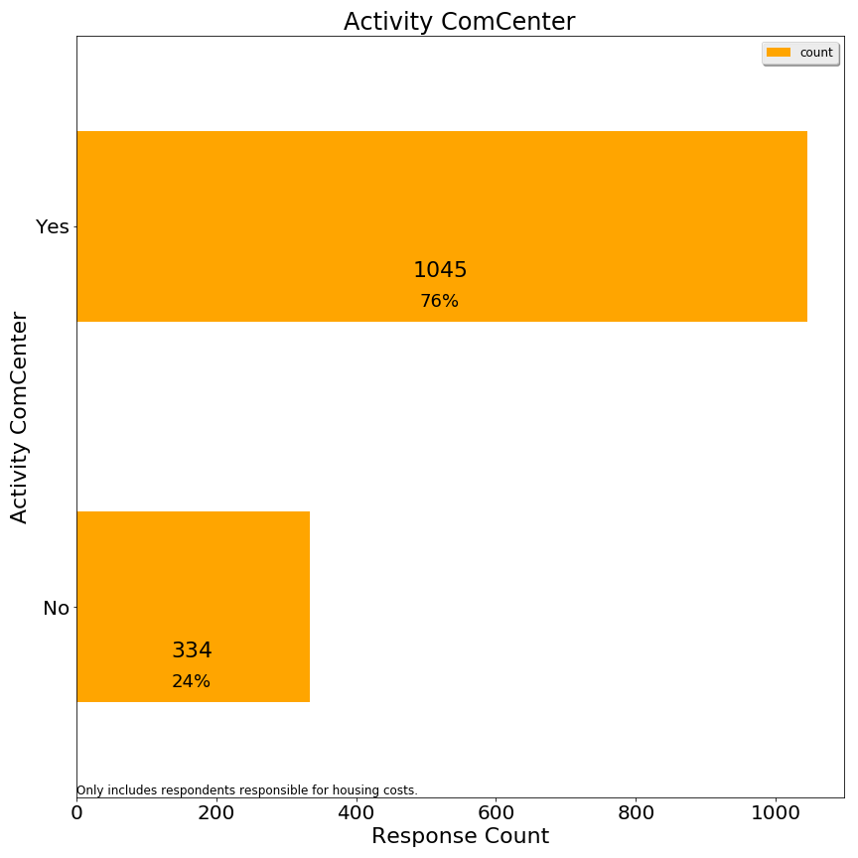

Q2. Used town swimming facilities

Lexington has an outdoor complex for swimming and splashing, as well as a beachfront style pond at the Old Reservoir.

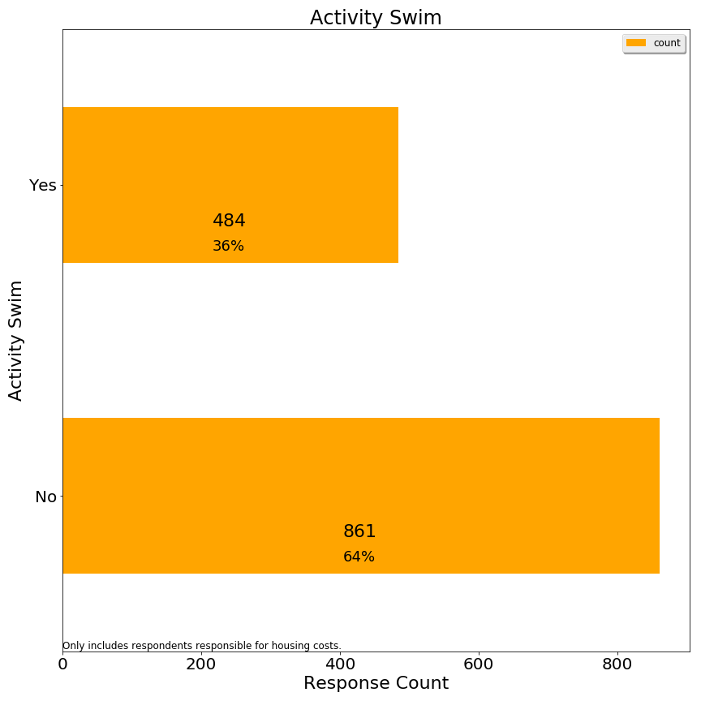

Q3. Used town recreational fields or courts

Lexington has numerous outdoor fields and tennis courts, some of which are lit for night play.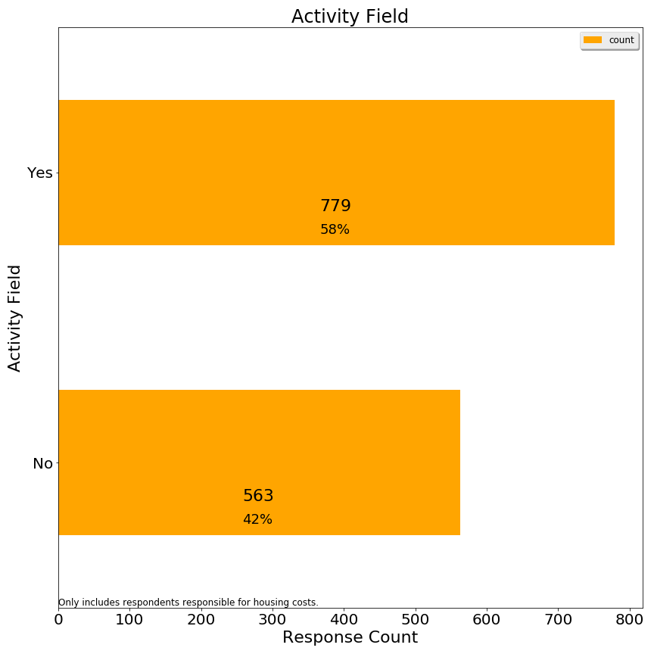)

Q4. Used Pine Meadows golf course

Lexington owns a public 9-hole golf course near route 128.

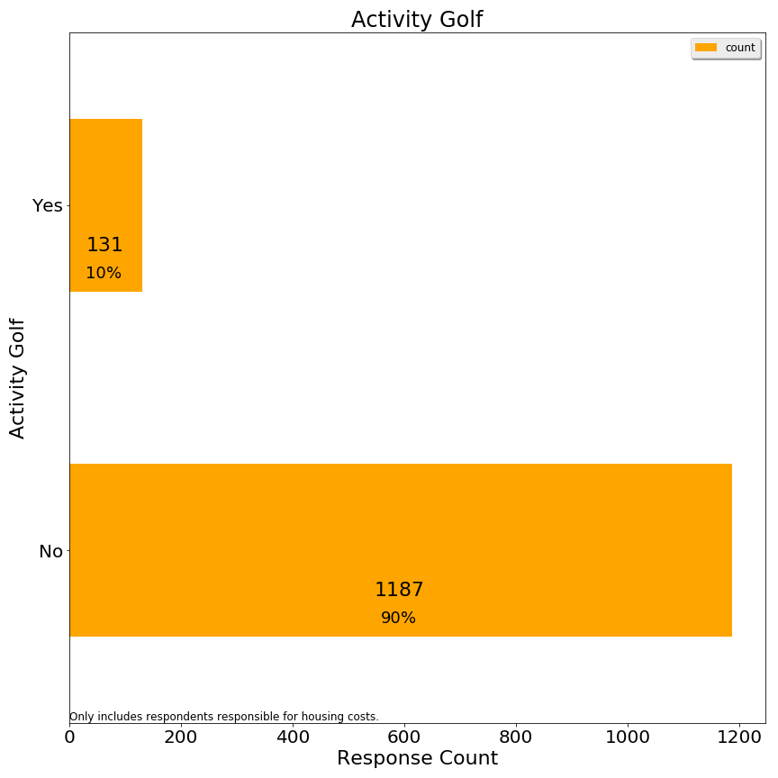

Q5. Used a school or neighborhood playground

Lexington has neighborhood playgrounds and school playgrounds, both of which are open to families without children in public schools.

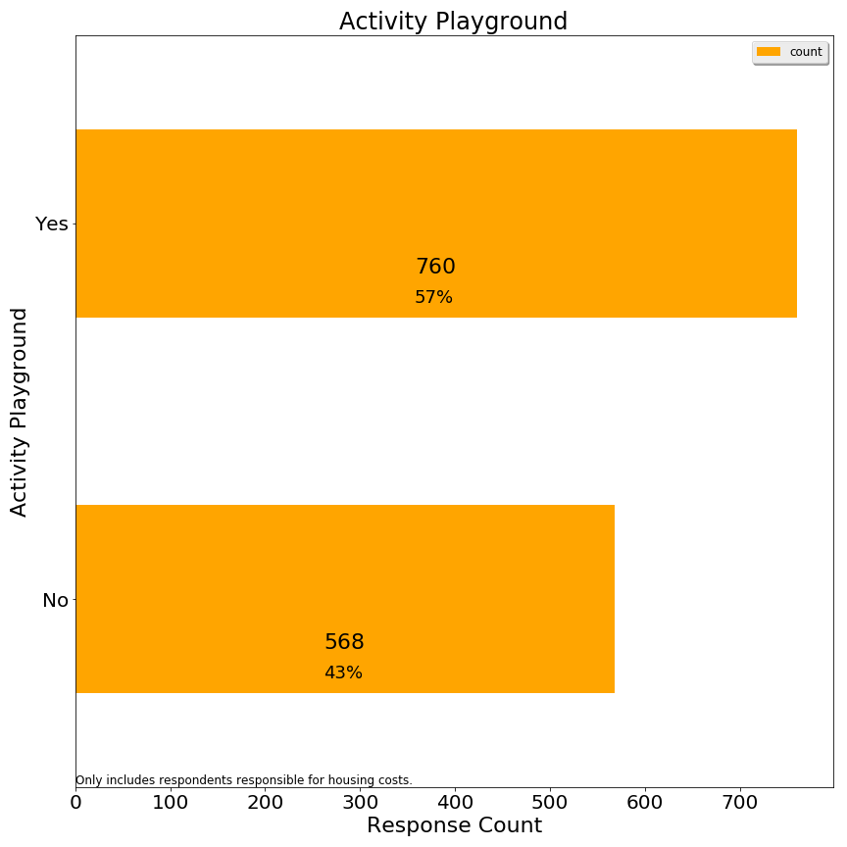

Q6. Used the Minuteman Bikeway

The Minuteman bikeway runs through Lexington from Arlington to Bedford.

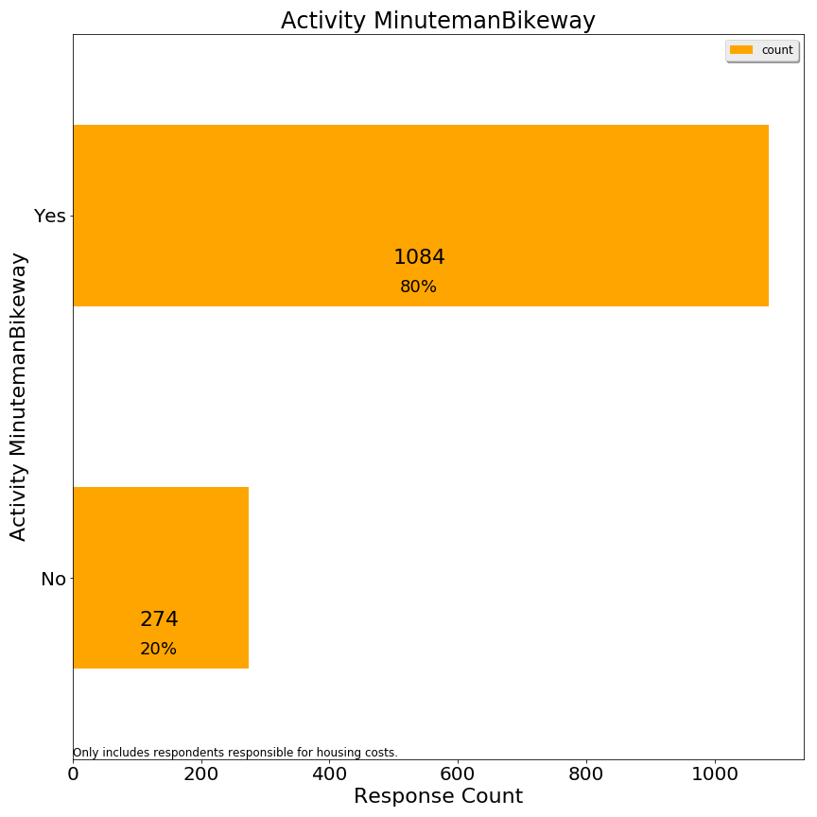

Q7. Used Lexpress bus

Lexpress is Lexington’s local bus service.

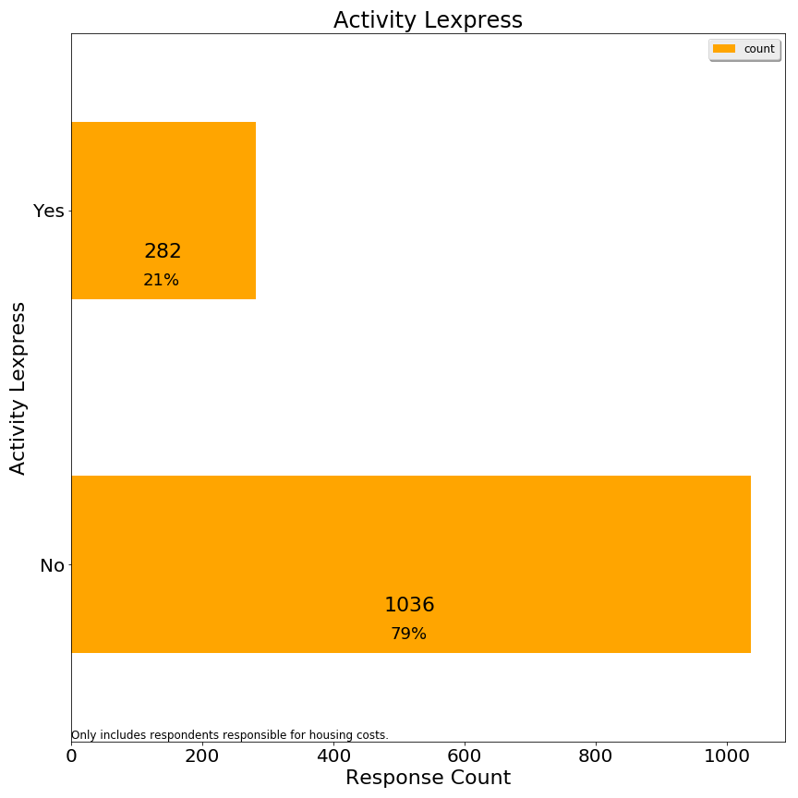

Q8. Visited Lexington conservation areas

Lexington prides itself on the large % of land dedicated to conservation.

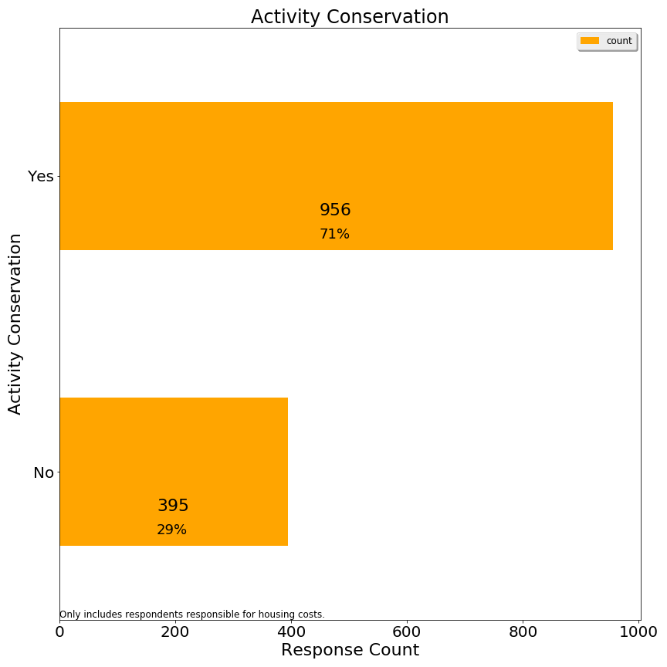

Q9. Directly received fire or police services

Lexington has 1 police station and 2 fire stations, facilities targeted for capital improvements.

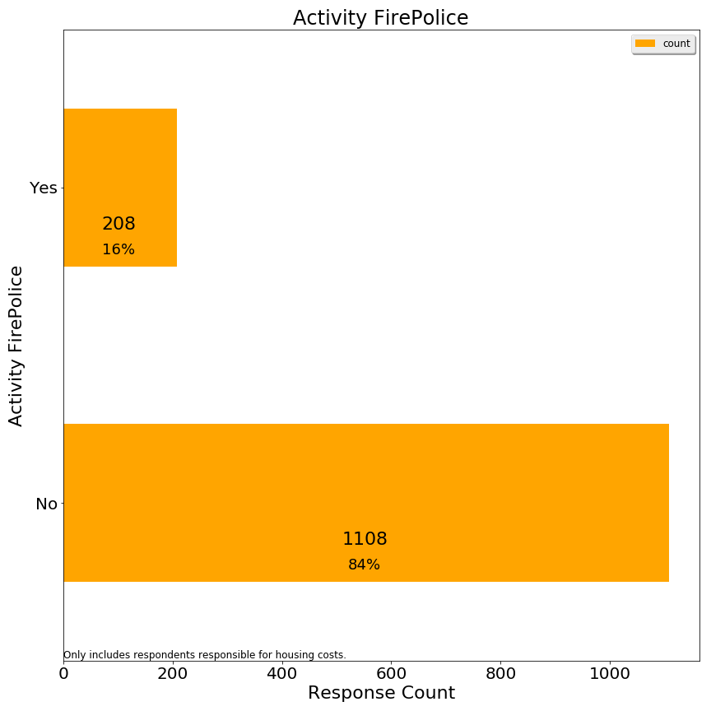

Q10. Attended Lexington public schools

Lexington public schools are a prime reason for residents to move to Lexington--to such an extent that enrollment has outpaced classroom facilities. 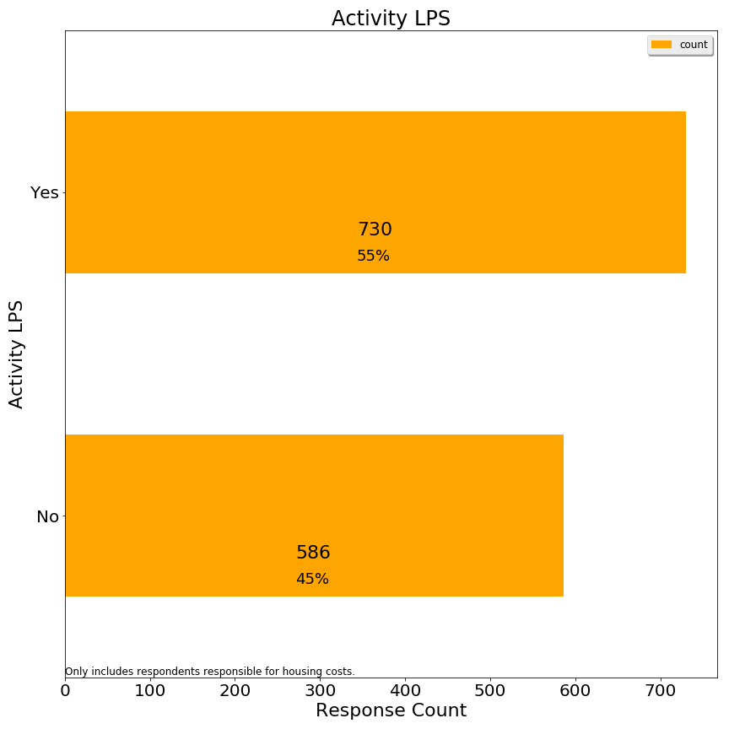

Q11. Participated in any town provided program or service for seniors

Lexington offers a variety of programs and transportation services for seniors.

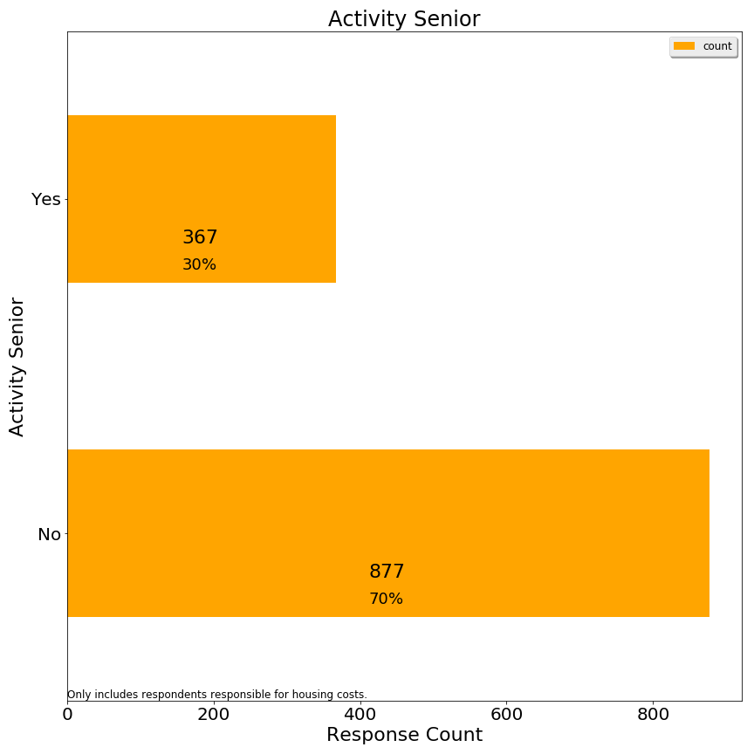

Q12.Used Cary library or attended a library event

Cary Memorial library hosts events and is Lexington’s only library at present.

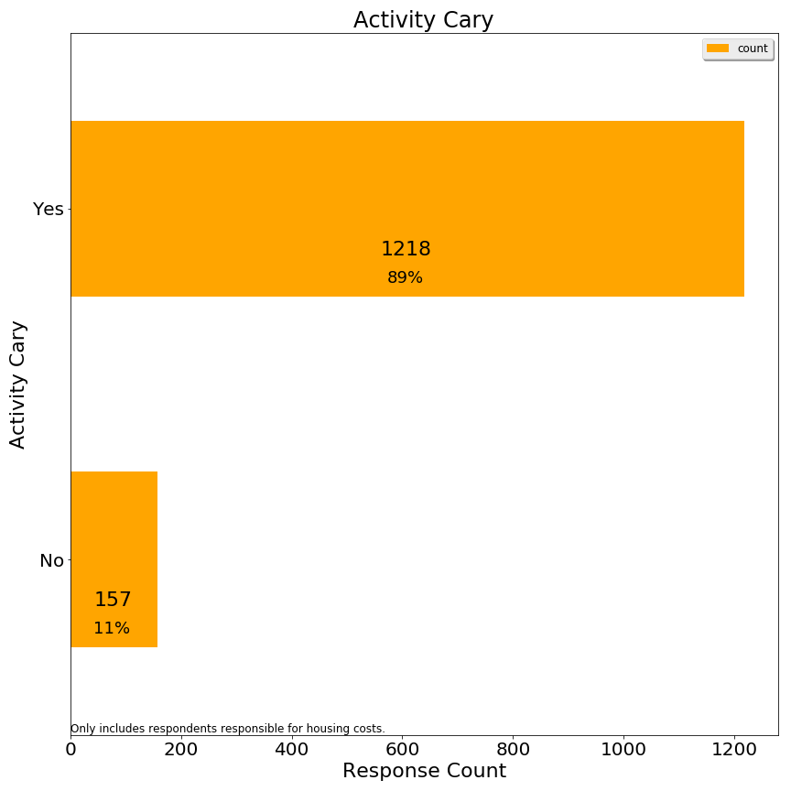

Q13.Served town government in any capacity (employee, committee member, Town Meeting Member, elected representative)

Lexington is governed by representative town meeting and has 21 citizens from each of 9 precincts, along with various town committees which include citizens not in town meeting.

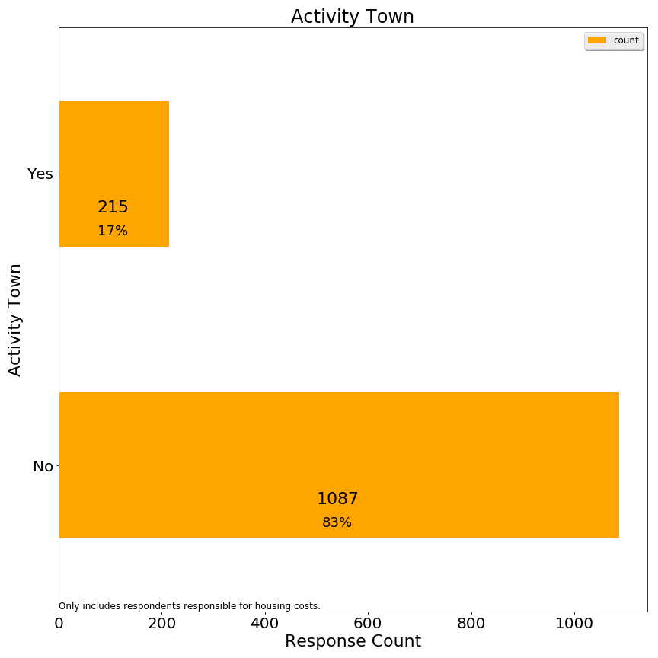

**Section 2: Affordability**

Q1. Are you aware that the Recreation & Community Programs Department offers financial aid for programs and services?

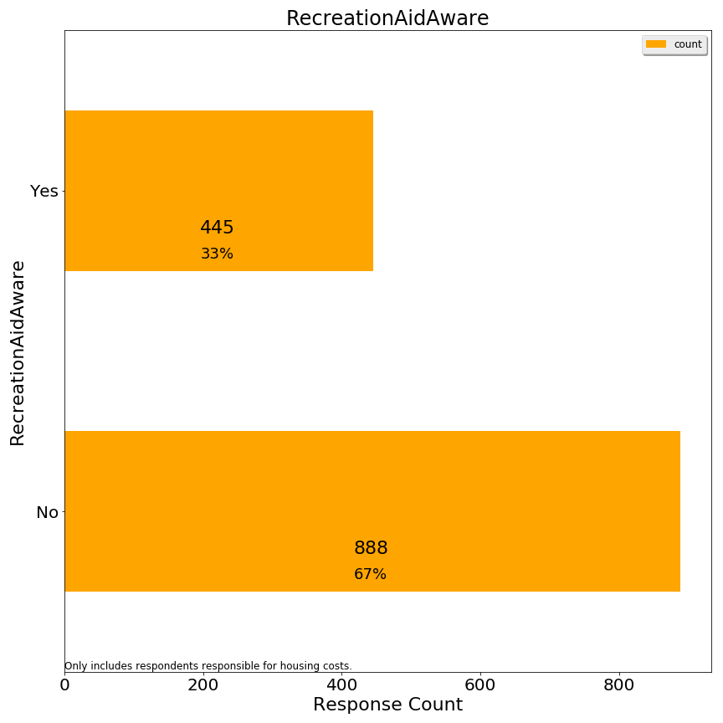

Q2. Has a household member received this type of financial assistance to participate in a program or service?

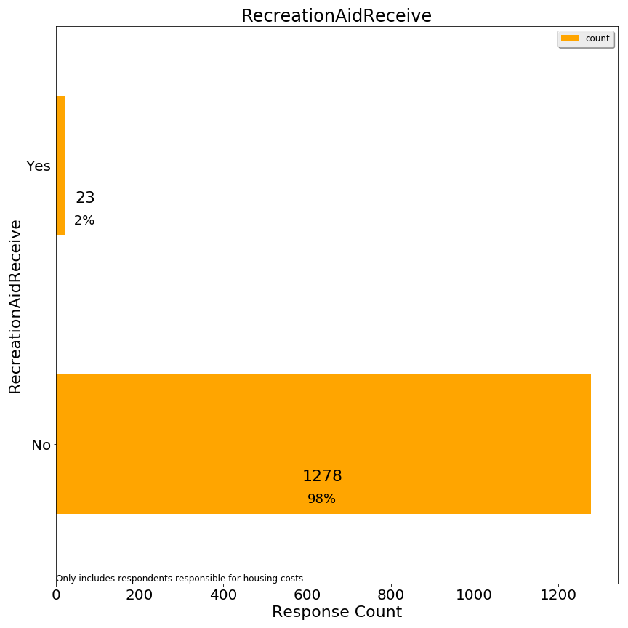

Q3. If your primary residence is rental, please indicate your monthly rental cost:

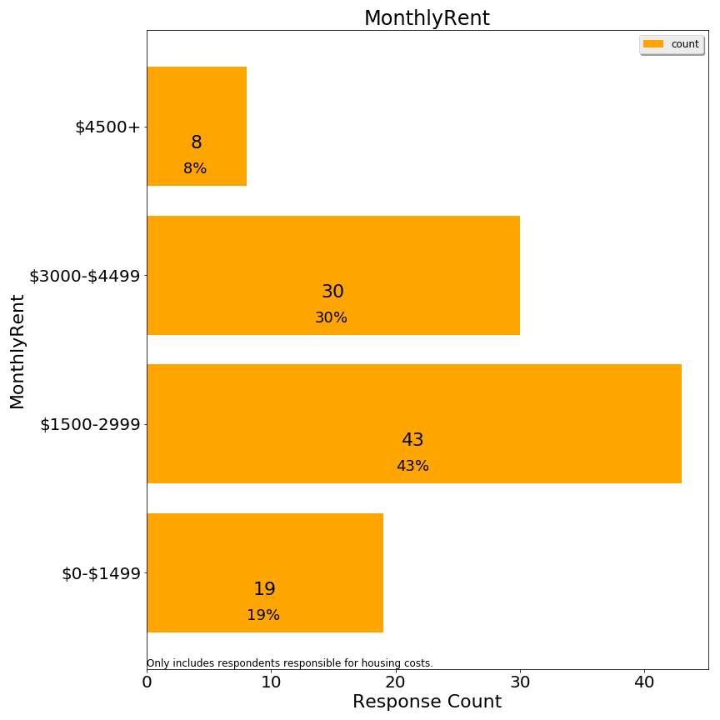

Q4. If you own your primary residence, please indicate your total monthly housing payment (mortgage, insurance, property taxes):

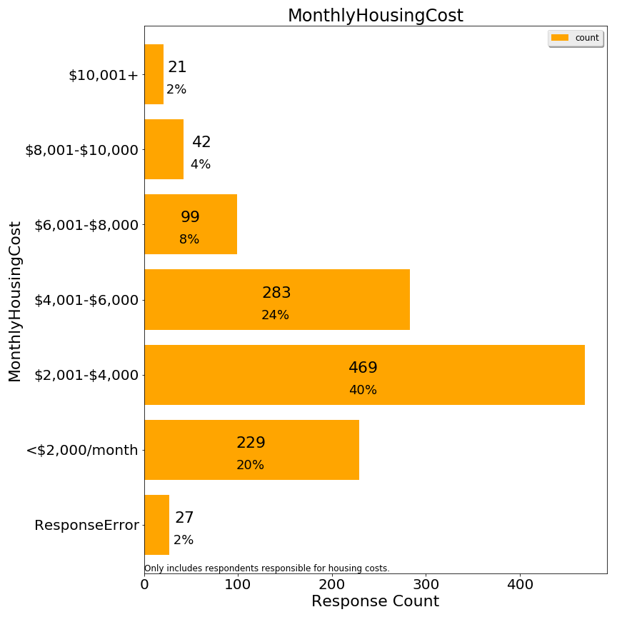

As indicated, some $10,001+ responses were re-coded as ResponseError because it was not conceivable to the Committee how it corresponded to a lower home value. We presume the respondents interpreted the figure as an annual cost when they saw a figure such as $10,001+.

Q5. Do you receive a property tax deferral or property tax credit due to limited income?

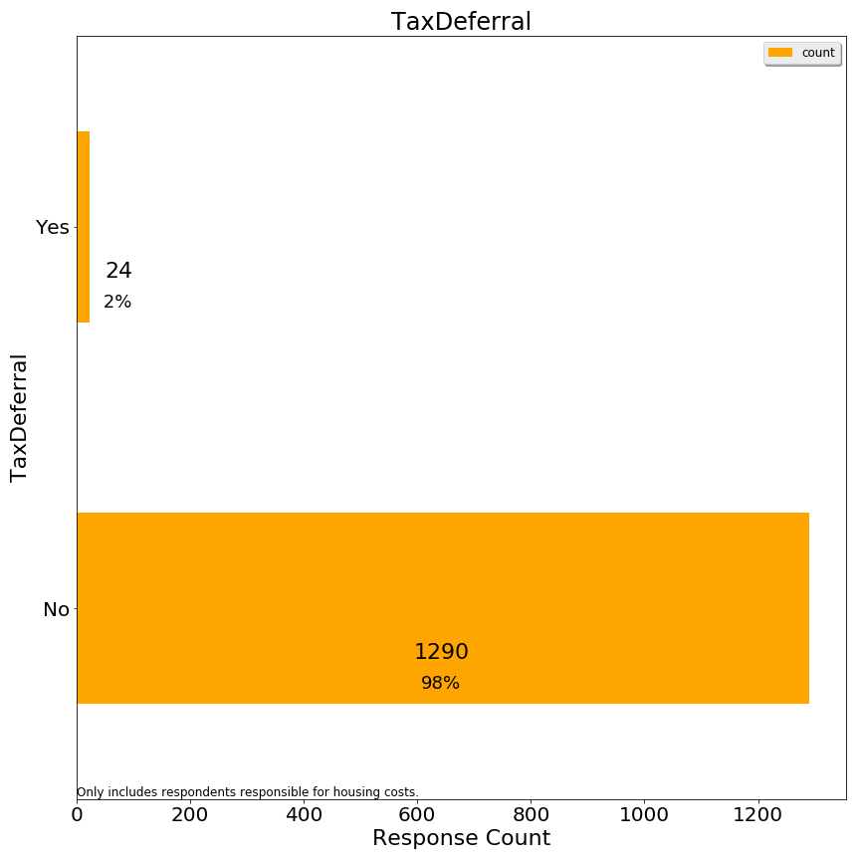

Q6. What level of stress does your household experience with payment of monthly housing costs?

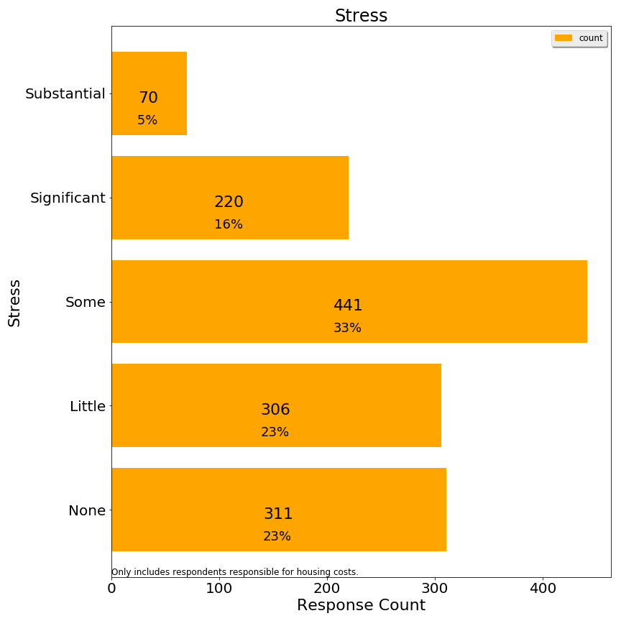

These stress codes were then grouped into high, medium and low for analysis purposes.

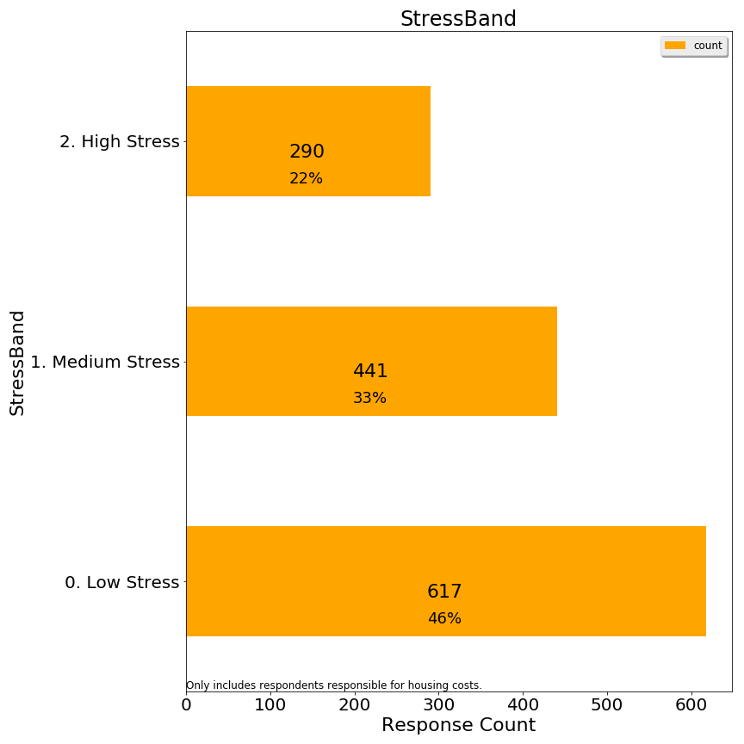

Q8. Thinking about all the costs of living in your owned property or rental (rent/mortgage, home maintenance, condo fees, property taxes, insurance, utilities), what portion of these costs do you estimate is related to property taxes?

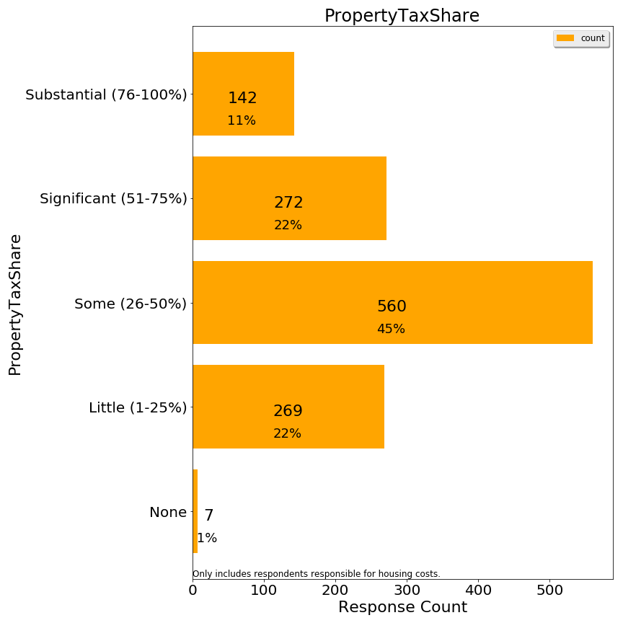

Some respondents criticized the labels which were attached to the %s, even suggesting that these labels implied taxes should be high. In hindsight, labels should not have been attached to the percentages.

Q9. Are you responsible for the housing costs at your residence (i.e. owner or lessee)?

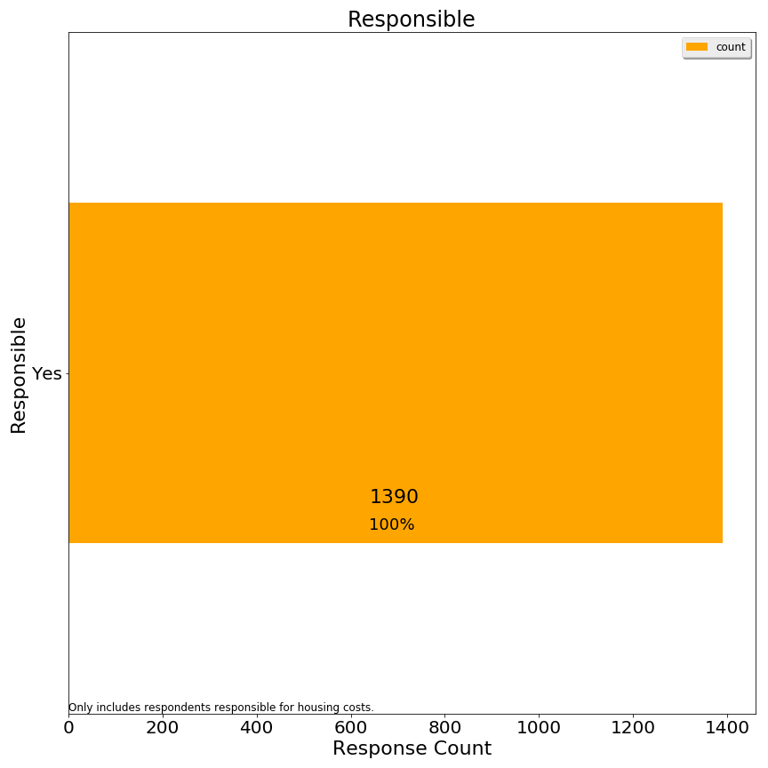

Q10. Are you considering relocating away from Lexington in the next 10 years?

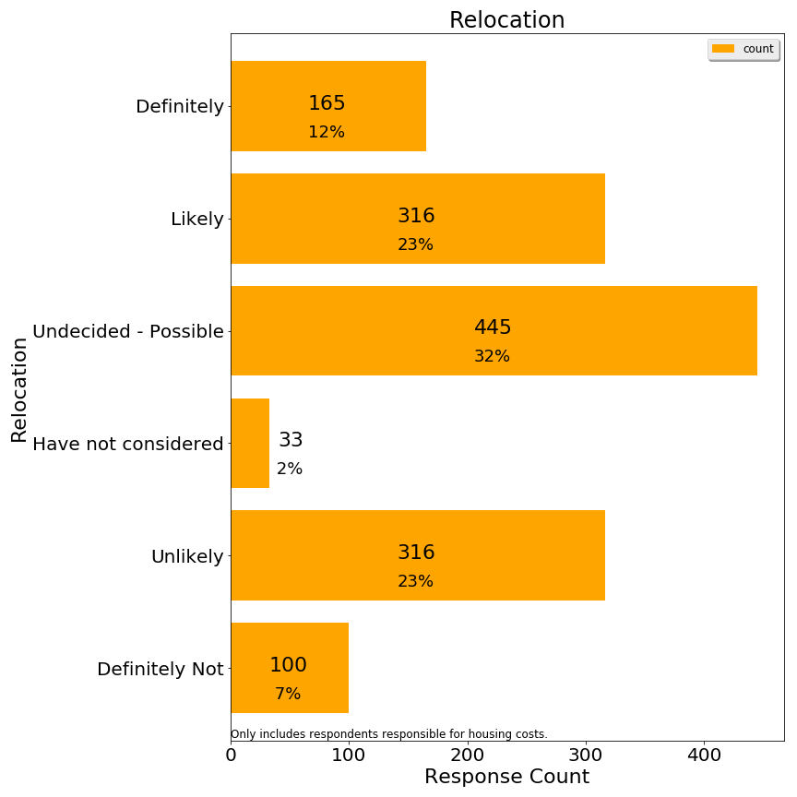

We regrouped responses for correlation analysis using a simpler relocation band variable:

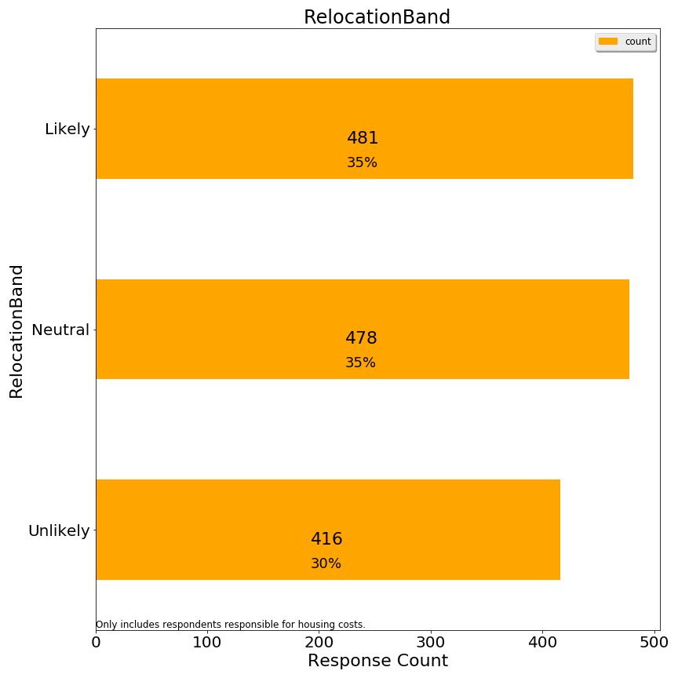

**Second 3: Demographics**

Q1. Age (respondent)

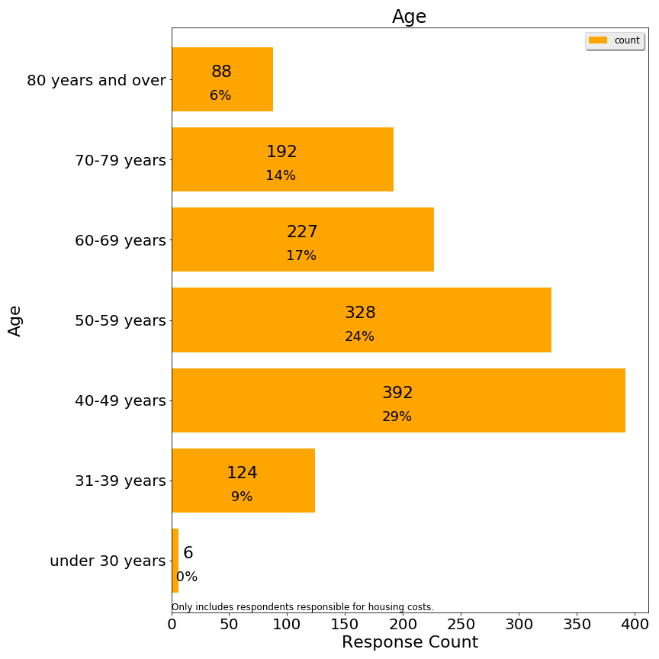

Q2. Size of household (number of people)

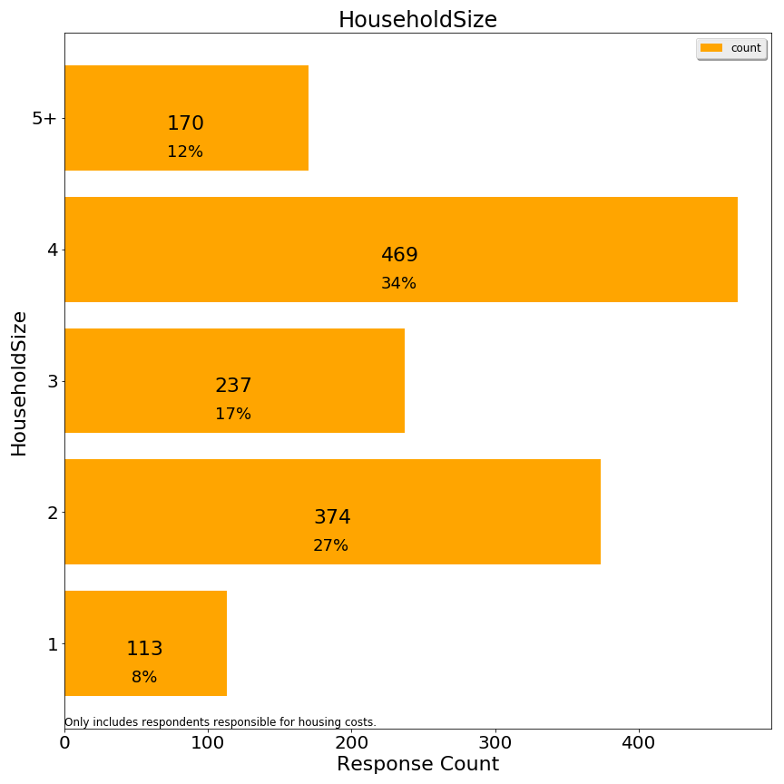

Q3. Disabilities within household (check all that apply)

*Not included*

Q4. Length of time living in town (respondent)

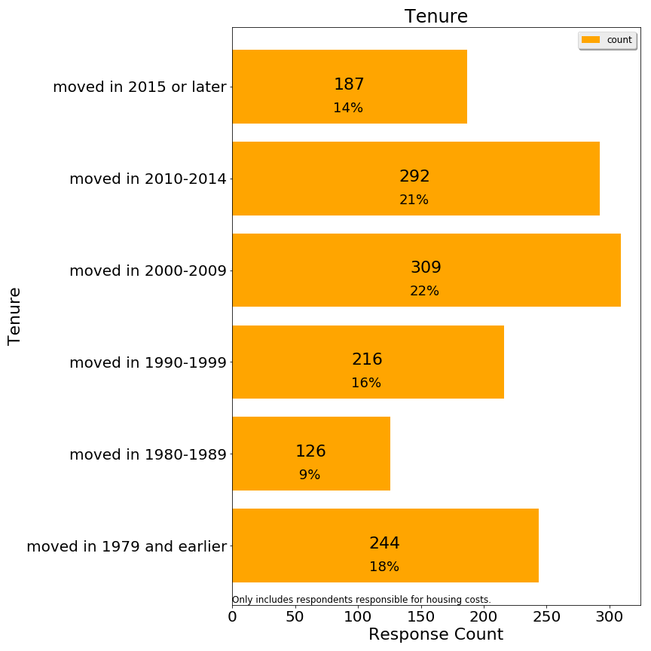

This question was ambiguous for respondents who moved in and out of Lexington multiple times.

Q5. What type of property is your residence?

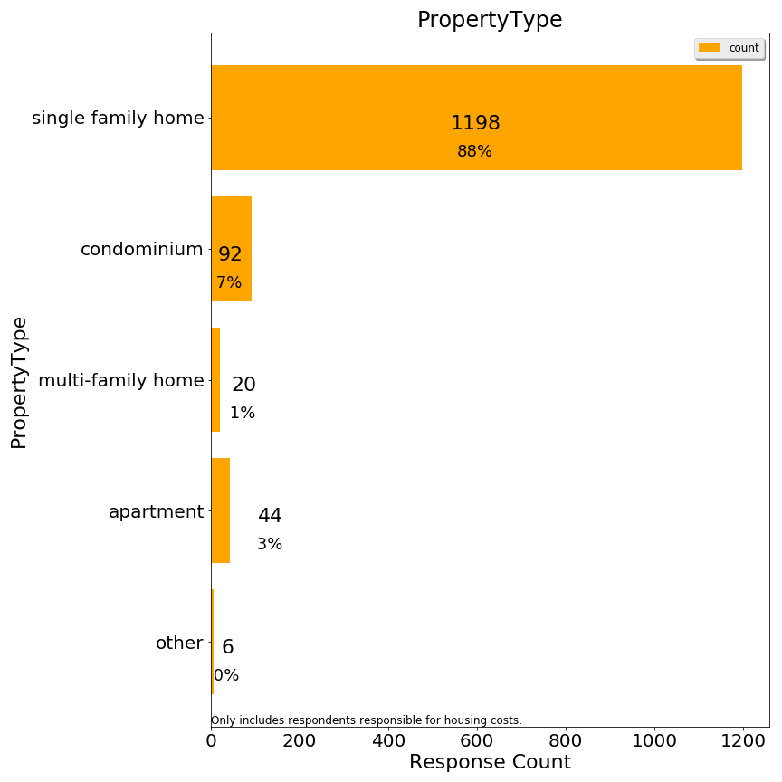

Q6. Approximate market property value of your Lexington residence (if owned):

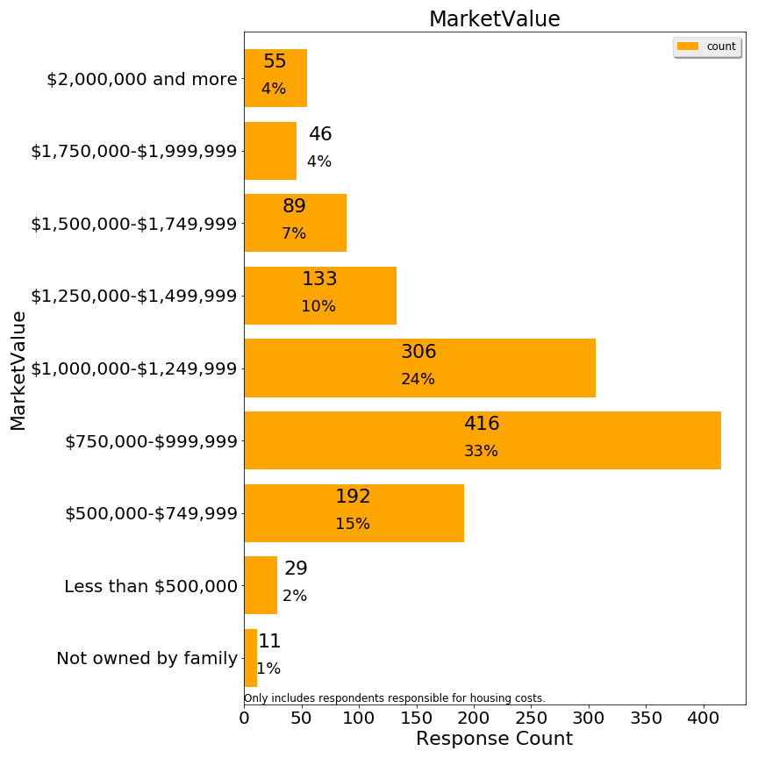

Q7. Please indicate your approximate household income in the past 12 months

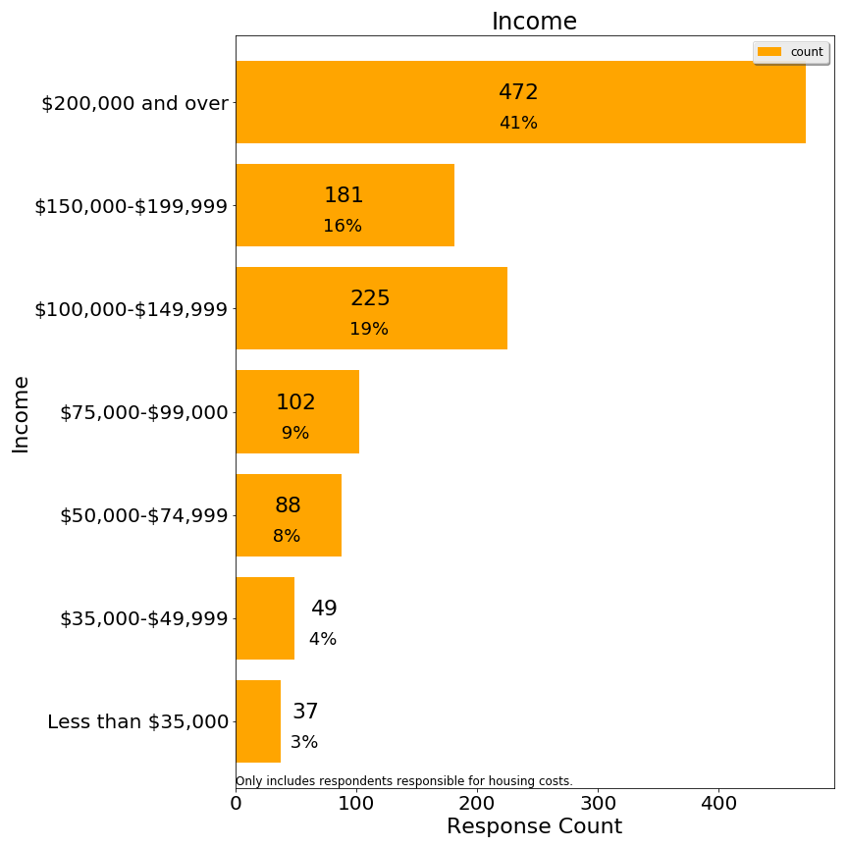

Additional charts on frequency distribution of derived variables are significant:

Number of Activities Reported

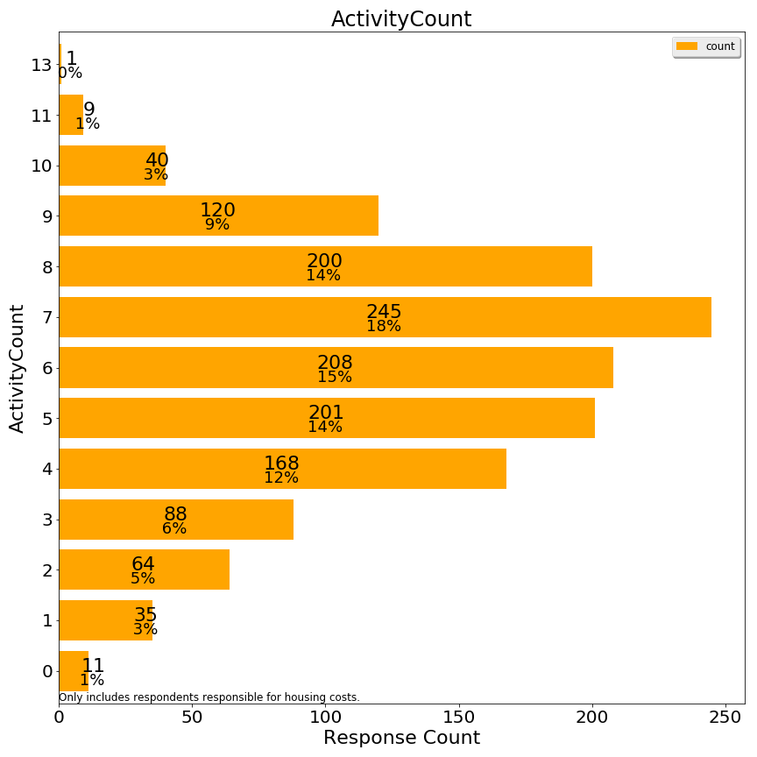

Whether respondent owns or rents



Number approximately qualified for a means-tested exemption (without asset test)

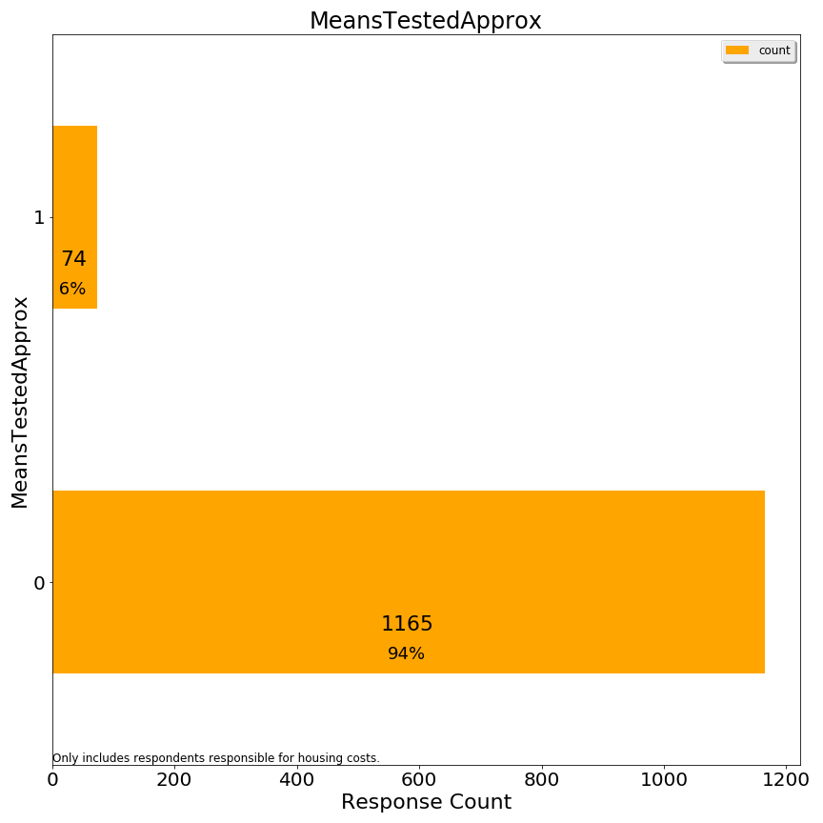

# Appendix: Related Documents

## Survey Data and Analysis

[Committee Draft Documents](https://www.lexingtonma.gov/residential-exemption-policy-study-committee-ad-hoc/pages/committee-draft-documents) contains these files:

* Survey Responses - contains answers to questions except for comments and source of survey: [Survey: Additional Comments (txt format)](https://www.lexingtonma.gov/sites/lexingtonma/files/pages/town_services_and_housing_costs_public_activities_oradditional.txt), [Survey: Additional Comments (xlsx format)](https://www.lexingtonma.gov/sites/lexingtonma/files/pages/town_services_and_housing_costs_public_activities_oradditional.xlsx)
* Open Comments File - contains text of comments question, redacted for privacy: [Survey: Comments (txt format)](https://www.lexingtonma.gov/sites/lexingtonma/files/pages/town_services_and_housing_costs_public_activities_orcomments.txt), [Survey: Comments (xlsx format)](https://www.lexingtonma.gov/sites/lexingtonma/files/pages/town_services_and_housing_costs_public_activities_orcomments.xlsx)
* Additional Comments File - contains text of additional comments, redacted for privacy: [Survey: Data With Augmented Fields (csv format)](https://www.lexingtonma.gov/sites/lexingtonma/files/pages/town_services_and_housing_costs_public.csv), [Survey: Data with Augmented Fields (xlsx format)](https://www.lexingtonma.gov/sites/lexingtonma/files/pages/town_services_and_housing_costs_public.xlsx)

**Analysis Files**

* Python Jupyter notebooks used to read and write files
* [Instructions to install python 3.7 with Anaconda](https://bit.ly/2FvRftC)

## Dr. Jonathan Haughton Tax Equilibrium Model

Dr. Haughton’s model is based on the Excel spreadsheet of residential assessed values found at the town website (<https://www.lexingtonma.gov/assessor>). Subsequently, the Committee became aware that a few smaller classes of residential property are not included in the published Lexington spreadsheet, and therefore not in Dr. Haugthon’s model. At the Lexington roundtable discussion, Dr. Haughton presented a 30% “clawback” based on a simple model, but this model which is specific to Lexington properties suggests a 28% “clawback”. (The clawback is the reduction in tax shift associated with the housing value change caused by the tax shift through hypothesized market capitalization.)

[Committee Draft Documents](https://www.lexingtonma.gov/residential-exemption-policy-study-committee-ad-hoc/pages/committee-draft-documents) contains the file [JonathanHaughton_SimulationLexingtonTaxes.xlsx](https://www.lexingtonma.gov/sites/lexingtonma/files/pages/jhsimulationslextaxes.xlsx).

1. The breakeven point (approximately $1,150,000) is the total of residential value in Lexington divided by the number of owner-occupied properties claiming a residential exemption.
2. It should be noted that despite low deferral participation, Lexington has the third-highest Tax Deferral participation rate in the State.
3. <https://www.lexingtonma.gov/sites/lexingtonma/files/uploads/ad_hoc_res_exempt_policy_committee_charge-101518.pdf>
4. <https://www.lexingtonma.gov/sites/lexingtonma/files/uploads/ad_hoc_res_exempt_policy_committee_charge-101518.pdf>
5. <https://en.wikipedia.org/wiki/Precision_and_recall>
6. Note: the Committee has not compared migration rates with other communities or over time, so the charge to study migration is not sufficient evidence that a “migration problem” exists for Lexington.
7. The simple interest rates on Lexington deferrals have ranged from a high of 4.77% in FY 2007, to a low of 0.12% in 2015. The FY 2019 interest rate is 1.96%. The income cut-off has increased incrementally from $40,000 in FY 2007 to $70,000 in FY 2019. Each year’s deferral is treated as an individual loan at the fixed interest rate in effect in its year of origin.
8. <https://lps.lexingtonma.org/cms/lib/MA01001631/Centricity/Domain/365/FY19%20Budget%20Presentation_FINAL.pdf>, slide 10.
9. <https://www.rhsohousing.org/node/81/housing-inventory>. Note: Under the 40B law, the Town’s SHI receives credit for all affordable and market rate units in a development when at least 20% to 25% of the units are deeded to be affordable. The Town's current nominal affordable housing percentage is 11.12%, although the actual percentage of affordable units is smaller.
10. One can conduct a thought experiment about the impact of conjoining or separating parcels of land from a primary residence based on opportunities to capture potential tax exemptions, and conclude that the residential exemption system is neutral to these transfers and therefore sensible.
11. The Committee does not have any evidence that Lexington would renegotiate with Brookhaven, so this section serves to make policy makers aware of this possibility or implied tax levels.
12. <https://malegislature.gov/Laws/GeneralLaws/PartI/TitleIX/Chapter59/Section5C>. From 1979-2016 a maximum 20% exemption was permitted without special legislation, but starting in 2016 this maximum was increased to 35%.
13. <https://www.lexingtonma.gov/sites/lexingtonma/files/uploads/fy19_classification_packet_for_boa_11.30.18_final.pdf>
14. Massachusetts Department of Revenue publications indicate that homes held in trust and occupied as the primary residence by a named trustee with a sufficient beneficial interest or life estate in the property would be considered owner-occupied. The Committee has no expertise in trust law and did not seek legal guidance on this matter, nor does any statement in this report constitute a legal opinion about eligibility.
15. A corollary is that combining and subdividing parcels changes the average residential parcel amount, but this is not a material consideration for Lexington.
16. The 9,265 figure from the tax classification packet is a rough estimate. Policy makers should treat this figure as an illustration, and evaluate from a longer perspective than how many parcels are owned in FY2019. <https://www.lexingtonma.gov/sites/lexingtonma/files/uploads/fy19_classification_packet_for_boa_11.30.18_final.pdf>
17. Properties are classified as multiple houses if multiple dwellings exist on a common residential parcel.
18. Verification failure could occur due to trust complexity, recent real estate transactions, and marital separation processes.
19. <https://www.investopedia.com/terms/p/progressivetax.asp>
20. The average single family tax bill is available in Boston’s own report, and it provides figures for Cambridge (FY17) and Brookline (FY18) used in those diagrams. The Boston report contains useful history and also demonstrates that the majority of Boston’s residential property is classified as condominium: <https://www.boston.gov/sites/default/files/imce-uploads/2018-03/fy2018_facts_figures.pdf>.
21. The only evidence of capitalization directly presented to the committee was the representation by brokers that buyers may have a “budget” which has to cover all monthly housing costs for a prospective property. General understanding of housing market forces is home buyers’ budgets impact offers for purchase, and thus housing prices. Members of the committee diverged in accepting market capitalization as a “fact”, with some members accepting general economic principles and others pointing out the lack of any specific evidence for these claims. This text refers to market capitalization as a “hypothesis” to represent the varied reactions to this argument.
22. This capitalization effect undermines the ability of the average citizen to compare home prices across markets. Boston home prices are often cited as indicators of the high cost of housing in the Boston area when tax rates are lower than many comparable cities. A corollary is that there are no “free lunches”, so a Lexington home buyer cannot save money by shifting assets to another city, but instead is shifting property tax costs to mortgage or investment opportunity costs. These capitalization effects seem true in principle but are difficult to accept at face value given varied circumstances of home buyers. This deserves further theoretical and empirical research.
23. Hypothetical example above uses 28% to give the reader a sense of the magnitude in practice.
24. 2.5% plus new growth, voter-approved operating overrides and debt exclusions plus the effect of “disappearing” personal property assets.
25. Operating overrides increase the levy limit, and debt exclusions are medium-term exemptions to the levy limit.
26. The Committee did not examine the relationship between apartment assessed values and market values, a concern raised by some residents. Katahdin Woods was selected as an example because conversion to condominiums is possible, but this illustration does not reflect any restrictions associated with affordable housing or prior Special Permit.
27. Certain Lexington apartments have restrictions associated with affordable housing. At Avalon Lexington Ridge and Avalon Lexington Hills, by law or by binding agreement, presently affordable units must remain affordable in perpetuity. Under the Special Permit by which Katahdin Woods was built, if the complex were to convert to condominiums, the Town would have to purchase Katahdin’s affordable units to retain their affordable status.
28. Several communities which adopted a means tested exemption instead of the SRE published studies.
29. Qualified subsidized housing inventory (SHI) could be reduced by conversions as well.
30. One issue to resolve is whether household assets should be prorated for beneficial interest or another adjustment to remove incentive to divorce to bring household assets under this threshold.
31. Asset level excluding primary residence, personal effects, motor vehicles and cemetery plots (as in 41C).
32. One issue to resolve is whether household assets should be prorated for beneficial interest or another adjustment to remove incentive to divorce to bring household assets under this threshold.
33. https://en.wikipedia.org/wiki/Precision_and_recall
34. Communication of results to the Recreation Department is occurring separately and is outside the scope of this report.
35. No further clarification was provided to respondents about interpreting the term “responsible”.
36. <https://www.census.gov/acs/www/data/data-tables-and-tools/>
37. For this chart, we combined the 70-79 and 80+ age classes into an age 70+ class due to the infrequent renter responses in this range.
38. [*https://sudbury.ma.us/assessors/2018/05/31/fy-2019-senior-means-tested-exemption-applications/*](https://sudbury.ma.us/assessors/2018/05/31/fy-2019-senior-means-tested-exemption-applications/)
39. One data source identifies the median rent in Lexington at $1,689. However, this seems far below market rates in general, so it is not clear if that figure is a rent controlled rent. <https://affordablehousingonline.com/housing-search/Massachusetts/Lexington>
40. Imputation of income could add about 100 respondents, but we have not elected to do any imputation.